Report No. 11636

A350-1000F MDCLS

CDP CONFIGURATION ITEM REQUIREMENTS DOCUMENT

|  |  |
| --- | --- |
| Module: |  |
| Configuration Type: |  |
| Configuration: |  |

ANCRA INTERNATIONAL, LLC

601 South Vincent Avenue

AZUSA, CA 91702

Ancra International LLC proprietary rights are included in the information disclosed herein. Recipient, by accepting this document, agrees that neither this document nor the information disclosed herein, nor any part thereof shall be reproduced or transferred to other documents or used or disclosed to others except as specifically authorized in writing by Ancra International LLC. Unpublished – all rights reserved under copyright laws.

© 2022 Ancra International LLC

Signature Page

**Ancra Signatures**

|  |  |  |  |
| --- | --- | --- | --- |
| **Prepared By:** |  |  | **07/06/2023** |
|  | **Srividya Ganesh** |  | **Date** |
| **Checked By:** |  |  | **07/06/2023** |
|  | **Prashant Baluchgi** |  | **Date** |
| **Approved By:** |  |  | **07/06/2023** |
|  | **Frank Poursartip** |  | **Date** |

Revision Record

|  |  |  |  |  |  |
| --- | --- | --- | --- | --- | --- |
| **Rev.**  **Level** | **Rev.**  **Date** | **Prep.**  **By** | **Check.**  **By** | **Effected**  **Pages** | **Change**  **Description** |
| A | 03/07/2023  04/26/2023  05/10/2023 | Srividya Ganesh | Prashant Baluchgi | All | Initial Baseline, as per PRs A350-17, A350-57  Corresponding Doors Baseline is 2023_03_03_CDP_CIRD_WP2_ENG_RELEASE  Updated as per PR A350-94, A350-39, A350-74  Corresponding Doors Baseline is:  2023_04_26_CDP_CIRD_WP3_ENG_RELEASE_01  Updated as per PR A350-94 Corresponding Doors Baseline is:  2023_05_10_CDP_CIRD_WP3_ENG_RELEASE |
| B | 07/06/2023 | Srividya Ganesh | Prashant Baluchgi | All | Updated as per PR A350-140, A350-141 Corresponding Doors Baseline is:  2023_07_06_CDP_CIRD_WP4_ENG_RELEASE_01 |
|  |  |  |  |  |  |

Table of Contents

1 INTRODUCTION 8

1.1 Scope 8

1.2 System Overview 8

1.2.1 Cargo Display Panel Overview 13

1.3 ​​​​​​​ Definitions, Acronyms & Abbreviations 13

1.3.1 Definitions 13

1.3.2 Acronyms & Abbreviations 14

1.4 Requirement Conventions 17

2 REFERENCES 17

3 DESIGN REQUIREMENTS 22

3.1 Certification Requirements 22

3.2 CDP Hardware Architecture 24

3.2.1 Resource Allocation 26

3.3 CDP Power Supplies 27

3.4 CDP External Interfaces 28

3.5 CDP Built in Test 35

3.5.1 Continuous Fault and Monitoring Function 35

3.5.2 START UP BIT (SBIT) 39

3.6 Mechanical Specifications 45

3.7 Growth Provision Requirements 46

3.8 Safety and Reliability Requirements 46

3.9 Environmental Requirements 47

3.9.1 Temperature 48

3.10 Design Life Requirements 49

4 CDP SOFTWARE REQUIREMENTS 49

4.1 CDP MODES 49

4.1.1 OFF Mode 50

4.1.2 Initialization Mode 52

4.1.3 Live data Mode 54

4.1.4 Invalid Mode 56

4.1.5 Data Loading Mode 56

4.2 CAN MESSAGE PROCESSING FUNCTION 59

4.2.1 Receive Message Processing 59

4.2.2 CAN Input Processing 85

4.2.3 Transmit Message Processing 87

4.3 CDP SOFTWARE OVERVIEW 88

4.4 CDP SW MAIN PAGE 92

4.5 CDP SW MAINTANENCE PAGE 113

4.5.1 DETAILED SYSTEM STATUS 115

4.5.2 CDP SW Continuous Monitoring page 123

4.6 CAN SIGNAL MAPPING TO DISPLAY INDICATIONS 140

4.6.1 CONTROL PANEL SIGNALS 140

4.6.2 PDU SIGNALS 187

4.7 ULD STATUS PAGE 192

5 TRACEABILITY REPORT 193

5.1 CDP CIRD to SysRD Trace 193

5.2 SysRD to CDP CIRD trace 196

List of Figures

Figure 1 - CDP CIRD in Requirement Hierarchy 8

Figure 2 - A350F Cargo Hold Area - Equipment Positions 9

Figure 3 - A350F MDCLS ARCHITECTURE 10

Figure 4 - CDP HARDWARE ARCHITECTURE 25

Figure 5 - CDP P3 CONNECTOR 31

Figure 6 - CDP MODES 50

Figure 7 - CDP CAN Data Loader 58

Figure 8 - CDP Page Levels 90

Figure 9 - Back Navigation Icon 91

Figure 10 - CDP MAIN PAGE LAYOUT 93

Figure 11 - CDP Main Page - Navigation to Maintenance Page Icon 94

Figure 12 - CDP Main Page - Legends Icon 94

Figure 13 - CDP Main Page- Pictorial representation of Control Panels 95

Figure 14 - Sample Main Page Layout with FWD zone enabled for MCP, ICP and OCPs and various LCPs access 96

Figure 15 - Sample Main page layout with AFT Zone Enabled for MCP, ICP and OCP and Various LCPs Access 96

Figure 16 - Sample Figure with Zone 8 and Zone 10 Enabled and with all three access zone definitions 97

Figure 17 - Panel Status Symbol 100

Figure 18 - Overall Panel Status indication 101

Figure 19 - PDU Representation Symbols 110

Figure 20 - CDP PDU Status Symbol 111

Figure 21 - COLOR-CODING INFORMATION FOR CONTROL PANEL AND PDU INDICATORS 112

Figure 22 - CDP SW Maintenance Page 114

Figure 23 - CDP MAINTENANCE PAGE - DETAILED SYSTEM STATUS 116

Figure 24 - CP TABLE REPRESENTATION 122

Figure 25 - PDU Color Coding information 123

Figure 26 - Continuous Monitoring Page Access sections classification 124

Figure 27 - CDP Continuous monitoring Page - Section -1 page 125

Figure 28 - CDP Continuous Monitoring Page - Section -3 Page 126

Figure 29 - CDP Continuous Monitoring Page - Section 6 Page 127

Figure 30 - CDP Continuous Monitoring - PDU Status Page 128

Figure 31 - CDP Continuous Monitoring Page - CP Status Page - MCP 131

Figure 32 - CDP Continuous Monitoring Page - CP Status Page - ICP 131

Figure 33 - CDP Continuous Monitoring Page - CP Status Page - OCP 132

Figure 34 - CDP Continuous Monitoring Page - CP Status Page - LCP 1, LCP 2, LCP 3 133

Figure 35 - CDP Continuous Monitoring Page - CP Status Page - LCP 4 134

List of Tables

Table 1 - A350F MDCLS Key components 11

Table 2 - Definitions 14

Table 3 - Acronym and abbreviations 17

Table 4 - Reference Documents 22

Table 5 - CDP Electrical Interface Signals at connector 33

Table 6 - Power Supply Monitor Voltage Limits 38

Table 7 - CDP HARDWARE PIN PROGRAMMING DISCRETES ASSIGNMENT 41

Table 8 - CAN MESSAGES RECEIVED 61

Table 9 - Cargo_Zone_Enabled 62

Table 10 - Redirected MCP Panel_Status_Cmd 63

Table 11 - Redirected OCP Panel_Status_Cmd 64

Table 12 - Redirected ICP Panel_Status_Cmd 65

Table 13 - Redirected LCP Panel_Status_Cmd 67

Table 14 - Redirected MCP Panel_Oper_Cmd 69

Table 15 - Redirected OCP Panel_Oper_Cmd 71

Table 16 - Redirected ICP Panel_Oper_Cmd 73

Table 17 - Redirected LCP Panel_Oper_Cmd [LCP 1/2/3] 78

Table 18 - Redirected LCP 4 Panel_Oper_Cmd 80

Table 19 - Redirected PDU PREPARE 81

Table 20 - Redirected PDU MOVE 81

Table 21 - Redirected PDU RETRACT 82

Table 22 - Redirected PDU STATUS_MSG_1 84

Table 23 - Redirected PDU STATUS_MSG_2 85

Table 24 - Redirected PDU STATUS_MSG_3 85

Table 25 - PDU STOP SIGNALs to Control Panel Page Mapping 87

Table 26 - CDP Tx CDP_STATUS_DATA 88

Table 27 - Panels Status Indication Mapping 109

Table 28 - Panel_Status signal on each LCP 159

Table 29 - Mux_Current_Voltage signal for each LCP 160

Table 30 - Measured_Current_Voltage Signal on each LCP 161

Table 31 - LCP Faults to signal mapping 164

Table 32 - MCP faults to signal mapping 172

Table 33 - ICP faults to signal mapping 181

Table 34 - OCP faults to signal mapping 187

Table 35 - PDU Status Indicators Signal Mapping 190

Table 36 - PDU Faults to signal mapping 191

Table 37 - PDU Status Signals to signal Mapping 192

# INTRODUCTION

## Scope

The purpose of this document is to capture high level requirements for Cargo Display Panel which is part of the A350-1000F Main Deck Cargo Loading System provided by Ancra. The Airbus A350-1000F Main Deck Cargo Loading System (MDCLS) includes the CPIOM, Common Remote Data Concentrators (cRDC), Power Drive Units (PDU), Control panels (CP) and Cargo Display Panel (CDP) which are required to translate cargo loading/unloading operator commands into ULD movement and positioning.

The CDP receives Controller Area Network (CAN) messages from all the Control Panels (CPs) and Power Drive Units (PDUs). This document describes the requirements associated with each indicator behavior in the CDP main page and Maintenance page based on associated signals received from CAN messages and required hardware.

This document falls at Tier 3 of the requirement hierarchy. Refer the System Development Plan for information on the requirement development process:

Refer to the below figure for CDP CIRD in Requirement Hierarchy

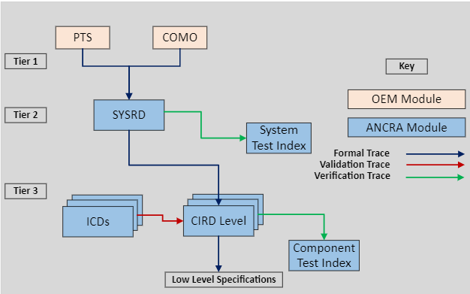

Figure 1 - CDP CIRD in Requirement Hierarchy

## System Overview

The A350-1000F is a freighter aircraft, designed and built by Airbus. The main deck cargo loading system will operate in a class E cargo compartment.

The A350-1000F fuselage frame stations and the position of PDUs, CPs and CDP in the cargo compartment and are as in the below indicative figures.

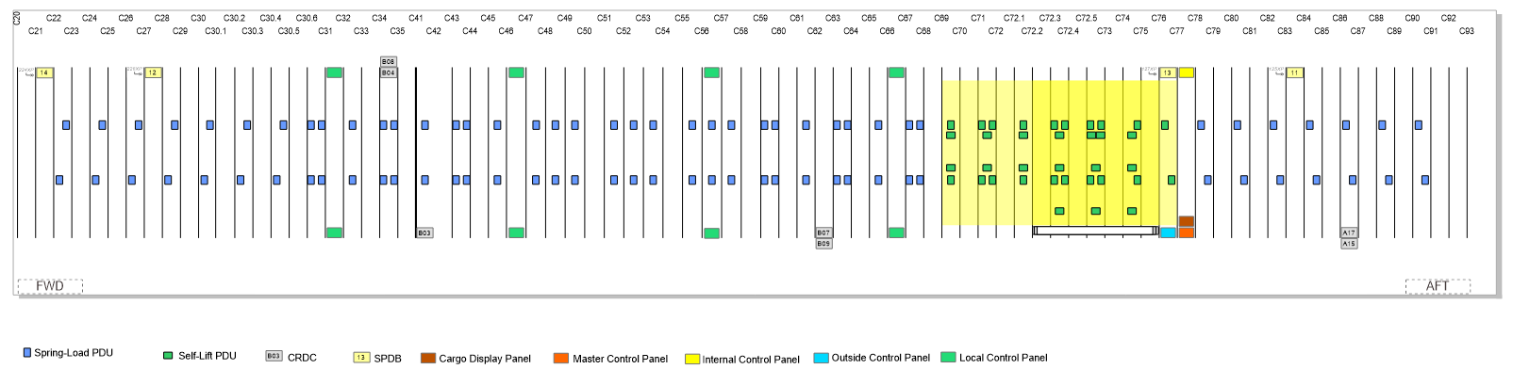

Figure 2 - A350F Cargo Hold Area - Equipment Positions

For the MDCLS three areas will be considered, Door & Extended entrance area, Forward cargo hold area and AFT cargo hold area. Inside the Door & Extended entrance area ULDs will be loaded into (IN) or unloaded out (OUT) of the aircraft. ULDs can be rotated (pallet turning) there. Inside the FWD, AFT cargo hold area, the ULDs will be transported on left hand (LH) side or on right hand (RH) side. Both sides can be operated separately. For ULDs transported in the middle or on both sides, operation can be performed either from left hand or from right hand side. ULDs will be loaded in or unloaded out of the Cargo Compartment via an external Cargo Loader.

MDCLS will move the ULDs in and out of the aircraft with the help of Power Drive Units (PDUs) based on the commands provided by the operator from the Control Panels (CP), the status of the MDCLS and equipment’s can be monitored in Cargo Display panel. ULDs will be guided and restraint by mechanical parts. To lock and unlock ULD, latches must be operated manually by the operator. Thus, the MDCLS will be a semi-automatic system.

The below Figure represents the A350-F MDCLS Architecture

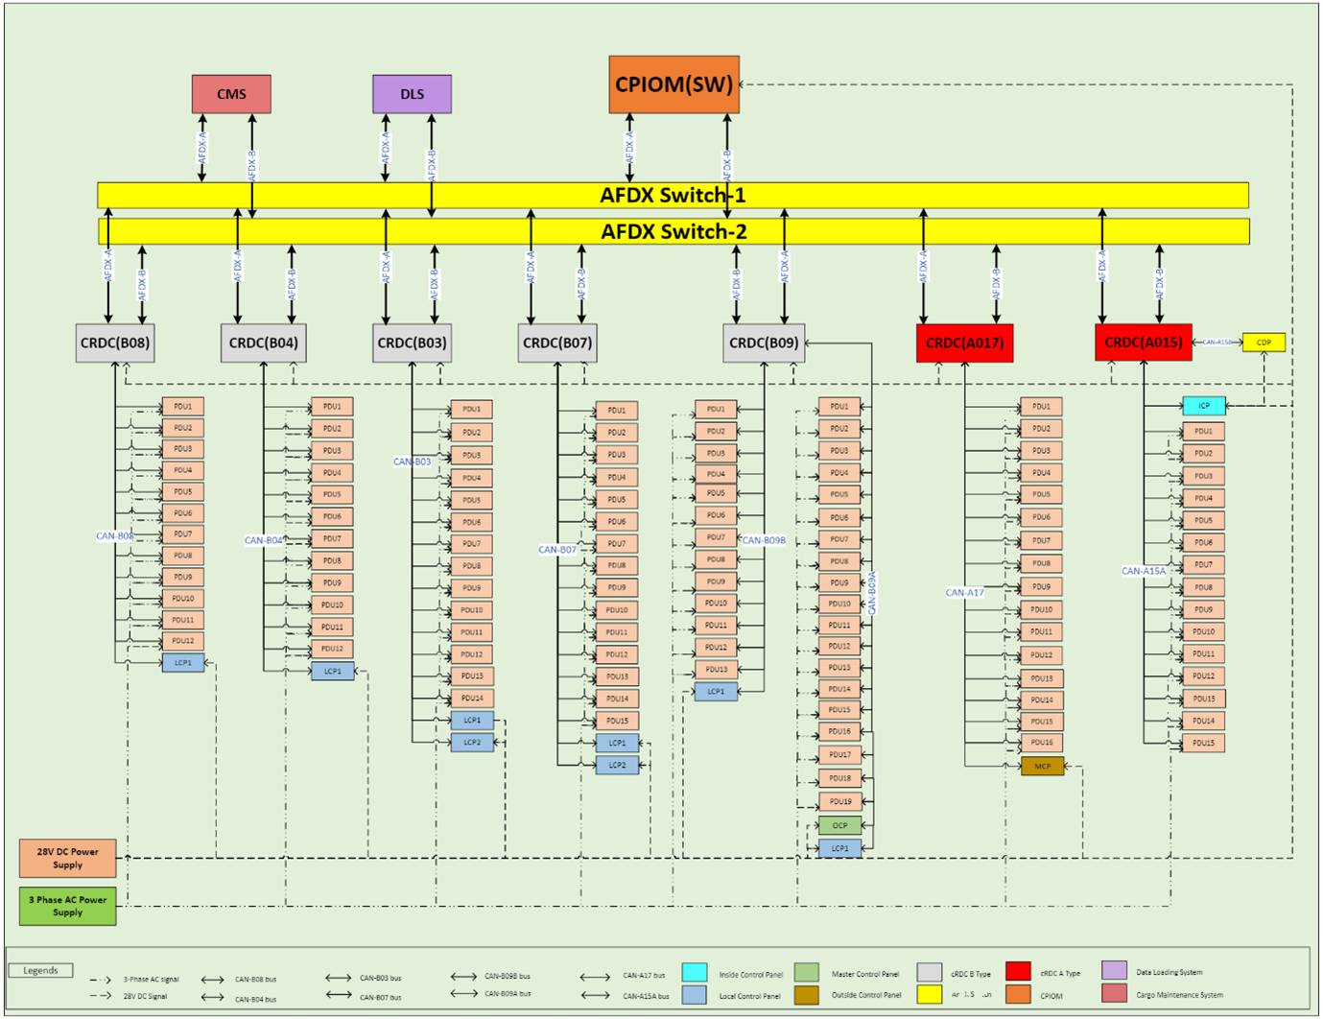

Figure 3 - A350F MDCLS ARCHITECTURE

The key components of the A350-1000F Main Deck Cargo Loading system include:

|  |  |  |  |  |
| --- | --- | --- | --- | --- |
| **S.NO** | **Equipment/Component** | **MDCLS** | **Qty** | **Supplier** |
| 1 | CPIOM  - MDCLS: Operational Software  - MDCLS: SBITE Software | Internal | 1  1 | Ancra |
| 2 | Common Remote Data Concentrators | Internal | 7 | Airbus |
| 3 | Control Panels (CPs)   * Outside Control Panel - 1 * Master Control Panel - 1 * Inside Control Panel - 1 * Local Control Panel - 6 * Local Control Panel 20FT - 2 | Internal | 11 | Ancra |
| 4 | Cargo Display Panel (CDP) | Internal | 1 | Ancra |
| 5 | Power Drive Units (PDUs)   * Spring Loaded PDUs – 80 * Self-Lift PDUs – 36 | Internal | 116 | Ancra |
| 6 | Secondary Power Distribution Box | Internal | 4 | Airbus |
| 7 | CAN Bus | Internal | 9 | Airbus |
| 8 | AFDX Switch Network | Internal | 2 | Airbus |
| 9 | Data Loading System | External | 1 | Airbus |
| 10 | Centralized Maintenance System | External | 1 | Airbus |
| 11 | SSPC | Internal | 4 | Airbus |

Table - A350F MDCLS Key components

**IMA CPIOM:** The Integrated Modular Avionics (IMA) Core Processing and Input / Output Module (CPIOM) is a high-performance computer capable of supporting multiple Hosted Applications (HAs) of differing Design Assurance Levels (DAL) on one computer.

The MDCLS Control and SBITE HAs will reside on a CPIOM. ANCRA will be supply these Hosted Applications.

The Primary function of the Control application is ULD type detection function, Speed Control Function, PDU(s) drive logic and PDU scrub protection. The Control application communicates with the cRDC’s via AFDX. The cRDC’s communicate with the Control Panels, CDP and PDU’s via CAN Bus. The translation of data from AFDX to CAN Bus and vice versa allows the Control HA to receive control panel commands and direct the various PDU’s in the Cargo Compartment.

In addition, Control application includes following functions:

* CPIOM State determination
* Continuous fault and Monitoring
* AFDX message processing
* Indication functions

The SBITE HA provides Built-in Test and monitoring functions for the MDCLS during system operation.

**Power Drive Unit:** The PDU is responsible for movement of ULD’s in the Freighter to facilitate loading and unloading. A series of Power Drive Units are installed on the Freighter to move the ULD’s laterally and longitudinally in the main deck cargo hold area of the Freighter as needed for the movement of ULDs. There are 2 types of PDUs: Spring Loaded PDU, Self-Lift PDU

The primary functionality of PDU is ULD Detection, ULD Movements laterally/longitudinally and Speed control for softer start and stop control of ULDs. PDU operates on 3 Phase AC power supply from ground power unit and communicates with the external devices on CAN bus.

**Control Panels (CP):** The CP primary function is to perform button/joystick Discrete Signal Processing. The discrete inputs received from joystick/switches are packed and transmitted on CAN bus. The MDCLS contains multiple control panels, the capabilities of control panel near the DOOR are different from control panels placed inside cargo holding area. Control panels are placed at strategic locations for better visibility and access. Below is the list of control panels:

* Outside Control Panel
* Master Control Panel
* Inside Control Panel
* Local Control Panel
* Local Control Panel with 20FT

**Cargo Display Panel (CDP):** The CDP primary function is to indicate the MDCLS status. The system status is received through the CAN bus and will be displayed on 17-inch Touch screen. In Addition, System status displayed in CDP supports Maintenance Features. The Main page offers visualization of the System and provides critical information about the status of the individual components of the System. The Maintenance Page provides more detailed information about the status of the components of the System and allows the Operator to perform troubleshooting operations.

**Common Remote Data Concentrator:** The Primary function of cRDCs is translating and routing of AFDX to CAN messages and vice versa for the MDCLS.  The translation is for data from the Control and BITE HAs in the CPIOM to the Control Panels, PDU’s and the Display Panel / Health Monitoring Display and vice versa.  The cRDC’s also control the flow of +28Vdc and 115V AC power to the PDU’s, Control Panel and Display Panel / Health Monitoring Display.

**Secondary Power Distribution Boxes:** The SPDBs control the flow of +28 Vdc power to the CP, CDP, and LCP’s. The SPDBs also provides 3 phase 115V AC Power to all PDU.

The interfaces used in MDCLS system are as follows:

**CAN:** The CAN protocol is based on the CAN FD / ARINC 825 standards. Controller Area Network bus or CAN bus is utilized to connect the cRDC’s with the various Control Panels (OCP, MCP, ICP and LCP’s). CAN Bus is also utilized to connect the cRDC’s with the PDU’s.

**AFDX:** Avionics Full Duplex Switched Ethernet or AFDX is utilized to connect the MDCLS Hosted Applications located in the CPIOM with the cRDC’s and SPDB’s. AFDX protocol is based on the ARINC 664 / part 7. The redundant design of the AFDX bus structure provides multiple paths for the communication of data to and from the Control HA and the cRDC’s. It also provides multiple paths for the communication of data to and from the BITE HA and cRDC’s and the BITE HA and the Central Maintenance System (CMS).

### Cargo Display Panel Overview

The Main Deck Cargo Loading System (MCDLS) includes a 17” Touch Screen Display called as Cargo Display Panel (CDP) to indicate System Status and support Maintenance Features. The Main page offers visualization of the System and provides critical information about the status of the individual components of the System. The Maintenance Page provides more detailed information about the status of the components of the System and allows the Operator to perform troubleshooting operations.

The Cargo Display Panel will be installed in the sidewall lining LH-side of the aircraft. CDP receives the system status data through the CRDC routed over a CAN interface. The CDP software reads the CAN messages received from the CRDC in the CAN controller, processes the CAN message, validates it and updates the display with the respective visual indications thereby providing live data of all the operational data for each equipment.

The Cargo Display Panel provides the visual indication for the following:

* PDU – Displays all the PDU status information such as PDU ID, PDU health status, Cover Status, Drive direction, Lift status, brake status
* Control Panel – Displays the status of all the buttons and switches present on all the Control Panels
* Cargo Zone – Displays the Zone information.
* ULD details – Displays ULD with its internal identification number and its position.

## ​​​​​​​ Definitions, Acronyms & Abbreviations

### Definitions

|  |  |
| --- | --- |
| **Term** | **Definition / Interpretation** |
| PDU_Healthy | PDU_Health is identified as PDU_Healthy when PDU_Health received on the CAN bus is 0 |
| PDU_HAS_FAILURE | PDU_Health is identified as PDU_HAS_FAILURE, when PDU_Health received on the CAN bus is 1 |
| Automatic_Hold | PDU Hold_Release is identified as Automatic_Hold when Hold_Release received on the CAN bus is 0 |
| Release | PDU Hold_Release is identified as Release when Hold_Release received on the CAN bus is1 |
| PDU_Covered | PDU_Cover_Status is identified as PDU_Covered when PDU_Cover_Status received on CAN bus is 1 |
| Not_Covered | PDU_Cover_Status is identified as Not_Covered when PDU_Cover_Status received on CAN bus is 0 |
| Roller_Rotating | PDU_Roller_Status is identified as Roller_Rotating when PDU_Roller_Status received on CAN bus is 1 |
| Not_Rotating | PDU_Roller_Status is identified as Not_Rotating when PDU_Roller_Status received on CAN bus is 0 |
| Self_Lifting | A PDU_Type is identified as Self_Lifting when PDU_Type signal received on the CAN bus is 1 |
| Spring_Loaded | A PDU_Type is identified as Spring_Loaded when PDU_Type signal received on the CAN bus is 0 |
| Ground | The Ground state is asserted producing the Boolean 1 state |
| Open | The Open State is de-asserted producing a Boolean 0 state. |
| Platform Software | CDP Platform Software is a COTS software and hosts the Dataloader and operational Software. This is the base for all operations performed by CDP Data loader and operational Software and contains all libraries, packages and drivers utilized by both CDP Data Loader and Operational Software. |
| Operational Software | This is the Software application hosted by the CDP Platform SW. The operational SW processes all the CAN messages received and displays them on the touch screen display panel. The use of word Operational Software and application Software will be used interchangeably in this document. |

Table - Definitions

### Acronyms & Abbreviations

|  |  |
| --- | --- |
| **Acronym** | **Abbreviation** |
| ABD | Airbus Directive |
| AC | Alternating Current |
| AFDX | Avionics Full-DupleX Switched Ethernet |
| ARINC | Aeronautical Radio Incorporated |
| ARM | Advanced RISC Machine |
| ARP | Aerospace Recommended Practice |
| BIT | Built-In-Test |
| BITE | Built In Test Equipment |
| CAN | Controller Area Network |
| CAN825 | CAN as per ARINC825 Specification |
| CDP | Cargo Display Panel |
| CIRD | Configuration Item Requirements Document |
| CMS | Centralized Maintenance System |
| CP | Control Panel |
| CPU | Central Processing Unit |
| CPIOM | Core Processing and Input / Output Module |
| CRDC | Common Remote Data Concentrator |
| DC | Direct Current |
| DDR | Double Data Rate |
| DLCS | Data Loading and Configuration System |
| DLS | Data Loading System |
| ECMP | Electronic Component Management Plan |
| FAL | Final Assembly Line |
| HW | Hardware |
| Hz | Hertz |
| ICD | Interface Control Document |
| ICP | Inside Control Panel |
| KB | KiloBytes |
| LCP | Local Control Panel |
| LCD | Liquid Crystal Display |
| LVDS | Low Voltage Differential Signal for LCD displays |
| Mbps | Mega Bits Per Second |
| MCP | Master Control Panel |
| MDCLS | Main Deck Cargo Loading System |
| ms | milliseconds |
| NVM | Non-Volatile Memory |
| NA | Not Applicable |
| PB | Protocol Base |
| PDU | Power Drive Unit |
| PTS | Purchaser Technical Specification |
| OCP | Outside Control Panel |
| RAM | Random Access Memory |
| RISC | Reduced Instruction Set Computer |
| RTCA | Radio Technical Commission of Aeronautics |
| SAE | Society of Automotive Engineers |
| SMARC | Smart Mobility ARChitecture |
| SOC | System On Chip |
| SOM | System On Modules |
| SW | Software |
| ULD | Unit Load Device |
| USB | Universal Serial Bus |
| V | Volts |
| VDC | Voltage Direct Current |

Table - Acronym and abbreviations

## Requirement Conventions

Use of ‘shall’, ‘will’, ‘should’ and ‘may’ within this specification observes the following rules:

* 'Shall’ indicates a something that is required; traceability and verification are required.
* ‘Should’ expresses a recommendation.
* 'May’ provides a permission.
* 'Will’ indicates a characteristic of the system, an imposed characteristic of the system, or a supplier action; traceability and verification are not required.

The requirements herein may be written at the box level or at a lower level.  The following terminology is used for consistency:

* Requirements applicable at the box level are indicated by "The CDP shall..."

# REFERENCES

The documents mentioned in below table were used to prepare this document. If the version number is not provided, the latest version of the document is used from the Configuration Management System.

|  |  |  |
| --- | --- | --- |
| **File / Document / Version** | **Description** |  |
| **Customer Documents** |  |  |
| A350F Layout_PWR_BUS_20220914.cdr | CAN/Pwr Bus Layout Diagram |  |
| V5024WD2102340 | A350F Main Deck Cargo Loading System - Statement of Work/Contract |  |
| V5024PTSS21002 | PTS Main Deck Cargo Loading System (MDCLS) |  |
| V4230RQ0702729 | CAN Detailed Functional Specification |  |
| V42SP0806471 | DFS CAN Dataloading |  |
| V42ME2300903 | CAN Data Loading - Technical Note |  |
| ABD0100 g2-0.0 | Introduction |  |
| ABD0100 g2-1.1 | General Requirements |  |
| ABD0100 g2-1.2 | Environmental Conditions Requirements |  |
| ABD0100 g2-1.3 | Aircraft Operability and Design Maturity |  |
| ABD0100 g2-1.4 | Maintainability Requirements |  |
| ABD0100 g2-1.5 | Manufacturing and Maintenance Tests requirements |  |
| ABD0100 g2-1.6 | Identification and Marking |  |
| ABD0100 g2-1.7 | Mechanical Requirements |  |
| ABD0100 g2-1.8 | Electrical Characteristics for AC and DC Equipment |  |
| ABD0100 g2-1.9 | Electronic |  |
| ABD0100 g2-1.10 | Software |  |
| ABD0100 g2-2.1 | Safety & Reliability requirements |  |
| ABD0100 g2-2.2 | Validation & Verification requirements |  |
| ABD0100 g2-2.3 | Equipment Development and Assurance |  |
| ABD0100 g2-2.4 | Software Development and Assurance |  |
| ABD0100 g2-2.5 | Electronic Hardware Development and Assurance |  |
| ABD0100 g2-2.6 | Formal Equipment Qualification and Declaration of Performance |  |
| ABD0100 g2-2.7 | Configuration Management requirements |  |
| ABD0100 g2-2.8 | Equipment Physical and Functional Robustness |  |
| ABD0100 g2-3.0 | Reviews and Life Cycle Data Requirements |  |
| ABD0031 | Fireworthiness Requirements for the Pressurized section of Fuselage |  |
| ABD0078 | Corrosion Protection |  |
| VRQ2100929 | Main Deck Cargo Loading System Perceived Quality Requirements for the Purchaser Technical Specification |  |
| X51RSDP07003 | Hard Chromium Free and Cadmium Free Design Principle |  |
| V24RP0607448 | Electrical System Virtual Prototyping A350 SABER models requirements Get info for Electrical System Virtual Prototyping A350 SABER models requirements |  |
| M1666.3 | Security Assurance Requirements for Suppliers (SAR) |  |
| M1635.1 | Method for Aircraft Operability and Design Maturity - general Rules |  |
| M20328 | Stress Dossier Quality Assurance |  |
| GSD-H-002 | Airbus Requirements for Ergonomics in Production |  |
| FM1400906 | S50 Harmonised Static Stress Dossier Checklist |  |
| FM0300705 | Skill Template for Static Stress Report |  |
| FM2000751 | Maintainability and Maintenance Evaluation |  |
| FM2000776 | Maintainability and Maintenance Evaluation (MME) Economics Data |  |
| V020D21017347 | A350F - Preliminary requirements for CLS to be mounted over FAL and preFAL junctions |  |
| RP1513539 | Maintainability Standard Tool List |  |
| UG1801159 | Guidelines for Skill template FM300705 for Static Stress Report |  |
| TN_ETI_016_01_98 | CLS Climatic PDU Test |  |
| CML | Consumable Material List |  |
| **Regulatory and Industry Documents** |  |  |
| SAE-ARP 4754 | Certification considerations for highly integrated or complex air-craft systems. |  |
| SAE-ARP 4761 | Guidelines and Methods for conducting the Safety Assessment Process on Civil Airborne Systems and Equipment |  |
| RTCA DO160 | Environmental Conditions and Test Procedures for Airborne Equipment |  |
| RTCA DO178 | Software Considerations in Airborne Systems and Equipment Certification |  |
| RTCA DO254/ED-80 | Design Assurance Guidance For Airborne Electronic Hardware |  |
| ARINC 825 | General Standardization of CAN (Controller Area Network) Bus Protocol for Airborne Use - CAN-FD |  |
| ARINC 615A-3 | Software Data Loader Using Ethernet Interface |  |
| ARINC 665-3 | Loadable Software Standards |  |
| IEEE 802.3 | IEEE Standard for Ethernet |  |
| NAS3610 | Specification for Cargo Unit Load Devices |  |
| AS36100 | Air Cargo Unit Load Devices - Performance Requirements and Test Parameters |  |
| SAE-AS 8879 | Screw Threads |  |
| MIL-STD-1472 | Design Criterias Human Engineering |  |
| IATA ULD | IATA ULD Regulations Manual |  |
| EASA CS 25 | Certification Specification and Acceptable Means of Compliance for Large Aeroplanes |  |
| FAA FAR 25 | Airworthiness Standards - Transport Category Airplanes |  |
| AMC 20-115 | Airborne Software Development Assurance Using EUROCAE ED-12 and RTCA DO-178 |  |
| AMC 20-152 replacing CRI F-08 | Electronic Hardware Development Assurance |  |
| AMC 20-189 | The Management of Open Problem Reports (OPRs) |  |
| AMC 20-115D Complementing CRI F-09 | Software Aspects of Certification, application of ED-12B/DO-178B, Field loadable SW, user modifiable SW, use of COTS |  |
| CRI F-10 | Use of COTS graphical processor |  |
| CRI F-15 | SW Formalized Requirements Validation & Verification AMC 20-115D Airborne Software Development Assurance Using EUROCAE ED-12 and RTCA DO-178 |  |
| Note -  When CRI F-15 does not apply, that means that AMC 20-115D application selected appropriate Technology supplement to ED12C |  |
| CRI F-17 | Incremental Certification of Systems making Use of Digital Equipment |  |
| CRI F-27 | Use of Object Oriented Techniques at Design or Source Code Level |  |
| Note -  When CRI F-27 does not apply, that means that AMC 20-115D application selected appropriate Technology supplement to ED12C |  |
| CRI F-29 | Configurations Files |  |
| Note - When CRI F-29 does not apply, that means that AMC 20-115D application selected ED12C that supersedes IM F29. When IM F-29 applies, that means that AMC 20-115D application selected ED12B that shall be complemented by IM-F29 |  |
| CRI F-30 | Secondary Data Files Equipment Environmental Qualification |  |
| AMC 20-189 | AMC 20-189 Management of Open Problem Reports |  |
| CRI F-41 | Non-operational embedded Software |  |
| CRI F-70 superseded by AMC 20-193 | Multicore Processors |  |
|  |  |  |
| **ANCRA Documents** |  |  |
| 11500 | System Development Plan |  |
| 11553 | System Qualification and Certification Plan |  |
| 11552 | System Validation and Verification Plan |  |
| 11560 | System Description Document A350 Integrated Cargo Handling System |  |
| 11632 | System Requirement Document |  |
| 11594 | INTERFACE CONTROL DOCUMENT FOR CAN COMMUNICATION (CAN - ICD) FOR THE A350-1000F MDCLS |  |
| 11595 | ELECTRICAL INTERFACE CONTROL DOCUMENT FOR THE A350-1000F MDCLS |  |
| 11647 | Plan for Hardware Aspects of Certification (PHAC) for CDP |  |
| 11644 | Plan for Software Aspects of Certification for CDP |  |
| 11399 | Electronic Component Management Plan FOR A350-1000F Main Deck Cargo Loading System |  |
| 11569 | Environmental Qualification Test Plan |  |
| 11907 | Mechanical CIRD |  |

Table - Reference Documents

# DESIGN REQUIREMENTS

## Certification Requirements

ID:CDP-CIRD-41434

The CDP **shall** be developed according to processes aligned with SAE ARP4754A, with the Function Development Assurance Level (FDAL) of Level D.

**Applicability:** HW, SW  
**Object Type:** Derived  
**Rational for Derived Req:**This requirement is for ARP 4754A compliance  
**Verification Method:** Inspection  
**Safety Tag:** true  
**Safety Impact:** false  
**Safety Rationale:** This is Derived Requirement. Failure of this requirement is not safety critical and is as per the Design assurance Level D.

ID:CDP-CIRD-41435

The CDP software **shall** be developed according to processes defined in RTCA DO-178C / EUROCAE ED-12C, with the Design Assurance Level (DAL) of Level D.

**Applicability:** SW  
**Object Type:** Decomposed  
**Verification Method:** Inspection  
**Safety Tag:** false  
**Safety Impact:** false  
**Safety Rationale:** NA

ID:CDP-CIRD-41437

The CDP hardware **shall** be developed according to the processes aligned with AMC 20-152A, DO-254/ EUROCAE ED-80 with the Design Assurance Level (DAL) of Level D.

**Applicability:** HW  
**Object Type:** Decomposed  
**Verification Method:** Inspection  
**Safety Tag:** false  
**Safety Impact:** false  
**Safety Rationale:** NA

ID:CDP-CIRD-41436

The equipment CDP **shall** demonstrate the compliance to ABD0100 g2.

**Applicability:** HW, SW  
**Object Type:** Decomposed  
**Verification Method:** Analysis  
**Safety Tag:** false  
**Safety Impact:** false  
**Safety Rationale:** NA

ID:CDP-CIRD-52154

Components selection for the CDP **shall** comply with ECMP report 11399.

**Applicability:** HW  
**Object Type:** Derived  
**Rational for Derived Req:**This requirement is for the ECMP compliance  
**Verification Method:** Analysis  
**Safety Tag:** true  
**Safety Impact:** false  
**Safety Rationale:** This is Derived Requirement. Failure of this requirement is not safety critical and is as per the Design assurance Level D.

ID:CDP-CIRD-52156

The CDP **shall** meet ABD0100 g2-1.8_C,ABD0100 g2-1.9_B requirements as applicable.

**Applicability:** HW  
**Object Type:** Derived  
**Rational for Derived Req:**This requirement is for ABD 1.8 and 1.9 compliance  
**Verification Method:** Analysis  
**Safety Tag:** true  
**Safety Impact:** false  
**Safety Rationale:** This is Derived Requirement. Failure of this requirement is not safety critical and is as per the Design assurance Level D.

## CDP Hardware Architecture

The CDP consists of a 17-inch touch screen display, processor which utilizes SMARC (Smart Mobile Architecture) based SOM module, Double Data Rate Random Access Memory (DDR RAM), Discrete Input/Output Interface, Ethernet Interface, 28V DC power interface, CAN interface and a USB interface. The high level hardware architecture is illustrated in Figure 4 - CDP HARDWARE ARCHITECTURE.

The SMARC (“Smart Mobility ARChitecture”) is a versatile small form factor computer Module definition targeting applications that require low power, low costs, and high performance. The Modules will typically use ARM SOCs. Alternative low power SOCs and CPUs and other RISC CPUs may be used as well. The Modules are used as building blocks for portable and stationary embedded systems. The core CPU and support circuits, including DRAM, boot flash, power sequencing, CPU power supplies, Gigabit Ethernet and dual channel LVDS display transmitter are concentrated on the Module. The Modules are used with application specific Carrier Boards that implement features such as touch controllers. The modular approach allows scalability, fast time to market and upgradability while still maintaining low costs, low power and small physical size.

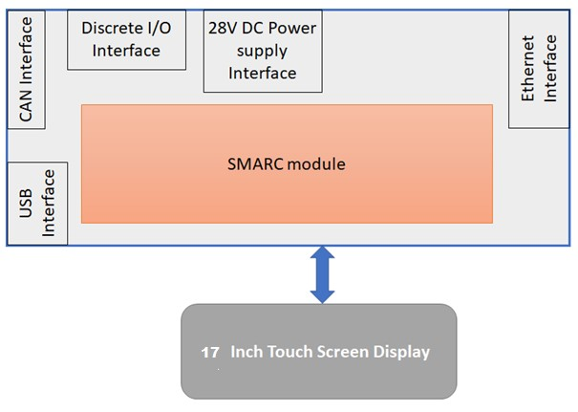

Figure 4 - CDP HARDWARE ARCHITECTURE

ID:CDP-CIRD-51992

The CDP **shall** use Intel Atom® based SMARC module.

**Applicability:** HW  
**Object Type:** Derived  
**Rational for Derived Req:**This is a derived requirement which specifies the processor to be used.  
**Verification Method:** Design Review  
**Safety Tag:** true  
**Safety Impact:** false  
**Safety Rationale:** This is Derived Requirement. Failure of this requirement is not safety critical and is as per the Design assurance Level D.

### Resource Allocation

#### Program Memory Allocation

ID:CDP-CIRD-29212

The CDP **shall** have DDR RAM with a minimum memory size of 4GB.

**Applicability:** HW  
**Object Type:** Derived  
**Rational for Derived Req:**This is a derived requirement which specifies about the RAM memory size to be used  
**Verification Method:** Analysis, Inspection  
**Safety Tag:** true  
**Safety Impact:** false  
**Safety Rationale:** This is Derived Requirement. Failure of this requirement is not safety critical and is as per the Design assurance Level D.

ID:CDP-CIRD-29213

The CDP **shall** have ARM, low power RISC or low power x86 CPUs / SOCs.

**Applicability:** HW  
**Object Type:** Derived  
**Rational for Derived Req:**This is a derived requirement which specifies about internal interfaces used.  
**Verification Method:** Analysis, Inspection  
**Safety Tag:** true  
**Safety Impact:** false  
**Safety Rationale:** This is Derived Requirement. Failure of this requirement is not safety critical and is as per the Design assurance Level D.

#### Non-Volatile Memory Allocation

ID:CDP-CIRD-47932

The CDP **shall** provide NVM storage with a minimum of 512 KB.

**Applicability:** HW  
**Object Type:** Decomposed  
**Verification Method:** Inspection  
**Safety Tag:** false  
**Safety Impact:** false  
**Safety Rationale:** NA

## CDP Power Supplies

ID:CDP-CIRD-26416

The CDP **shall** operate with input range 18.5VDC to 32.5VDC.

**Applicability:** HW  
**Object Type:** Decomposed  
**Verification Method:** Test  
**Safety Tag:** false  
**Safety Impact:** false  
**Safety Rationale:** NA

ID:CDP-CIRD-26417

The CDP **shall** be in operative mode within 10 seconds after power-up.

**Applicability:** HW, SW  
**Object Type:** Verbatim  
**Verification Method:** Test  
**Safety Tag:** false  
**Safety Impact:** false  
**Safety Rationale:** NA

ID:CDP-CIRD-52153

The CDP **shall** not re-boot and remain in its mode of operation if the transparency time is less than 10ms.

Note: Refer ABD0100 g2-1.8 for definition of transparency time

**Applicability:** HW  
**Object Type:** Derived  
**Rational for Derived Req:**This is a derived requirement which specifies about the CDP transparency time.  
**Verification Method:** Test  
**Safety Tag:** true  
**Safety Impact:** false  
**Safety Rationale:** This is Derived Requirement. Failure of this requirement is not safety critical and is as per the Design assurance Level D.

ID:CDP-CIRD-52155

The CDP **shall** protect against internal power supply failure.

Note: Refer ABD0100 g2-1.9 Section 5.1.3 for details.

**Applicability:** HW  
**Object Type:** Derived  
**Rational for Derived Req:**This requirement is for internal power supply monitoring  
**Verification Method:** Analysis  
**Safety Tag:** true  
**Safety Impact:** false  
**Safety Rationale:** This is Derived Requirement. Failure of this requirement is not safety critical and is as per the Design assurance Level D.

ID:CDP-CIRD-52157

The CDP **shall** draw no more than 3 Amps from the power bus at its full operation.

**Applicability:** HW  
**Object Type:** Derived  
**Rational for Derived Req:**This is a derived requirement which specifies about the maximum current to be drawn.  
**Verification Method:** Test  
**Safety Tag:** true  
**Safety Impact:** false  
**Safety Rationale:** This is Derived Requirement. Failure of this requirement is not safety critical and is as per the Design assurance Level D.

## CDP External Interfaces

ID:CDP-CIRD-26419

The CDP **shall** provide a CAN interface port with maximum 1Mbps data rate.

**Applicability:** HW  
**Object Type:** Decomposed  
**Verification Method:** Test  
**Safety Tag:** false  
**Safety Impact:** false  
**Safety Rationale:** NA

The CDP willprovide a 100Mbps Ethernet port for future use.

Note: Do not populate any components for the ethernet Circuit

ID:CDP-CIRD-26422

The CDP **shall** provide 4 spare connector pins.

**Applicability:** HW  
**Object Type:** Decomposed  
**Verification Method:** Analysis  
**Safety Tag:** false  
**Safety Impact:** false  
**Safety Rationale:** NA

ID:CDP-CIRD-26424

The CDP **shall** provide a 17-inch touch screen color display screen with 1920 X 1080 resolution and 60Hz refresh rate.

**Applicability:** HW  
**Object Type:** Decomposed  
**Verification Method:** Inspection  
**Safety Tag:** false  
**Safety Impact:** false  
**Safety Rationale:** NA

ID:CDP-CIRD-26421

The CDP **shall** provide a USB interface to support loading of the Platform Software.

Note:  USB interface should be accessible only at shop and not be operable during service.

**Applicability:** HW  
**Object Type:** Decomposed  
**Verification Method:** Inspection  
**Safety Tag:** false  
**Safety Impact:** false  
**Safety Rationale:** NA

ID:CDP-CIRD-41438

The CDP software **shall** provide a means to load the Operational software through the CAN interface.

**Applicability:** HW  
**Object Type:** Derived  
**Rational for Derived Req:**This is a derived requirement which specifies about means to lead the Operational SW  
**Verification Method:** Analysis  
**Safety Tag:** true  
**Safety Impact:** false  
**Safety Rationale:** This is Derived Requirement. Failure of this requirement is not safety critical and is as per the Design assurance Level D.

ID:CDP-CIRD-85128

The CDP aircraft connector shall meet the specifications identified in Interface Control Document for A350 Main Deck Cargo Loading System Electrical,Rpt 11595

**Applicability:** HW  
**Object Type:** Decomposed  
**Verification Method:** Design Review  
**Safety Tag:** false  
**Safety Impact:** false  
**Safety Rationale:** NA

ID:CDP-CIRD-41439

The CDP **shall** have one EN3646RS1419 male contact external connector (P3) to interface with aircraft harness signals. Refer to the below figure for the connector layout.

**Applicability:** HW  
**Object Type:** Decomposed  
**Verification Method:** Inspection  
**Safety Tag:** false  
**Safety Impact:** false  
**Safety Rationale:** NA

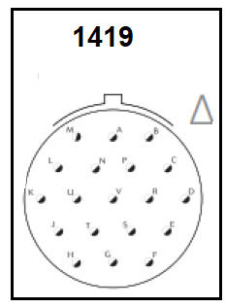

Figure 5 - CDP P3 CONNECTOR

ID:CDP-CIRD-41442

The CDP **shall** have pin mapping from the aircraft connector to P3 connector as shown in the table below.

**Applicability:** HW  
**Object Type:** Derived  
**Rational for Derived Req:**This is a derived requirement which specifies about connector details.  
**Verification Method:** Inspection  
**Safety Tag:** true  
**Safety Impact:** false  
**Safety Rationale:** This is Derived Requirement. Failure of this requirement is not safety critical and is as per the Design assurance Level D.

|  |  |  |  |
| --- | --- | --- | --- |
| **Sl. No.** | **Signal name** | **Pin number (P3) EN3646 1419** | **Description** |
|  | CAN_H | A | CAN Bus High signal |
|  | CAN_L | B | CAN Bus Low signal |
|  | CAN_SHLD | C | CAN Bus Shield |
|  | 28V_IN | G | 28V DC power input |
|  | 28V_IN | H | 28V DC power input |
|  | 28V_GND | J | Ground signal |
|  | 28V_GND | K | Ground signal |
|  | CASE_GROUND | D | CASE GROUND |
|  | HPP_ADD_1 | L | Hardware Pin program 1 (OPEN) |
|  | HPP_ADD_2 | M | Hardware Pin program 2 (OPEN) |
|  | HPP_ADD_3 | N | Hardware Pin program 3 (GND) |
|  | HPP_ADD_4 | P | Hardware Pin program 4 (GND) |
|  | HPP_ADD_PAR | R | Hardware Pin program parity pin (GND)    (Odd Parity) |
|  | HPP_ADD_GND | S | Ground pin for pin programming |
|  | Bonding | E | Bonding pin of Enclosure |
|  | SPARE_1 | F | Spare pin for future use |
|  | SPARE_2 | T | Spare pin for future use |
|  | SPARE_3 | U | Spare pin for future use |
|  | SPARE_4 | V | Spare pin for future use |

Table - CDP Electrical Interface Signals at connector

ID:CDP-CIRD-43458

The CDP HW **shall** provide 5 pin-programming configuration discretes

* 4 discrete pins for CDP installation address
* 1 discrete pin for Parity

**Applicability:** HW  
**Object Type:** Decomposed  
**Verification Method:** Test  
**Safety Tag:** false  
**Safety Impact:** false  
**Safety Rationale:** NA

ID:CDP-CIRD-50113

The CDP HW **shall** implement the 5 pin programming pins as Ground/Open circuit type discrete inputs.

**Applicability:** HW  
**Object Type:** Derived  
**Rational for Derived Req:**This is a derived requirement which specifies about the Hardware pin programming pins  
**Verification Method:** Test  
**Safety Tag:** true  
**Safety Impact:** false  
**Safety Rationale:** This is Derived Requirement. Failure of this requirement is not safety critical and is as per the Design assurance Level D.

ID:CDP-CIRD-50114

The CDP HW **shall** consider an input voltage between -4.0V and +4.5V as Ground state (Low).

Note: The Ground state (Low) voltage corresponds to logical state '1'.

**Applicability:** HW  
**Object Type:** Derived  
**Rational for Derived Req:**This is a derived requirement which specifies about the electrical characteristic of Ground state  
**Verification Method:** Test  
**Safety Tag:** true  
**Safety Impact:** false  
**Safety Rationale:** This is Derived Requirement. Failure of this requirement is not safety critical and is as per the Design assurance Level D.

ID:CDP-CIRD-50115

The CDP HW **shall** consider an input voltage between +10.5V and +49V as Open state (High)

Note: The Open state (high) voltage corresponds to logical state '0'.

**Applicability:** HW  
**Object Type:** Derived  
**Rational for Derived Req:**This is a derived requirement which specifies about the electrical characteristic of Open state  
**Verification Method:** Test  
**Safety Tag:** true  
**Safety Impact:** false  
**Safety Rationale:** This is Derived Requirement. Failure of this requirement is not safety critical and is as per the Design assurance Level D.

ID:CDP-CIRD-50116

The CDP HW **shall** provide a source current of 1 mA +/- 15% for each programming pin.

**Applicability:** HW  
**Object Type:** Derived  
**Rational for Derived Req:**This is a derived requirement which specifies about the electrical characteristics  
**Verification Method:** Test  
**Safety Tag:** true  
**Safety Impact:** false  
**Safety Rationale:** This is Derived Requirement. Failure of this requirement is not safety critical and is as per the Design assurance Level D.

## CDP Built in Test

### Continuous Fault and Monitoring Function

#### Signals Subject to ADC Monitoring

##### Input Voltage Measurement

ID:CDP-CIRD-52023

The CDP **shall** measure its 28VDC input voltage.

**Applicability:** HW, SW  
**Object Type:** Derived  
**Rational for Derived Req:**This is a derived requirement which specifies about the input voltage measurement  
**Verification Method:** Test  
**Safety Tag:** true  
**Safety Impact:** false  
**Safety Rationale:** This is Derived Requirement. Failure of this requirement is not safety critical and is as per the Design assurance Level D.

##### Input Current Measurement

ID:CDP-CIRD-51862

The CDP **shall** measure its 28VDC input current consumption

**Applicability:** HW, SW  
**Object Type:** Derived  
**Rational for Derived Req:**This is a derived requirement which specifies about the input current measurement  
**Verification Method:** Test  
**Safety Tag:** true  
**Safety Impact:** false  
**Safety Rationale:** This is Derived Requirement. Failure of this requirement is not safety critical and is as per the Design assurance Level D.

#### Input Power Supply Monitoring

Input Power supply monitoring includes overvoltage and undervoltage voltage monitoring. The CDP External Power Overvoltage/ Undervoltage Monitor is intended to detect external input power overvoltage/undervoltage condition that could damage the CDP Display circuitry and provides necessary data store downs and prepares for the shutdown before the actual shutdown.

ID:CDP-CIRD-25803

The CDP HW **shall** provide independent Overvoltage and undervoltage monitoring Circuits to monitor the input power supply for overvoltage or undervoltage conditions.

**Applicability:** HW  
**Object Type:** Derived  
**Rational for Derived Req:**This is a derived requirement which specifies about the input power supply monitor.  
**Verification Method:** Design Review  
**Safety Tag:** true  
**Safety Impact:** false  
**Safety Rationale:** This is Derived Requirement. Failure of this requirement is not safety critical and is as per the Design assurance Level D.

ID:CDP-CIRD-52227

The CDP **shall** set Input Power Over Voltage Fault when the 28VDC input power is above Over_voltage_Limit for more than 10ms.

Note: Refer Req. ID. 52233 For Over_voltage_Limit Value.

**Applicability:** HW, SW  
**Object Type:** Derived  
**Rational for Derived Req:**This is a derived requirement which specifies about the input power supply monitor.  
**Verification Method:** Test  
**Safety Tag:** true  
**Safety Impact:** false  
**Safety Rationale:** This is Derived Requirement. Failure of this requirement is not safety critical and is as per the Design assurance Level D.

ID:CDP-CIRD-52228

The CDP **shall** Clear Input Power Over Voltage Fault when the 28VDC input power is below Reset_Over_Voltage_Limit for more than 10ms.

Note: Refer Req. ID. 52233 For Reset_Over_voltage_Limit Value.

**Applicability:** HW, SW  
**Object Type:** Derived  
**Rational for Derived Req:**This is a derived requirement which specifies about the input power supply monitor.  
**Verification Method:** Test  
**Safety Tag:** true  
**Safety Impact:** false  
**Safety Rationale:** This is Derived Requirement. Failure of this requirement is not safety critical and is as per the Design assurance Level D.

ID:CDP-CIRD-52229

The CDP **shall** set Input Power Under Voltage Fault when the 28VDC input power is below Under_Voltage_Limit for more than 10ms.

Note: Refer Req. ID. 52233 For Under_Voltage_Limit Value.

**Applicability:** HW, SW  
**Object Type:** Derived  
**Rational for Derived Req:**This is a derived requirement which specifies about the input power supply monitor.  
**Verification Method:** Test  
**Safety Tag:** true  
**Safety Impact:** false  
**Safety Rationale:** This is Derived Requirement. Failure of this requirement is not safety critical and is as per the Design assurance Level D.

ID:CDP-CIRD-52230

The CDP **shall** Clear Input Power Under Voltage Fault when the 28VDC input power is below Reset_Under_Voltage_Limit for more than 10ms.

Note: Refer Req. ID. 52233 For Reset_Under_Voltage_Limit Value.

**Applicability:** HW, SW  
**Object Type:** Derived  
**Rational for Derived Req:**This is a derived requirement which specifies about the input power supply monitor.  
**Verification Method:** Test  
**Safety Tag:** true  
**Safety Impact:** false  
**Safety Rationale:** This is Derived Requirement. Failure of this requirement is not safety critical and is as per the Design assurance Level D.

|  |  |
| --- | --- |
| **Voltage Limits** | **Values** |
| Over_voltage_Limit | 32.5 VDC - Threshold |
| Under_Voltage_Limit | 18.5 VDC + Threshold |
| Threshold | 0.5 VDC |
| Reset_Over_Voltage_Limit | 31.7 VDC |
| Reset_Under_Voltage_Limit | 24 VDC |

Table - Power Supply Monitor Voltage Limits

ID:CDP-CIRD-52231

The CDP **shall** detect Input power supply fault when Input Power Under Voltage Fault is set.

**Applicability:** HW, SW  
**Object Type:** Derived  
**Rational for Derived Req:**This is a derived requirement which specifies about the input power supply monitor.  
**Verification Method:** Test  
**Safety Tag:** true  
**Safety Impact:** false  
**Safety Rationale:** This is Derived Requirement. Failure of this requirement is not safety critical and is as per the Design assurance Level D.

ID:CDP-CIRD-52232

The CDP **shall** perform the following upon detecting the Input power supply fault:  
1. Log the Power supply fault in the NVM.  
2. Enter into Fail-Safe Mode by shutting down the CDP Display.

**Applicability:** HW, SW  
**Object Type:** Derived  
**Rational for Derived Req:**This is a derived requirement which specifies about the input power supply monitor.  
**Verification Method:** Test  
**Safety Tag:** true  
**Safety Impact:** false  
**Safety Rationale:** This is Derived Requirement. Failure of this requirement is not safety critical and is as per the Design assurance Level D.

#### Internal Power Monitor

ID:CDP-CIRD-52235

If the voltages of the derived power supplies go below the under-voltage limit, the CDP **shall** go for hardware reset.

Note: Under voltage limit and tolerance for derived power supplies will be as per Hardware circuit implementation / realization.

**Applicability:** HW, SW  
**Object Type:** Derived  
**Rational for Derived Req:**This is a derived requirement which specifies about the input power supply monitor.  
**Verification Method:** Test  
**Safety Tag:** true  
**Safety Impact:** false  
**Safety Rationale:** This is Derived Requirement. Failure of this requirement is not safety critical and is as per the Design assurance Level D.

#### Input data Monitor

### START UP BIT (SBIT)

Start-up BIT (SBIT) is performed after the power-up. The purpose of the SBIT is to ensure that CDP is initialized correctly as determined by the hardware pin programming discretes, and to confirm the software integrity by verifying the SW CRC.

ID:CDP-CIRD-47952

The CDP **shall** execute the following tests during SBIT:

* Pin Programming Discrete Processing and Monitoring
* Operational Software integrity test

**Applicability:** SW  
**Object Type:** Derived  
**Rational for Derived Req:**This is a derived requirement which specifies about the SBIT tests  
**Verification Method:** Test  
**Safety Tag:** true  
**Safety Impact:** false  
**Safety Rationale:** This is Derived Requirement. Failure of this requirement is not safety critical and is as per the Design assurance Level D.

ID:CDP-CIRD-52274

The CDP **shall** set SBIT_Fail to True if

* CDP_Pin_Programming_Discrete_Fault is True or
* CDP_Operational_SW_Integrity_Fault is True

and to False otherwise.

**Applicability:** SW  
**Object Type:** Derived  
**Rational for Derived Req:**This is a derived requirement which specifies about the criteria's that set the SBIT Failure.  
**Verification Method:** Test  
**Safety Tag:** true  
**Safety Impact:** false  
**Safety Rationale:** This is Derived Requirement. Failure of this requirement is not safety critical and is as per the Design assurance Level D.

#### Pin Programming Discrete Processing and Monitoring

ID:CDP-CIRD-25798

The CDP **shall** decode its Pin programming discretes to determine the installation address in accordance with the following table:

**Applicability:** HW  
**Object Type:** Derived  
**Rational for Derived Req:**This is a derived requirement which specifies the CDP Pin programming discrete mapping against which the CDP compares during SBIT.  
**Verification Method:** Test  
**Safety Tag:** true  
**Safety Impact:** false  
**Safety Rationale:** This is Derived Requirement. Failure of this requirement is not safety critical and is as per the Design assurance Level D.

|  |  |  |  |  |  |
| --- | --- | --- | --- | --- | --- |
| **LRU** **ID** | **HPP_ADD_PAR** | **HPP_ADD_4** | **HPP_ADD_3** | **HPP_ADD_2** | **HPP_ADD_1** |
| CDP | GND | GND | GND | OPEN | OPEN |

Table - CDP HARDWARE PIN PROGRAMMING DISCRETES ASSIGNMENT

ID:CDP-CIRD-44186

The CDP **shall** determine any single failure of pin programming discrete input applying the odd Parity Check

Additional Information: For odd parity, if the sum of all data bits is even, excluding the parity bit, the parity bit should be set to 1, else if the sum of all data bits is odd, the parity bit is set to 0.

**Applicability:** HW, SW  
**Object Type:** Derived  
**Rational for Derived Req:**This is a derived requirement which specifies the Parity Check on the pin programming discretes which needs to be odd Parity where the sum of all the HPP data bits should be odd.  
**Verification Method:** Test  
**Safety Tag:** true  
**Safety Impact:** false  
**Safety Rationale:** This is Derived Requirement. Failure of this requirement is not safety critical and is as per the Design assurance Level D.

ID:CDP-CIRD-47954

The CDP **shall** set Parity_Valid to False  if the Parity bit read from the HPP_ADDR_PAR doesnot match with the computed Parity else set Parity_Valid to True.

**Applicability:** SW  
**Object Type:** Derived  
**Rational for Derived Req:**This is a derived requirement to set the validity of Parity bit.  
**Verification Method:** Test  
**Safety Tag:** true  
**Safety Impact:** false  
**Safety Rationale:** This is Derived Requirement. Failure of this requirement is not safety critical and is as per the Design assurance Level D.

ID:CDP-CIRD-47953

The CDP **shall** perform a validity check of the CDP pin programming discrete pins to ensure the LRU is installed in a valid position identified for the CDP.

**Applicability:** SW  
**Object Type:** Derived  
**Rational for Derived Req:**This is a derived requirement which specifies the validity check on the pin programming discrete.  
**Verification Method:** Test  
**Safety Tag:** true  
**Safety Impact:** false  
**Safety Rationale:** This is Derived Requirement. Failure of this requirement is not safety critical and is as per the Design assurance Level D.

ID:CDP-CIRD-47955

The CDP **shall** latch its installation address until the power is cycled.

**Applicability:** SW  
**Object Type:** Derived  
**Rational for Derived Req:**This is a derived requirement for latching the installation address.  
**Verification Method:** Test  
**Safety Tag:** true  
**Safety Impact:** false  
**Safety Rationale:** This is Derived Requirement. Failure of this requirement is not safety critical and is as per the Design assurance Level D.

ID:CDP-CIRD-52264

The CDP **shall** set HPP_ADDR_Disc_Valid to True if the Pin programming discretes matches with the Pin programming discrete mentioned in Table 7 - CDP HARDWARE PIN PROGRAMMING DISCRETES ASSIGNMENT else set HPP_ADDR_Disc_Valid to False.

**Applicability:** SW  
**Object Type:** Derived  
**Rational for Derived Req:**This is a derived requirement which specifies about the comparison of HPP discretes with the stored value and setting the HPP discretes validity accordingly.  
**Verification Method:** Test  
**Safety Tag:** true  
**Safety Impact:** false  
**Safety Rationale:** This is Derived Requirement. Failure of this requirement is not safety critical and is as per the Design assurance Level D.

ID:CDP-CIRD-52270

The CDP **shall** set CDP_Pin_Programming_Discrete_Fault to True if Parity_Valid is False or HPP_ADDR_Disc_Valid is False

**Applicability:** SW  
**Object Type:** Derived  
**Rational for Derived Req:**This is a derived requirement used to detect the CDP Pin programming fault.  
**Verification Method:** Test  
**Safety Tag:** true  
**Safety Impact:** false  
**Safety Rationale:** This is Derived Requirement. Failure of this requirement is not safety critical and is as per the Design assurance Level D.

ID:CDP-CIRD-52271

The CDP **shall** store the CDP_Pin_Programming_Discrete_Fault in NVM when set.

**Applicability:** SW  
**Object Type:** Derived  
**Rational for Derived Req:**This is a derived requirement to log the Pin programming fault in NVM if detected.  
**Verification Method:** Test  
**Safety Tag:** true  
**Safety Impact:** false  
**Safety Rationale:** This is Derived Requirement. Failure of this requirement is not safety critical and is as per the Design assurance Level D.

#### Operational Software integrity test

ID:CDP-CIRD-47956

The CDP software **shall** read the software CRC from flash memory during SBIT.

**Applicability:** SW  
**Object Type:** Derived  
**Rational for Derived Req:**This is a derived requirement which specifies about the process of reading the SW CRC from Flash memory during SBIT.  
**Verification Method:** Test  
**Safety Tag:** true  
**Safety Impact:** false  
**Safety Rationale:** This is Derived Requirement. Failure of this requirement is not safety critical and is as per the Design assurance Level D.

The Operational Software Integrity test uses the Operational SW CRC to confirm software integrity.

ID:CDP-CIRD-47958

The CDP **shall** verify the Operational SW Integrity during SBIT by verifying that the embedded Software CRC matches the computed CRC value.

Note: The actual CRC is performed after transferring the Operational SW to RAM.

**Applicability:** SW  
**Object Type:** Derived  
**Rational for Derived Req:**This is a derived requirement which specifies about verifying the Operational SW integrity.   
**Verification Method:** Test  
**Safety Tag:** true  
**Safety Impact:** false  
**Safety Rationale:** This is Derived Requirement. Failure of this requirement is not safety critical and is as per the Design assurance Level D.

ID:CDP-CIRD-52272

The CDP **shall** set CDP_Operational_SW_Integrity_Fault to True if the embedded SW CRC doesnot match with the computed CRC and to False otherwise.

**Applicability:** SW  
**Object Type:** Derived  
**Rational for Derived Req:**This is a derived requirement which specifies about the criteria to detect an Operational SW Integrity Fault.  
**Verification Method:** Test  
**Safety Tag:** true  
**Safety Impact:** false  
**Safety Rationale:** This is Derived Requirement. Failure of this requirement is not safety critical and is as per the Design assurance Level D.

ID:CDP-CIRD-52273

The CDP **shall** store the CDP_Operational_SW_Integrity_Fault in NVM if set.

**Applicability:** SW  
**Object Type:** Derived  
**Rational for Derived Req:**This requirement is about the logging of Operational SW integrity Fault in to NVM when detected.  
**Verification Method:** Test  
**Safety Tag:** true  
**Safety Impact:** false  
**Safety Rationale:** This is Derived Requirement. Failure of this requirement is not safety critical and is as per the Design assurance Level D.

ID:CDP-CIRD-85272

The CDP **shall** use the CRC-32-IEEE802.3 polynomial: 0x04C11DB7 (seed value 0xFFFFFFFF) for CRC computation of Operational Software.

**Applicability:** SW  
**Object Type:** Decomposed  
**Verification Method:** Test  
**Safety Tag:** false  
**Safety Impact:** false  
**Safety Rationale:** NA

## Mechanical Specifications

Refer Mechanical CIRD document Rpt 11907 for the mechanical specifications of the CDP.

## Growth Provision Requirements

ID:CDP-CIRD-51852

The following spare capacities **shall** be provided with CDP for later expansion:

* 50% additional RAM/ROM Capacity

**Applicability:** HW, SW  
**Object Type:** Verbatim  
**Verification Method:** Analysis  
**Safety Tag:** false  
**Safety Impact:** false  
**Safety Rationale:** NA

## Safety and Reliability Requirements

ID:CDP-CIRD-51854

The CDP **shall** be designed to provide guarantee of 500000 Flight hours MTBF or 100000 Flight Cycles MCBF, whichever occurs last.

**Applicability:** HW  
**Object Type:** Decomposed  
**Verification Method:** Analysis  
**Safety Tag:** false  
**Safety Impact:** false  
**Safety Rationale:** NA

ID:CDP-CIRD-85549

The CDP shall be designed to minimize the risk of unintentional misuse.

**Applicability:** HW, SW  
**Object Type:** Decomposed  
**Verification Method:** Analysis, Design Review  
**Safety Tag:** false  
**Safety Impact:** false  
**Safety Rationale:** NA

## Environmental Requirements

ID:CDP-CIRD-51856

The CDP **shall** comply with the requirements of ABD0100 g2-1.2 as applicable.

**Applicability:** HW  
**Object Type:** Derived  
**Rational for Derived Req:**This requirement is about the ABD 1.2 compliance  
**Verification Method:** Analysis  
**Safety Tag:** true  
**Safety Impact:** false  
**Safety Rationale:** This is Derived Requirement. Failure of this requirement is not safety critical and is as per the Design assurance Level D.

ID:CDP-CIRD-84404

The CDP **shall** meet the environmental requirements as defined in the Environmental Qualification Test Plan, Rpt 11569.

**Applicability:** HW  
**Object Type:** Derived  
**Rational for Derived Req:**This requirement specifies to comply as per the requirements in Environmental Qualification Test Plan.  
**Verification Method:** Compliance Statement, Design Review  
**Safety Tag:** true  
**Safety Impact:** false  
**Safety Rationale:** This is Derived Requirement. Failure of this requirement is not safety critical and is as per the Design assurance Level D.

ID:CDP-CIRD-52055

The CDP **shall** be protected against corrosion resulting from contact between solid materials and considering occurrence of the following fluids (alone and in combination):

* Heat transfer fluids
* Cleaning agents (e.g. Synclair A2 Gel, Ardrox1900B)
* Disinfectants (e.g. Airdal)
* Extinguishing agents
* Insecticides
* Sea Salt water
* Animal urine
* Water / waste

**Applicability:** HW  
**Object Type:** Verbatim  
**Verification Method:** Design Review  
**Safety Tag:** false  
**Safety Impact:** false  
**Safety Rationale:** NA

ID:CDP-CIRD-52056

Selected materials and surface protection as well as their combinations **shall** be compatible with the aircraft interfaces to avoid corrosion issues.

**Applicability:** HW  
**Object Type:** Verbatim  
**Verification Method:** Design Review, Inspection  
**Safety Tag:** false  
**Safety Impact:** false  
**Safety Rationale:** NA

ID:CDP-CIRD-52057

The CDP **shall** be adequately protected to avoid (self-) corrosion.

**Applicability:** HW  
**Object Type:** Verbatim  
**Verification Method:** Design Review  
**Safety Tag:** false  
**Safety Impact:** false  
**Safety Rationale:** NA

### Temperature

ID:CDP-CIRD-51861

The CDP **shall** operate within the temperature range of -40 °C to +70 °C.

**Applicability:** HW  
**Object Type:** Verbatim  
**Verification Method:** Test  
**Safety Tag:** false  
**Safety Impact:** false  
**Safety Rationale:** NA

ID:CDP-CIRD-52065

The CDP **shall** not be damaged by, and remain functional after, exposure to temperatures within the range of -55 deg C to +85 deg C.

**Applicability:** HW  
**Object Type:** Verbatim  
**Verification Method:** Analysis  
**Safety Tag:** false  
**Safety Impact:** false  
**Safety Rationale:** NA

## Design Life Requirements

ID:CDP-CIRD-51858

The CDP **shall** be designed for a service life of at least 120000 FH corresponding to 28800 flight cycles or 25 years whatever comes first.

**Applicability:** HW  
**Object Type:** Verbatim  
**Verification Method:** Analysis  
**Safety Tag:** false  
**Safety Impact:** false  
**Safety Rationale:** NA

# CDP SOFTWARE REQUIREMENTS

## CDP MODES

The CDP operates in one of the following modes. CDP mode transitions are illustrated in the below figure:

* Off Mode : The CDP is unpowered and the display is off.
* Initialization Mode : Initiated following the application of 28 VDC or at Power On Reset, initializes hardware, software and determines configuration.
* Live data mode : The CDP enters Live Data Mode after successful initialization and continues to stay in this mode.
* Invalid Mode : The CDP enters Invalid Mode when the initialization is Failed.
* Data Loading Mode : The CDP enters Data Loading Mode following the reception of Data load Request.

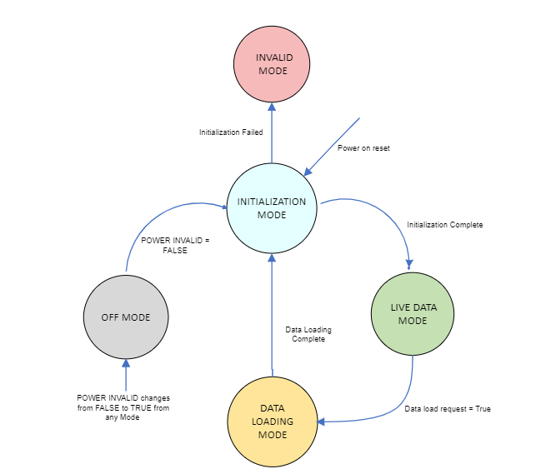

Figure 6 - CDP MODES

### OFF Mode

The OFF Mode is defined as, the power to the CDP is below a minimum operating voltage (less than 18.5 VDC) for more than 10ms. During this mode, the CDP application SW will log any existing faults and issue the shutdown command to Platform SW. CDP display will be switched off during this mode.

ID:CDP-CIRD-47941

The CDP **shall** set the "Power Invalid" to TRUE when the following condition is met. Otherwise, set to False.

* Input Power Voltage is less than 18.5 VDC for more than 10ms.

**Applicability:** HW, SW  
**Object Type:** Derived  
**Rational for Derived Req:**This is a derived requirement which specifies the criteria to set the Power Invalid which is an input condition to transition to OFF Mode.  
**Verification Method:** Test  
**Safety Tag:** true  
**Safety Impact:** false  
**Safety Rationale:** This is Derived Requirement. Failure of this requirement is not safety critical and is as per the Design assurance Level D.

ID:CDP-CIRD-47942

The CDP **shall** transition to OFF Mode when "Power Invalid" is True.

**Applicability:** HW, SW  
**Object Type:** Derived  
**Rational for Derived Req:**This is a derived requirement which specifies the transition criteria for OFF Mode  
**Verification Method:** Test  
**Safety Tag:** true  
**Safety Impact:** false  
**Safety Rationale:** This is Derived Requirement. Failure of this requirement is not safety critical and is as per the Design assurance Level D.

ID:CDP-CIRD-47943

The CDP **shall** perform the following in "OFF Mode":

* CAN communication [both transmitter and receiver] disabled
* CDP Display Disabled
* Log any existing faults in NVM.
* Shut down the Platform SW.

**Applicability:** HW, SW  
**Object Type:** Derived  
**Rational for Derived Req:**This is a derived requirement which specifies about the operations performed in OFF mode.  
**Verification Method:** Test  
**Safety Tag:** true  
**Safety Impact:** false  
**Safety Rationale:** This is Derived Requirement. Failure of this requirement is not safety critical and is as per the Design assurance Level D.

### Initialization Mode

Once the power is applied, the CDP enters Initialization Mode and remains in this mode until the Initialization Sequence Completes. The Initialization Sequence is defined as a sequence of steps that define the initial states of all of the input and output signals of the CDP. During the Initialization Mode, the CDP determines its installation address, initializes RAM Memory, initializes faults(if any) to unfailed state, initializes CDP output states.

ID:CDP-CIRD-47945

The CDP **shall** transition to Initialization mode if Power on Reset occurs or Power Invalid transitions from True to False and remains to be False.

Note : A power Cycle will trigger a Power on Reset.

**Applicability:** SW  
**Object Type:** Derived  
**Rational for Derived Req:**This is a derived requirement which specifies the transition criteria for Initialization Mode.  
**Verification Method:** Test  
**Safety Tag:** true  
**Safety Impact:** false  
**Safety Rationale:** This is Derived Requirement. Failure of this requirement is not safety critical and is as per the Design assurance Level D.

ID:CDP-CIRD-47946

After transitioning to Initialization Mode, the CDP **shall** execute the following in sequence:

* Initialize Hardware Components
* Initialize outputs
* Initialize faults (if any) to unfailed state
* Boot the Platform Software
* Execute Start up BIT (SBIT)
* Transition to Live data Mode / Invalid Mode

Note: Refer Section 3.5.2 for SBIT

**Applicability:** SW  
**Object Type:** Decomposed  
**Verification Method:** Test  
**Safety Tag:** false  
**Safety Impact:** false  
**Safety Rationale:** NA

ID:CDP-CIRD-47947

The CDP **shall** set its outputs as follows while in "Initialization Mode"

* CAN communication [both transmitter and receiver] disabled
* CDP Display Disabled

**Applicability:** SW  
**Object Type:** Derived  
**Rational for Derived Req:**This is a derived requirement which specifies about the operations performed in Initialization mode.  
**Verification Method:** Test  
**Safety Tag:** true  
**Safety Impact:** false  
**Safety Rationale:** This is Derived Requirement. Failure of this requirement is not safety critical and is as per the Design assurance Level D.

ID:CDP-CIRD-47948

The CDP **shall** consider Initialization as successful and Complete if SBIT_Fail remains to be in False upon SBIT completion.

**Applicability:** SW  
**Object Type:** Derived  
**Rational for Derived Req:**This is a derived requirement which specifies the criteria for Initialization to be considered as successful.  
**Verification Method:** Test  
**Safety Tag:** true  
**Safety Impact:** false  
**Safety Rationale:** This is Derived Requirement. Failure of this requirement is not safety critical and is as per the Design assurance Level D.

ID:CDP-CIRD-47949

The CDP **shall** consider Initialization Failed if SBIT_Fail is True.

**Applicability:** SW  
**Object Type:** Derived  
**Rational for Derived Req:**This is a derived requirement which specifies the criteria for Initialization to be considered as Fail.  
**Verification Method:** Test  
**Safety Tag:** true  
**Safety Impact:** false  
**Safety Rationale:** This is Derived Requirement. Failure of this requirement is not safety critical and is as per the Design assurance Level D.

ID:CDP-CIRD-47950

If a failure of the CDP Operational SW Integrity is detected, the CDP **shall** be inhibited from executing its application program, and disable its outputs.

**Applicability:** SW  
**Object Type:** Derived  
**Rational for Derived Req:**This is derived requirement which specifies about the CDP's response when the Operational SW integrity fault is detected  
**Verification Method:** Test  
**Safety Tag:** true  
**Safety Impact:** false  
**Safety Rationale:** This is Derived Requirement. Failure of this requirement is not safety critical and is as per the Design assurance Level D.

From Initialization Mode, the CDP will either transition to Live data Mode or Invalid Mode, depending upon the status of SBIT_Fail. If the SBIT_Fail is True, then the CDP transitions to the Invalid Mode, otherwise to Live Data Mode.

### Live data Mode

The Live Data mode is defined as normal operational mode. In this mode CDP enables CDP display, performs CAN data processing, display the main page layout and update all the indication functions based on associated incoming data. This mode also enables to navigate to other pages.

ID:CDP-CIRD-47959

Upon successful completion of the initialization mode, the CDP **shall** transition to Live data mode.

**Applicability:** SW  
**Object Type:** Derived  
**Rational for Derived Req:**This is a derived requirement which specifies the transition criteria for Live Data Mode.  
**Verification Method:** Test  
**Safety Tag:** true  
**Safety Impact:** false  
**Safety Rationale:** This is Derived Requirement. Failure of this requirement is not safety critical and is as per the Design assurance Level D.

ID:CDP-CIRD-47960

The CDP **shall** perform the following in Live Data Mode:

* Enable CAN Communication [Receiver and Transmitter]
* Enable the Display screen
* Perform screen touch processing
* CAN Receive message Processing
* CAN signal to Display indication mapping
* CDP SW Application Page determination and visual display.
* Update LRU status indications
* Application Pages Navigation Processing

**Applicability:** SW  
**Object Type:** Derived  
**Rational for Derived Req:**This is a derived requirement which specifies about the operations performed in Live Data mode.  
**Verification Method:** Test  
**Safety Tag:** true  
**Safety Impact:** false  
**Safety Rationale:** This is Derived Requirement. Failure of this requirement is not safety critical and is as per the Design assurance Level D.

### Invalid Mode

Invalid mode is defined to be a Fail Safe Mode. When CDP detects HW Pin programming fault or Operational SW integrity Failure, the CDP transitions to Invalid Mode and disables the CAN communication and the display.

ID:CDP-CIRD-47961

The CDP **shall** enter Invalid Mode if the Initialization is Failed i.e SBIT_Fail is True .

**Applicability:** SW  
**Object Type:** Derived  
**Rational for Derived Req:**This is a derived requirement which specifies the transition criteria for Invalid Mode  
**Verification Method:** Test  
**Safety Tag:** true  
**Safety Impact:** false  
**Safety Rationale:** This is Derived Requirement. Failure of this requirement is not safety critical and is as per the Design assurance Level D.

ID:CDP-CIRD-47962

The CDP **shall** perform the following in Invalid Mode:

* CAN communication [both transmitter and receiver] disabled
* CDP Display Disabled

**Applicability:** SW  
**Object Type:** Derived  
**Rational for Derived Req:**This is a derived requirement which specifies about the operations performed in Invalid mode.  
**Verification Method:** Test  
**Safety Tag:** true  
**Safety Impact:** false  
**Safety Rationale:** This is Derived Requirement. Failure of this requirement is not safety critical and is as per the Design assurance Level D.

### Data Loading Mode

The CDP will transition to Data load mode from Live Data mode when it receives the data load request from DLCS. During Data load mode, CDP will receive new operational software image via CAN bus as per the protocol defined in CAN Dataloading Detailed Functional Specification. CDP will use RAM memory to store the new operational SW image while it is receiving from DLCS. Once the complete image has been received, the image will be written into flash memory operational SW partition.

ID:CDP-CIRD-47963

The CDP **shall** transition from Live Data mode to Data Loading Mode when the Data Loading Request is received from the Data Load Application on the CRDC via CAN bus.

**Applicability:** SW  
**Object Type:** Derived  
**Rational for Derived Req:**This is a derived requirement which specifies the transition criteria for Data Loading Mode  
**Verification Method:** Test  
**Safety Tag:** true  
**Safety Impact:** false  
**Safety Rationale:** This is Derived Requirement. Failure of this requirement is not safety critical and is as per the Design assurance Level D.

ID:CDP-CIRD-47964

During Data Loading Mode, the CDP **shall** perform the following in sequence:

* Enable CAN transmitter
* Perform Data Loading operation as defined in requirement CDP-CIRD-41447
* Disable CAN transmitter once the Data Loading operation is completed.

**Applicability:** SW  
**Object Type:** Derived  
**Rational for Derived Req:**This is a derived requirement which specifies about the operations performed in Data Loading mode.  
**Verification Method:** Design Review, Inspection  
**Safety Tag:** true  
**Safety Impact:** false  
**Safety Rationale:** This is Derived Requirement. Failure of this requirement is not safety critical and is as per the Design assurance Level D.

The following diagram shows the general architecture for Remote Data Loading using the CAN bus as a connection between cRDC and CDP.

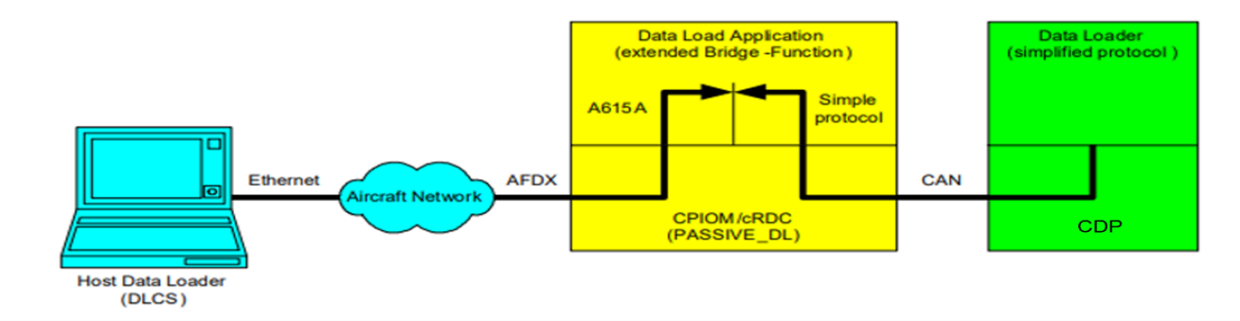

Figure 7 - CDP CAN Data Loader

The requirements for the Dataloading of the Cargo Display Panel using cRDC as bridge between the AFDX network and the CAN bus are detailed in CAN DFS (CAN Detailed Functional Specification), “CAN_Dataloading_DFS_v2.4V42SP0806471.pdf”.

ID:CDP-CIRD-41447

The CDP Software **shall** implement Data loading operation as per the LRU requirements detailed in CAN DFS, "V42SP0806471”

**Applicability:** SW  
**Object Type:** Decomposed  
**Verification Method:** Analysis  
**Safety Tag:** false  
**Safety Impact:** false  
**Safety Rationale:** NA

ID:CDP-CIRD-52262

The CDP Operational Software **shall** be field loadable and formatted in accordance with ARINC 665-3 standard.

**Applicability:** SW  
**Object Type:** Decomposed  
**Verification Method:** Design Review  
**Safety Tag:** false  
**Safety Impact:** false  
**Safety Rationale:** NA

## CAN MESSAGE PROCESSING FUNCTION

ID:CDP-CIRD-41451

The CDP **shall** receive messages from all the Control Panels, PDUs and CPIOM through CRDC-A15 via CAN-A15A bus in accordance with the protocol and definition in CAN ICD Rpt 11594.

**Applicability:** SW  
**Object Type:** Decomposed  
**Verification Method:** Test  
**Safety Tag:** false  
**Safety Impact:** false  
**Safety Rationale:** NA

ID:CDP-CIRD-51859

The CDP **shall** implement the CAN interface according to the specifications mentioned in V4230RQ0702729.

**Applicability:** SW  
**Object Type:** Derived  
**Rational for Derived Req:**This requirement is about the implementation of CAN interface as per the CAN DFS V4230RQ0702729   
**Verification Method:** Analysis, Test  
**Safety Tag:** true  
**Safety Impact:** false  
**Safety Rationale:** This is Derived Requirement. Failure of this requirement is not safety critical and is as per the Design assurance Level D.

### Receive Message Processing

ID:CDP-CIRD-26432

The Cargo Display Panel (CDP) **shall** implement the function identifier field and node identifier field of CAN data frame as specified in CAN-ICD Rpt 11594 for each of the messages outlined below.

**Applicability:** SW  
**Object Type:** Decomposed  
**Verification Method:** Analysis, Test  
**Safety Tag:** false  
**Safety Impact:** false  
**Safety Rationale:** NA

ID:CDP-CIRD-29218

The CDP **shall** identify PDUs and Control Panels location based on "Translated Node ID". Refer CAN ICD Rpt 11594.

**Applicability:** SW  
**Object Type:** Decomposed  
**Verification Method:** Test  
**Safety Tag:** false  
**Safety Impact:** false  
**Safety Rationale:** NA

ID:CDP-CIRD-42132

The CDP **shall** receive the following messages via CAN bus and process the messages at the rate mentioned below:

Note: Refer CAN-ICD Rpt 11594

**Applicability:** SW  
**Object Type:** Decomposed  
**Verification Method:** Test  
**Safety Tag:** false  
**Safety Impact:** false  
**Safety Rationale:** NA

|  |  |
| --- | --- |
| **MESSAGE NAME** | **UPDATE RATE** |
| CARGO_ZONE_ENABLED | 250 ms |
| PANEL_OPER_CMD | 250 ms |
| PANEL_STATUS_CMD | 250 ms |
| STATUS_MSG_1 | 250 ms |
| STATUS_MSG_2 | 250 ms |
| STATUS_MSG_3 | 250 ms |
| PREPARE | 250 ms |
| MOVE | 250ms |
| RETRACT | 250 ms |

Table - CAN MESSAGES RECEIVED

#### CARGO_ZONE_ENABLED

ID:CDP-CIRD-26434

The CDP **shall** receive the **CARGO_ZONE_ENABLED** message computed at CPIOM, from the CRDC via CAN bus with the following signals:

**Applicability:** SW  
**Object Type:** Decomposed  
**Verification Method:** Test  
**Safety Tag:** false  
**Safety Impact:** false  
**Safety Rationale:** NA

|  |
| --- |
| **Signal_Name** |
| Access_Zone_1_Enabled |
| Access_Zone_2_Enabled |
| Access_Zone_3_Enabled |
| Access_Zone_4_Enabled |
| Access_Zone_5_Enabled |
| Access_Zone_6_Enabled |
| Access_Zone_7_Enabled |
| Access_Zone_8_Enabled |
| Access_Zone_9_Enabled |
| Access_Zone_10_Enabled |
| Access_Zone_11_Enabled |
| Access_Zone_12_Enabled |
| Access_Zone_13_Enabled |
| Access_Zone_14_Enabled |
| Access_Zone_15_Enabled |
| Access_Zone_16_Enabled |
| Access_Zone_17_Enabled |
| Access_Zone_18_Enabled |
| Access_Zone_19_Enabled |
| Access_Zone_20_Enabled |
| Access_Zone_21_Enabled |
| Access_Zone_22_Enabled |
| Access_Zone_23_Enabled |
| Access_Zone_24_Enabled |
| Access_Zone_25_Enabled |
| Access_Zone_26_Enabled |
| Access_Zone_27_Enabled |
| Access_Zone_28_Enabled |
| Access_Zone_29_Enabled |

Table - Cargo_Zone_Enabled

#### Control Panel Redirected Messages

##### PANEL_STATUS_CMD

###### Master Control Panel (MCP)

ID:CDP-CIRD-26438

The CDP **shall** receive the redirected MCP PANEL_STATUS_CMD message via CAN bus from CPIOM, with the signals identified in below table in column "PANEL_STATUS_CMD from CPIOM to MCP" and assigned to the signal names mentioned in column "CDP Signal Mapping":

**Applicability:** SW  
**Object Type:** Decomposed  
**Verification Method:** Test  
**Safety Tag:** false  
**Safety Impact:** false  
**Safety Rationale:** NA

|  |  |
| --- | --- |
| **PANEL_STATUS_CMD from CPIOM to MCP** | **CDP Signal Mapping** |
| LED_System_Active | MCP_LED_System_Active |
| PB_On_Off_LED | MCP_PB_On_Off_LED |
| PB_Zone_Select_AFT_LED | MCP_PB_Zone_Select_AFT_LED |
| PB_Zone_Select_FWD_LED | MCP_PB_Zone_Select_FWD_LED |
| PB_Side_Select_Left_LED | MCP_PB_Side_Select_Left_LED |
| PB_Side_Select_Right_LED | MCP_PB_Side_Select_Right_LED |
| PB_Dual_Operator_LED | MCP_PB_Dual_Operator_LED |
| PB_20FT_LED | MCP_PB_20FT_LED |
| PB_LCP_LH2_1_Enable_LED | MCP_PB_LCP_LH2_1_Enable_LED |
| PB_LCP_LH4_3_Enable_LED | MCP_PB_LCP_LH4_3_Enable_LED |
| PB_LCP_RH2_1_Enable_LED | MCP_PB_LCP_RH2_1_Enable_LED |
| PB_LCP_RH4_3_Enable_LED | MCP_PB_LCP_RH4_3_Enable_LED |
| PB_Spin_LED | MCP_PB_Spin_LED |

Table - Redirected MCP Panel_Status_Cmd

###### Outside Control Panel (OCP)

ID:CDP-CIRD-26440

The CDP **shall** receive the redirected OCP PANEL_STATUS_CMD message via CAN bus from CPIOM, with the signals identified in below table in column "PANEL_STATUS_CMD from CPIOM to OCP" and assigned to the signal names mentioned in column "CDP Signal Mapping":

**Applicability:** SW  
**Object Type:** Decomposed  
**Verification Method:** Test  
**Safety Tag:** false  
**Safety Impact:** false  
**Safety Rationale:** NA

|  |  |
| --- | --- |
| **PANEL_STATUS_CMD from CPIOM to OCP** | **CDP Signal Mapping** |
| LED_System_Active | OCP_LED_System_Active |
| PB_On_Off_LED | OCP_PB_On_Off_LED |
| PB_Side_Select_Left_LED | OCP_PB_Side_Select_Left_LED |
| PB_Side_Select_Right_LED | OCP_PB_Side_Select_Right_LED |
| PB_Zone_Select_AFT_LED | OCP_PB_Zone_Select_AFT_LED |
| PB_Zone_Select_FWD_LED | OCP_PB_Zone_Select_FWD_LED |
| PB_Dual_Operator_LED | OCP_PB_Dual_Operator_LED |
| PB_20FT_LED | OCP_PB_20FT_LED |

Table - Redirected OCP Panel_Status_Cmd

###### Inside Control Panel (ICP)

ID:CDP-CIRD-26442

The CDP **shall** receive the redirected ICP PANEL_STATUS_CMD message via CAN bus from CPIOM, with the signals identified in below table in column "PANEL_STATUS_CMD from CPIOM to ICP" and assigned to the signal names mentioned in column "CDP Signal Mapping":

**Applicability:** SW  
**Object Type:** Decomposed  
**Verification Method:** Test  
**Safety Tag:** false  
**Safety Impact:** false  
**Safety Rationale:** NA

|  |  |
| --- | --- |
| **PANEL_STATUS_CMD from CPIOM to ICP** | **CDP Signal Mapping** |
| LED_System_Active | ICP_LED_System_Active |
| PB_On_Off_LED | ICP_PB_On_Off_LED |
| PB_Zone_Select_AFT_LED | ICP_PB_Zone_Select_AFT_LED |
| PB_Zone_Select_FWD_LED | ICP_PB_Zone_Select_FWD_LED |
| PB_Side_Select_Left_LED | ICP_PB_Side_Select_Left_LED |
| PB_Side_Select_Right_LED | ICP_PB_Side_Select_Right_LED |
| PB_Dual_Operator_LED | ICP_PB_Dual_Operator_LED |
| PB_20FT_LED | ICP_PB_20FT_LED |
| PB_LCP_LH2_1_Enable_LED | ICP_PB_LCP_LH2_1_Enable_LED |
| PB_LCP_LH4_3_Enable_LED | ICP_PB_LCP_LH4_3_Enable_LED |
| PB_LCP_RH2_1_Enable_LED | ICP_PB_LCP_RH2_1_Enable_LED |
| PB_LCP_RH4_3_Enable_LED | ICP_PB_LCP_RH4_3_Enable_LED |
| PB_Spin_LED | ICP_PB_Spin_LED |

Table - Redirected ICP Panel_Status_Cmd

###### Local Control Panel (LCP)

ID:CDP-CIRD-26444

The CDP **shall** receive the redirected LCP PANEL_STATUS_CMD message via CAN bus from CPIOM, with the signals identified in below table in column "PANEL_STATUS_CMD from CPIOM to LCP X" and assigned to the signal names mentioned in column "CDP Signal Mapping":

Note: "X" corresponds to any of 1 LH , 2 LH, 3 LH, 4 LH, 1 RH, 2 RH, 3 RH, 4 RH.

**Applicability:** SW  
**Object Type:** Decomposed  
**Verification Method:** Test  
**Safety Tag:** false  
**Safety Impact:** false  
**Safety Rationale:** NA

|  |  |
| --- | --- |
| **PANEL_STATUS_CMD from CPIOM to LCP1 LH** | **CDP Signal Mapping** |
| LED_Panel_Enabled | LCP1LH_LED_Panel_Enabled |
| PB_Dual_Lane | LCP1LH_PB_Dual_Lane_LED |
| PB_Unlock_Next | LCP1LH_PB_Unlock_Next_LED |
|  |  |
| **PANEL_STATUS_CMD from CPIOM to LCP2 LH** | **CDP Signal Mapping** |
| LED_Panel_Enabled | LCP2LH_LED_Panel_Enabled |
| PB_Dual_Lane | LCP2LH_PB_Dual_Lane_LED |
| PB_Unlock_Next | LCP2LH_PB_Unlock_Next_LED |
|  |  |
| **PANEL_STATUS_CMD from CPIOM to LCP3 LH** | **CDP Signal Mapping** |
| LED_Panel_Enabled | LCP3LH_LED_Panel_Enabled |
| PB_Dual_Lane | LCP3LH_PB_Dual_Lane_LED |
| PB_Unlock_Next | LCP3LH_PB_Unlock_Next_LED |
|  |  |
| **PANEL_STATUS_CMD from CPIOM to LCP4 LH** | **CDP Signal Mapping** |
| LED_Panel_Enabled | LCP4LH_LED_Panel_Enabled |
| PB_Dual_Lane | LCP4LH_PB_Dual_Lane_LED |
| PB_Unlock_Next | LCP4LH_PB_Unlock_Next_LED |
|  |  |
| **PANEL_STATUS_CMD from CPIOM to LCP1 RH** | **CDP Signal Mapping** |
| LED_Panel_Enabled | LCP1RH_LED_Panel_Enabled |
| PB_Dual_Lane | LCP1RH_PB_Dual_Lane_LED |
| PB_Unlock_Next | LCP1RH_PB_Unlock_Next_LED |
|  |  |
| **PANEL_STATUS_CMD from CPIOM to LCP2 RH** | **CDP Signal Mapping** |
| LED_Panel_Enabled | LCP2RH_LED_Panel_Enabled |
| PB_Dual_Lane | LCP2RH_PB_Dual_Lane_LED |
| PB_Unlock_Next | LCP2RH_PB_Unlock_Next_LED |
|  |  |
| **PANEL_STATUS_CMD from CPIOM to LCP3 RH** | **CDP Signal Mapping** |
| LED_Panel_Enabled | LCP3RH_LED_Panel_Enabled |
| PB_Dual_Lane | LCP3RH_PB_Dual_Lane_LED |
| PB_Unlock_Next | LCP3RH_PB_Unlock_Next_LED |
|  |  |
| **PANEL_STATUS_CMD from CPIOM to LCP4 RH** | **CDP Signal Mapping** |
| LED_Panel_Enabled | LCP4RH_LED_Panel_Enabled |
| PB_Dual_Lane | LCP4RH_PB_Dual_Lane_LED |
| PB_Unlock_Next | LCP4RH_PB_Unlock_Next_LED |

Table - Redirected LCP Panel_Status_Cmd

##### PANEL_OPER_CMD

###### Master Control Panel

ID:CDP-CIRD-26447

The CDP **shall** receive the redirected MCP PANEL_OPER_CMD message via CAN bus from MCP, with the signals identified in below table in column "PANEL_OPER_CMD from MCP" and assigned to the signal names mentioned in column "CDP Signal Mapping":

**Applicability:** SW  
**Object Type:** Decomposed  
**Verification Method:** Test  
**Safety Tag:** false  
**Safety Impact:** false  
**Safety Rationale:** NA

|  |  |
| --- | --- |
| **PANEL_OPER_CMD from MCP** | **CDP Signal Mapping** |
| PB_Power_On_Off | MCP_PB_Power_On_Off |
| PB_PDU_Stop | MCP_PB_PDU_Stop |
| PB_Side_Select_Left | MCP_PB_Side_Select_Left |
| PB_Side_Select_Right | MCP_PB_Side_Select_Right |
| PB_Zone_Select_AFT | MCP_PB_Zone_Select_AFT |
| PB_Zone_Select_FWD | MCP_PB_Zone_Select_FWD |
| PB_LCP_LH2_1_Enable | MCP_PB_LCP_LH2_1_Enable |
| PB_LCP_LH4_3_Enable | MCP_PB_LCP_LH4_3_Enable |
| PB_LCP_RH2_1_Enable | MCP_PB_LCP_RH2_1_Enable |
| PB_LCP_RH4_3_Enable | MCP_PB_LCP_RH4_3_Enable |
| PB_Dual_Operator | MCP_PB_Dual_Operator |
| PB_20FT | MCP_PB_20FT |
| Joystick_AFT | MCP_Joystick_AFT |
| Joystick_FWD | MCP_Joystick_FWD |
| Joystick_IN | MCP_Joystick_IN |
| Joystick_OUT | MCP_Joystick_OUT |
| Joystick_NEUTRAL | MCP_Joystick_NEUTRAL |
| TGLS_20FT_OUT | MCP_TGLS_20FT_OUT |
| TGLS_20FT_IN | MCP_TGLS_20FT_IN |
| PB_Spin | MCP_PB_Spin |
| Switch_Fault_Status | MCP_Switch_Fault_Status |
| PB_Power_On_Off_Fault | MCP_PB_Power_On_Off_Fault |
| PB_PDU_Stop_Fault | MCP_PB_PDU_Stop_Fault |
| PB_Side_Select_Left_Fault | MCP_PB_Side_Select_Left_Fault |
| PB_Side_Select_Right_Fault | MCP_PB_Side_Select_Right_Fault |
| PB_Zone_Select_AFT_Fault | MCP_PB_Zone_Select_AFT_Fault |
| PB_Zone_Select_FWD_Fault | MCP_PB_Zone_Select_FWD_Fault |
| PB_LCP_LH2_1_Enable_Fault | MCP_PB_LCP_LH2_1_Enable_Fault |
| PB_LCP_LH4_3_Enable_Fault | MCP_PB_LCP_LH4_3_Enable_Fault |
| PB_LCP_RH2_1_Enable_Fault | MCP_PB_LCP_RH2_1_Enable_Fault |
| PB_LCP_RH4_3_Enable_Fault | MCP_PB_LCP_RH4_3_Enable_Fault |
| PB_Dual_Operator_Fault | MCP_PB_Dual_Operator_Fault |
| PB_20FT_Fault | MCP_PB_20FT_Fault |
| Joystick_Fault | MCP_Joystick_Fault |
| TGLS_20FT_Fault | MCP_TGLS_20FT_Fault |
| PB_Spin_Fault | MCP_PB_Spin_Fault |
| PB_Lamp_Test_Fault | MCP_PB_Lamp_Test_Fault |
| LED_System_Active_Fault | MCP_LED_System_Active_Fault |
| Mux_Current_Voltage | MCP_Mux_Current_Voltage |
| Panel_Status | MCP_Panel_Status |
| Measured_Current_Voltage | MCP_Measured_Current_Voltage |

Table - Redirected MCP Panel_Oper_Cmd

###### Outside Control Panel

ID:CDP-CIRD-26449

The CDP **shall** receive the redirected OCP PANEL_OPER_CMD message via CAN bus from OCP, with the signals identified in below table in column "PANEL_OPER_CMD from OCP" and assigned to the signal names mentioned in column "CDP Signal Mapping":

**Applicability:** SW  
**Object Type:** Decomposed  
**Verification Method:** Test  
**Safety Tag:** false  
**Safety Impact:** false  
**Safety Rationale:** NA

|  |  |
| --- | --- |
| **PANEL_OPER_CMD from OCP** | **CDP Signal Mapping** |
| PB_Power_On_Off | OCP_PB_Power_On_Off |
| PB_PDU_Stop | OCP_PB_PDU_Stop |
| PB_Side_Select_Left | OCP_PB_Side_Select_Left |
| PB_Side_Select_Right | OCP_PB_Side_Select_Right |
| PB_Zone_Select_AFT | OCP_PB_Zone_Select_AFT |
| PB_Zone_Select_FWD | OCP_PB_Zone_Select_FWD |
| TGLS_20FT_ IN | OCP_TGLS_20FT_ IN |
| TGLS_20FT_OUT | OCP_TGLS_20FT_OUT |
| PB_Dual_Operator | OCP_PB_Dual_Operator |
| PB_20FT | OCP_PB_20FT |
| TGLS_IN_OUT_IN | OCP_TGLS_IN_OUT_IN |
| TGLS_IN_OUT_OUT | OCP_TGLS_IN_OUT_OUT |
| TGLS_L_R_FWD | OCP_TGLS_L_R_FWD |
| TGLS_L_R_AFT | OCP_TGLS_L_R_AFT |
| Switch_Fault_Status | OCP_Switch_Fault_Status |
| PB_Power_On_Off_Fault | OCP_PB_Power_On_Off_Fault |
| PB_PDU_Stop_Fault | OCP_PB_PDU_Stop_Fault |
| PB_Side_Select_Left_Fault | OCP_PB_Side_Select_Left_Fault |
| PB_Side_Select_Right_Fault | OCP_PB_Side_Select_Right_Fault |
| PB_Zone_Select_AFT_Fault | OCP_PB_Zone_Select_AFT_Fault |
| PB_Zone_Select_FWD_Fault | OCP_PB_Zone_Select_FWD_Fault |
| TGLS_20FT_Fault | OCP_TGLS_20FT_Fault |
| PB_Dual_Operator_Fault | OCP_PB_Dual_Operator_Fault |
| PB_20FT_Fault | OCP_PB_20FT_Fault |
| TGLS_IN_OUT_Fault | OCP_TGLS_IN_OUT_Fault |
| TGLS_L_R_Fault | OCP_TGLS_L_R_Fault |
| PB_Lamp_Test_Fault | OCP_PB_Lamp_Test_Fault |
| LED_System_Active_Fault | OCP_LED_System_Active_Fault |
| Panel_Status | OCP_Panel_Status |
| Mux_Current_Voltage | OCP_Mux_Current_Voltage |
| Measured_Current_Voltage | OCP_Measured_Current_Voltage |
|  |  |

Table - Redirected OCP Panel_Oper_Cmd

###### Inside Control Panel

ID:CDP-CIRD-26451

The CDP **shall** receive the redirected ICP PANEL_OPER_CMD message via CAN bus from ICP, with the signals identified in below table in column "PANEL_OPER_CMD from ICP" and assigned to the signal names mentioned in column "CDP Signal Mapping":

**Applicability:** SW  
**Object Type:** Decomposed  
**Verification Method:** Test  
**Safety Tag:** false  
**Safety Impact:** false  
**Safety Rationale:** NA

|  |  |
| --- | --- |
| **PANEL_OPER_CMD from ICP** | **CDP Signal Mapping** |
| PB_Power_On_Off | ICP_PB_Power_On_Off |
| PB_PDU_Stop | ICP_PB_PDU_Stop |
| PB_Side_Select_Left | ICP_PB_Side_Select_Left |
| PB_Side_Select_Right | ICP_PB_Side_Select_Right |
| PB_Zone_Select_AFT | ICP_PB_Zone_Select_AFT |
| PB_Zone_Select_FWD | ICP_PB_Zone_Select_FWD |
| PB_LCP_LH2_1_Enable | ICP_PB_LCP_LH2_1_Enable |
| PB_LCP_LH4_3_Enable | ICP_PB_LCP_LH4_3_Enable |
| PB_LCP_RH2_1_Enable | ICP_PB_LCP_RH2_1_Enable |
| PB_LCP_RH4_3_Enable | ICP_PB_LCP_RH4_3_Enable |
| PB_Dual_Operator | ICP_PB_Dual_Operator |
| PB_20FT | ICP_PB_20FT |
| Joystick_AFT | ICP_Joystick_AFT |
| Joystick_FWD | ICP_Joystick_FWD |
| Joystick_IN | ICP_Joystick_IN |
| Joystick_OUT | ICP_Joystick_OUT |
| Joystick_NEUTRAL | ICP_Joystick_NEUTRAL |
| TGLS_20FT_OUT | ICP_TGLS_20FT_OUT |
| TGLS_20FT_IN | ICP_TGLS_20FT_IN |
| PB_Spin | ICP_PB_Spin |
| Switch_Fault_Status | ICP_Switch_Fault_Status |
| PB_Power_On_Off_Fault | ICP_PB_Power_On_Off_Fault |
| PB_PDU_Stop_Fault | ICP_PB_PDU_Stop_Fault |
| PB_Side_Select_Left_Fault | ICP_PB_Side_Select_Left_Fault |
| PB_Side_Select_Right_Fault | ICP_PB_Side_Select_Right_Fault |
| PB_Zone_Select_AFT_Fault | ICP_PB_Zone_Select_AFT_Fault |
| PB_Zone_Select_FWD_Fault | ICP_PB_Zone_Select_FWD_Fault |
| PB_LCP_LH2_1_Enable_Fault | ICP_PB_LCP_LH2_1_Enable_Fault |
| PB_LCP_LH4_3_Enable_Fault | ICP_PB_LCP_LH4_3_Enable_Fault |
| PB_LCP_RH2_1_Enable_Fault | ICP_PB_LCP_RH2_1_Enable_Fault |
| PB_LCP_RH4_3_Enable_Fault | ICP_PB_LCP_RH4_3_Enable_Fault |
| PB_Dual_Operator_Fault | ICP_PB_Dual_Operator_Fault |
| PB_20FT_Fault | ICP_PB_20FT_Fault |
| Joystick_Fault | ICP_Joystick_Fault |
| TGLS_20FT_Fault | ICP_TGLS_20FT_Fault |
| PB_Spin_Fault | ICP_PB_Spin_Fault |
| PB_Lamp_Test_Fault | ICP_PB_Lamp_Test_Fault |
| LED_System_Active_Fault | ICP_LED_System_Active_Fault |
| Mux_Current_Voltage | ICP_Mux_Current_Voltage |
| Panel_Status | ICP_Panel_Status |
| Measured_Current_Voltage | ICP_Measured_Current_Voltage |

Table - Redirected ICP Panel_Oper_Cmd

###### Local Control Panel

ID:CDP-CIRD-26453

The CDP **shall** receive the redirected LCP X PANEL_OPER_CMD message (where X is one of LCP1LH, LCP2LH, LCP3LH, LCP1RH, LCP2RH and LCP3RH) via CAN bus from the LCPs with the signals identified in below table in column "PANEL_OPER_CMD from LCP X" and assigned to the signal names mentioned in column "CDP Signal Mapping":

**Applicability:** SW  
**Object Type:** Decomposed  
**Verification Method:** Test  
**Safety Tag:** false  
**Safety Impact:** false  
**Safety Rationale:** NA

|  |  |
| --- | --- |
| **PANEL_OPER_CMD from LCP 1 LH** | **CDP Signal Mapping** |
| PB_PDU_Stop | LCP1LH_PB_PDU_Stop |
| TGLS_Drive_FWD | LCP1LH_TGLS_Drive_FWD |
| TGLS_Drive_AFT | LCP1LH_TGLS_Drive_AFT |
| PB_Dual_Lane | LCP1LH_PB_Dual_Lane |
| PB_Unlock_Next | LCP1LH_PB_Unlock_Next |
| Switch_Fault_Status | LCP1LH_Switch_Fault_Status |
| PB_PDU_Stop_Fault | LCP1LH_PB_PDU_Stop_Fault |
| TGLS_Drive_Fault | LCP1LH_TGLS_Drive_Fault |
| PB_Dual_Lane_Fault | LCP1LH_PB_Dual_Lane_Fault |
| PB_Unlock_Next_Fault | LCP1LH_PB_Unlock_Next_Fault |
| PB_Lamp_Test_Fault | LCP1LH_PB_Lamp_Test_Fault |
| LED_Panel_Enabled_Fault | LCP1LH_LED_Panel_Enabled_Fault |
| Panel_Status | LCP1LH_Panel_Status |
| Mux_Current_Voltage | LCP1LH_Mux_Current_Voltage |
| Measured_Current_Voltage | LCP1LH_Measured_Current_Voltage |
|  |  |
| **PANEL_OPER_CMD from LCP 1 RH** | **CDP Signal Mapping** |
| PB_PDU_Stop | LCP1RH_PB_PDU_Stop |
| TGLS_Drive_FWD | LCP1RH_TGLS_Drive_FWD |
| TGLS_Drive_AFT | LCP1RH_TGLS_Drive_AFT |
| PB_Dual_Lane | LCP1RH_PB_Dual_Lane |
| PB_Unlock_Next | LCP1RH_PB_Unlock_Next |
| Switch_Fault_Status | LCP1RH_Switch_Fault_Status |
| PB_PDU_Stop_Fault | LCP1RH_PB_PDU_Stop_Fault |
| TGLS_Drive_Fault | LCP1RH_TGLS_Drive_Fault |
| PB_Dual_Lane_Fault | LCP1RH_PB_Dual_Lane_Fault |
| PB_Unlock_Next_Fault | LCP1RH_PB_Unlock_Next_Fault |
| PB_Lamp_Test_Fault | LCP1RH_PB_Lamp_Test_Fault |
| LED_Panel_Enabled_Fault | LCP1RH_LED_Panel_Enabled_Fault |
| Panel_Status | LCP1RH_Panel_Status |
| Mux_Current_Voltage | LCP1RH_Mux_Current_Voltage |
| Measured_Current_Voltage | LCP1RH_Measured_Current_Voltage |
|  |  |
| **PANEL_OPER_CMD from LCP 2 LH** | **CDP Signal Mapping** |
| PB_PDU_Stop | LCP2LH_PB_PDU_Stop |
| TGLS_Drive_FWD | LCP2LH_TGLS_Drive_FWD |
| TGLS_Drive_AFT | LCP2LH_TGLS_Drive_AFT |
| PB_Dual_Lane | LCP2LH_PB_Dual_Lane |
| PB_Unlock_Next | LCP2LH_PB_Unlock_Next |
| Switch_Fault_Status | LCP2LH_Switch_Fault_Status |
| PB_PDU_Stop_Fault | LCP2LH_PB_PDU_Stop_Fault |
| TGLS_Drive_Fault | LCP2LH_TGLS_Drive_Fault |
| PB_Dual_Lane_Fault | LCP2LH_PB_Dual_Lane_Fault |
| PB_Unlock_Next_Fault | LCP2LH_PB_Unlock_Next_Fault |
| PB_Lamp_Test_Fault | LCP2LH_PB_Lamp_Test_Fault |
| LED_Panel_Enabled_Fault | LCP2LH_LED_Panel_Enabled_Fault |
| Panel_Status | LCP2LH_Panel_Status |
| Mux_Current_Voltage | LCP2LH_Mux_Current_Voltage |
| Measured_Current_Voltage | LCP2LH_Measured_Current_Voltage |
|  |  |
| **PANEL_OPER_CMD from LCP 2 RH** | **CDP Signal Mapping** |
| PB_PDU_Stop | LCP2RH_PB_PDU_Stop |
| TGLS_Drive_FWD | LCP2RH_TGLS_Drive_FWD |
| TGLS_Drive_AFT | LCP2RH_TGLS_Drive_AFT |
| PB_Dual_Lane | LCP2RH_PB_Dual_Lane |
| PB_Unlock_Next | LCP2RH_PB_Unlock_Next |
| Switch_Fault_Status | LCP2RH_Switch_Fault_Status |
| PB_PDU_Stop_Fault | LCP2RH_PB_PDU_Stop_Fault |
| TGLS_Drive_Fault | LCP2RH_TGLS_Drive_Fault |
| PB_Dual_Lane_Fault | LCP2RH_PB_Dual_Lane_Fault |
| PB_Unlock_Next_Fault | LCP2RH_PB_Unlock_Next_Fault |
| PB_Lamp_Test_Fault | LCP2RH_PB_Lamp_Test_Fault |
| LED_Panel_Enabled_Fault | LCP2RH_LED_Panel_Enabled_Fault |
| Panel_Status | LCP2RH_Panel_Status |
| Mux_Current_Voltage | LCP2RH_Mux_Current_Voltage |
| Measured_Current_Voltage | LCP2RH_Measured_Current_Voltage |
|  |  |
| **PANEL_OPER_CMD from LCP 3 LH** | **CDP Signal Mapping** |
| PB_PDU_Stop | LCP3LH_PB_PDU_Stop |
| TGLS_Drive_FWD | LCP3LH_TGLS_Drive_FWD |
| TGLS_Drive_AFT | LCP3LH_TGLS_Drive_AFT |
| PB_Dual_Lane | LCP3LH_PB_Dual_Lane |
| PB_Unlock_Next | LCP3LH_PB_Unlock_Next |
| Switch_Fault_Status | LCP3LH_Switch_Fault_Status |
| PB_PDU_Stop_Fault | LCP3LH_PB_PDU_Stop_Fault |
| TGLS_Drive_Fault | LCP3LH_TGLS_Drive_Fault |
| PB_Dual_Lane_Fault | LCP3LH_PB_Dual_Lane_Fault |
| PB_Unlock_Next_Fault | LCP3LH_PB_Unlock_Next_Fault |
| PB_Lamp_Test_Fault | LCP3LH_PB_Lamp_Test_Fault |
| LED_Panel_Enabled_Fault | LCP3LH_LED_Panel_Enabled_Fault |
| Panel_Status | LCP3LH_Panel_Status |
| Mux_Current_Voltage | LCP3LH_Mux_Current_Voltage |
| Measured_Current_Voltage | LCP3LH_Measured_Current_Voltage |
|  |  |
| **PANEL_OPER_CMD from LCP 3 RH** | **CDP Signal Mapping** |
| PB_PDU_Stop | LCP3RH_PB_PDU_Stop |
| TGLS_Drive_FWD | LCP3RH_TGLS_Drive_FWD |
| TGLS_Drive_AFT | LCP3RH_TGLS_Drive_AFT |
| PB_Dual_Lane | LCP3RH_PB_Dual_Lane |
| PB_Unlock_Next | LCP3RH_PB_Unlock_Next |
| Switch_Fault_Status | LCP3RH_Switch_Fault_Status |
| PB_PDU_Stop_Fault | LCP3RH_PB_PDU_Stop_Fault |
| TGLS_Drive_Fault | LCP3RH_TGLS_Drive_Fault |
| PB_Dual_Lane_Fault | LCP3RH_PB_Dual_Lane_Fault |
| PB_Unlock_Next_Fault | LCP3RH_PB_Unlock_Next_Fault |
| PB_Lamp_Test_Fault | LCP3RH_PB_Lamp_Test_Fault |
| LED_Panel_Enabled_Fault | LCP3RH_LED_Panel_Enabled_Fault |
| Panel_Status | LCP3RH_Panel_Status |
| Mux_Current_Voltage | LCP3RH_Mux_Current_Voltage |
| Measured_Current_Voltage | LCP3RH_Measured_Current_Voltage |

Table - Redirected LCP Panel_Oper_Cmd [LCP 1/2/3]

###### Local Control Panel (20 FT)

ID:CDP-CIRD-26455

The CDP **shall** receive the redirected LCP 4LH/RH PANEL_OPER_CMD message via CAN bus from the LCPs with the signals identified in below table in column "PANEL_OPER_CMD from LCP X" and assigned to the signal names mentioned in column "CDP Signal Mapping":

Note: "X" may be any of 4 LH or 4 RH

**Applicability:** SW  
**Object Type:** Decomposed  
**Verification Method:** Test  
**Safety Tag:** false  
**Safety Impact:** false  
**Safety Rationale:** NA

|  |  |
| --- | --- |
| **PANEL_OPER_CMD from LCP 4LH** | **CDP Signal Mapping** |
| PB_PDU_Stop | LCP4LH_PB_PDU_Stop |
| TGLS_Drive_FWD | LCP4LH_TGLS_Drive_FWD |
| TGLS_Drive_AFT | LCP4LH_TGLS_Drive_AFT |
| TGLS_L_R_LEFT | LCP4LH_TGLS_L_R_LEFT |
| TGLS_L_R_RIGHT | LCP4LH_TGLS_L_R_RIGHT |
| TGLS_20FT_IN | LCP4LH_TGLS_20FT_IN |
| TGLS_20FT_OUT | LCP4LH_TGLS_20FT_OUT |
| PB_Dual_Lane | LCP4LH_PB_Dual_Lane |
| PB_Unlock_Next | LCP4LH_PB_Unlock_Next |
| Switch_Fault_Status | LCP4LH_Switch_Fault_Status |
| PB_PDU_Stop_Fault | LCP4LH_PB_PDU_Stop_Fault |
| TGLS_Drive_Fault | LCP4LH_TGLS_Drive_Fault |
| TGLS_L_R_Fault | LCP4LH_TGLS_L_R_Fault |
| TGLS_20FT_Fault | LCP4LH_TGLS_20FT_Fault |
| PB_Dual_Lane_Fault | LCP4LH_PB_Dual_Lane_Fault |
| PB_Unlock_Next_Fault | LCP4LH_PB_Unlock_Next_Fault |
| PB_Lamp_Test_Fault | LCP4LH_PB_Lamp_Test_Fault |
| LED_Panel_Enabled_Fault | LCP4LH_LED_Panel_Enabled_Fault |
| Mux_Current_Voltage | LCP4LH_Mux_Current_Voltage |
| Panel_Status | LCP4LH_Panel_Status |
| Measured_Current_Voltage | LCP4LH_Measured_Current_Voltage |
|  |  |
| **PANEL_OPER_CMD from LCP 4RH** | **CDP Signal Mapping** |
| PB_PDU_Stop | LCP4RH_PB_PDU_Stop |
| TGLS_Drive_FWD | LCP4RH_TGLS_Drive_FWD |
| TGLS_Drive_AFT | LCP4RH_TGLS_Drive_AFT |
| TGLS_L_R_LEFT | LCP4RH_TGLS_L_R_LEFT |
| TGLS_L_R_RIGHT | LCP4RH_TGLS_L_R_RIGHT |
| TGLS_20FT_IN | LCP4RH_TGLS_20FT_IN |
| TGLS_20FT_OUT | LCP4RH_TGLS_20FT_OUT |
| PB_Dual_Lane | LCP4RH_PB_Dual_Lane |
| PB_Unlock_Next | LCP4RH_PB_Unlock_Next |
| Switch_Fault_Status | LCP4RH_Switch_Fault_Status |
| PB_PDU_Stop_Fault | LCP4RH_PB_PDU_Stop_Fault |
| TGLS_Drive_Fault | LCP4RH_TGLS_Drive_Fault |
| TGLS_L_R_Fault | LCP4RH_TGLS_L_R_Fault |
| TGLS_20FT_Fault | LCP4RH_TGLS_20FT_Fault |
| PB_Dual_Lane_Fault | LCP4RH_PB_Dual_Lane_Fault |
| PB_Unlock_Next_Fault | LCP4RH_PB_Unlock_Next_Fault |
| PB_Lamp_Test_Fault | LCP4RH_PB_Lamp_Test_Fault |
| LED_Panel_Enabled_Fault | LCP4RH_LED_Panel_Enabled_Fault |
| Mux_Current_Voltage | LCP4RH_Mux_Current_Voltage |
| Panel_Status | LCP4RH_Panel_Status |
| Measured_Current_Voltage | LCP4RH_Measured_Current_Voltage |

Table - Redirected LCP 4 Panel_Oper_Cmd

#### Power Drive Units (PDUs) Redirected Messages

##### PREPARE

ID:CDP-CIRD-26458

The CDP **shall** receive the redirected PDU **PREPARE** message via CAN bus from CPIOM with the signals identified in below table in column "PREPARE Signal from CPIOM to PDU" and assigned to the signal names mentioned in column "CDP Signal Mapping":

**Applicability:** SW  
**Object Type:** Decomposed  
**Verification Method:** Test  
**Safety Tag:** false  
**Safety Impact:** false  
**Safety Rationale:** NA

|  |  |
| --- | --- |
| **PREPARE Signal from CPIOM to PDU** | **CDP Signal Mapping** |
| Command_Identification_Code | Prepare_PDU_X_Command_Identification_Code |
| Direction_Velocity | Prepare_PDU_X_Direction_Velocity |
| Group_Identifier | Prepare_PDU_X_Group_Identifier |
| Expiry_Time | Prepare_PDU_X_Expiry_Time |

Table - Redirected PDU PREPARE

##### MOVE

ID:CDP-CIRD-26460

The CDP **shall** receive the redirected PDU MOVE message via CAN bus from CPIOM with the signals identified in below table in column "MOVE Signal from CPIOM to PDU" and assigned to the signal names mentioned in column "CDP Signal Mapping":

**Applicability:** SW  
**Object Type:** Decomposed  
**Verification Method:** Test  
**Safety Tag:** false  
**Safety Impact:** false  
**Safety Rationale:** NA

|  |  |
| --- | --- |
| **MOVE Signal from CPIOM to PDU** | **CDP Signal Mapping** |
| Command_Identification_Code | Move_PDU_X_Command_Identification_Code |
| Direction_Velocity | Move_PDU_X_Direction_Velocity |
| Group_Identifier | Move_PDU_X_Group_Identifier |
| Expiry_Time | Move_PDU_X_Expiry_Time |

Table - Redirected PDU MOVE

##### RETRACT

ID:CDP-CIRD-26462

The CDP **shall** receive the redirected PDU RETRACT message via CAN bus from CPIOM with the signals identified in below table in column "RETRACT Signal from CPIOM to PDU" and assigned to the signal names mentioned in column "CDP Signal Mapping":

**Applicability:** SW  
**Object Type:** Decomposed  
**Verification Method:** Test  
**Safety Tag:** false  
**Safety Impact:** false  
**Safety Rationale:** NA

|  |  |
| --- | --- |
| **RETRACT Signal from CPIOM to PDU** | **CDP Signal Mapping** |
| Command_Identification_Code | Retract_PDU_X_Command_Identification_Code |
| Direction_Velocity | Retract_PDU_X_Direction_Velocity |
| Group_Identifier | Retract_PDU_X_Group_Identifier |
| Expiry_Time | Retract_PDU_X_Expiry_Time |

Table - Redirected PDU RETRACT

##### STATUS_MSG_1

ID:CDP-CIRD-26464

The CDP **shall** receive the redirected PDU STATUS_MSG_1 message via CAN bus from the PDUs with the signals identified in below table in column "STATUS_MSG_1 FROM PDU X" and assigned to the signal names mentioned in column "CDP Signal Mapping":

**Applicability:** SW  
**Object Type:** Decomposed  
**Verification Method:** Test  
**Safety Tag:** false  
**Safety Impact:** false  
**Safety Rationale:** NA

|  |  |
| --- | --- |
| **STATUS_MSG_1 FROM PDU X** | **CDP Signal Mapping** |
| PDU_Type | PDU_X_PDU_Type |
| PDU_Health_Status | PDU_X_PDU_Health_Status |
| PDU_Cover_Status | PDU_X_PDU_Cover_Status |
| PDU_Roller_Position | PDU_X_PDU_Roller_Position |
| PDU_Mode | PDU_X_PDU_Mode |
| PDU_State | PDU_X_PDU_State |
| Drive_Motor_Mode | PDU_X_Drive_Motor_Mode |
| Lift_Motor_Mode | PDU_X_Lift_Motor_Mode |
| Drive_Motor_State | PDU_X_Drive_Motor_State |
| Lift_Motor_Control_Seq_State | PDU_X_Lift_Motor_Control_Seq_State |
| Lift_Motor_State | PDU_X_Lift_Motor_State |
| Active_Drive_Command_Direction | PDU_X_Active_Drive_Command_Direction |
| Hold_Status | PDU_X_Hold_Status |
| HVDC_Over_Voltage_Fault | PDU_X_HVDC_Over_Voltage_Fault |
| HVDC_Under_Voltage_Fault | PDU_X_HVDC_Under_Voltage_Fault |
| IGBT_Protection_Trip | PDU_X_IGBT_Protection_Trip |
| Board_Over_Temperature_Fault | PDU_X_Board_Over_Temperature_Fault |
| 115VAC_Phase_Fault | PDU_X_115VAC_Phase_Fault |
| Drive_Motor_Hall_Sensor_State_Error | PDU_X_Drive_Motor_Hall_Sensor_State_Error |
| Lift_Motor_Hall_Sensor_State_Error | PDU_X_Lift_Motor_Hall_Sensor_State_Error |
| Drive_Motor_State_Machine_Error | PDU_X_Drive_Motor_State_Machine_Error |
| Lift_Motor_State_Machine_Error | PDU_X_Lift_Motor_State_Machine_Error |
| Lift_Mechanism_Fault | PDU_X_Lift_Mechanism_Fault |
| CAN_Address_Pin_Parity_Fault | PDU_X_CAN_Address_Pin_Parity_Fault |
| Program_Integrity_Check_Fault | PDU_X_Program_Integrity_Check_Fault |
| RAM_Fault | PDU_X_RAM_Fault |
| NVM_Fault | PDU_X_NVM_Fault |
| HVDC_Over_Current_Fault | PDU_X_HVDC_Over_Current_Fault |
| ATRU_Right_Coil_Over_Temperature_Fault | PDU_X_ATRU_Right_Coil_Over_Temperature_Fault |
| ATRU_Left_Coil_Over_Temperature_Fault | PDU_X_ATRU_Left_Coil_Over_Temperature_Fault |
| Drive_Motor_Over_Temperature_Fault | PDU_X_Drive_Motor_Over_Temperature_Fault |
| IGBT_Onchip_Over_Temperature_Fault | PDU_X_IGBT_Onchip_Over_Temperature_Fault |
| DM_Current_Fault_Monitoring_Status | PDU_X_DM_Current_Fault_Monitoring_Status |
| LM_Current_Fault_Monitoring_Status | PDU_X_LM_Current_Fault_Monitoring_Status |

Table - Redirected PDU STATUS_MSG_1

##### STATUS_MSG_2

ID:CDP-CIRD-26466

The CDP **shall** receive the redirected PDU STATUS_MSG_2 message via CAN bus from the PDUs with the signals identified in below table in column "STATUS_MSG_2 FROM PDU X" and assigned to the signal names mentioned in column "CDP Signal Mapping":

**Applicability:** SW  
**Object Type:** Decomposed  
**Verification Method:** Test  
**Safety Tag:** false  
**Safety Impact:** false  
**Safety Rationale:** NA

|  |  |
| --- | --- |
| **STATUS_MSG_2 FROM PDU X** | **CDP Signal Mapping** |
| Current_Mux | PDU_X_Current_Mux |
| Voltage_Mux | PDU_X_Voltage_Mux |
| Temperature_Mux | PDU_X_Temperature_Mux |
| Measured_Current | PDU_X_Measured_Current |
| Measured_Voltage | PDU_X_Measured_Voltage |
| Measured_Temperature | PDU_X_Measured_Temperature |

Table - Redirected PDU STATUS_MSG_2

##### STATUS_MSG_3

ID:CDP-CIRD-84190

The CDP **shall** receive the redirected PDU STATUS_MSG_3 message via CAN bus from the PDUs with the signals identified in below table in column "STATUS_MSG_3 FROM PDU X" and assigned to the signal names mentioned in column "CDP Signal Mapping":

**Applicability:** SW  
**Object Type:** Decomposed  
**Verification Method:** Analysis, Design Review  
**Safety Tag:** false  
**Safety Impact:** false  
**Safety Rationale:** NA

|  |  |
| --- | --- |
| **STATUS_MSG_3 FROM PDU X** | **CDP Signal Mapping** |
| PDU_Roller_Speed | PDU_X_PDU_Roller_Speed |
| PDU_LM_Speed | PDU_X_PDU_LM_Speed |
| PDU_LM_Hall_Count | PDU_X_PDU_LM_Hall_Count |

Table - Redirected PDU STATUS_MSG_3

### CAN Input Processing

ID:CDP-CIRD-41444

The CDP **shall** process the incoming message when the following are true:

* Valid node id [Translated node id]
* Valid CRC
* Valid function identifier

**Applicability:** SW  
**Object Type:** Derived  
**Rational for Derived Req:**This is a derived requirement which specifies about the criteria to process a CAN message received  
**Verification Method:** Test  
**Safety Tag:** true  
**Safety Impact:** false  
**Safety Rationale:** This is Derived Requirement. Failure of this requirement is not safety critical and is as per the Design assurance Level D.

#### PDU STOP Input

ID:CDP-CIRD-42282

When any of the "PDU STOP "signals listed in the below table is set to ON, the CDP **shall** automatically navigate to and display the respective Control Panel Page in which "PDU STOP" signal has been set to ON.

Note: The Control Panel Page mentioned here corresponds to the pages mentioned in the Continuous Monitoring Page of Maintenance page that would display the status of the related Control Panel when selected for monitoring. Refer to requirements CDP-CIRD-28636 for the CP status page.

**Applicability:** SW  
**Object Type:** Decomposed  
**Verification Method:** Test  
**Safety Tag:** false  
**Safety Impact:** false  
**Safety Rationale:** NA

|  |  |
| --- | --- |
| **PDU STOP SIGNALS** | **CONTROL PANEL PAGE TO BE DISPLAYED** |
| MCP_PB_PDU_Stop | MCP Status Page |
| ICP_PB_PDU_Stop | ICP Status Page |
| OCP_PB_PDU_Stop | OCP Status Page |
| LCP1LH_PB_PDU_Stop | LCP1 LH Status Page |
| LCP2LH_PB_PDU_Stop | LCP2 LH Status Page |
| LCP3LH_PB_PDU_Stop | LCP3 LH Status Page |
| LCP4LH_PB_PDU_Stop | LCP4 LH Status Page |
| LCP1RH_PB_PDU_Stop | LCP1 RH Status Page |
| LCP2RH_PB_PDU_Stop | LCP2 RH Status Page |
| LCP3RH_PB_PDU_Stop | LCP3 RH Status Page |
| LCP4RH_PB_PDU_Stop | LCP4 RH Status Page |

Table - PDU STOP SIGNALs to Control Panel Page Mapping

ID:CDP-CIRD-42283

Upon navigating to the respective Control Panel Page, the CDP **shall** highlight the PDU stop status in Red colour

**Applicability:** SW  
**Object Type:** Decomposed  
**Verification Method:** Test  
**Safety Tag:** false  
**Safety Impact:** false  
**Safety Rationale:** NA

### Transmit Message Processing

ID:CDP-CIRD-84212

The CDP **shall** transmit the following status signals as CDP_STATUS_DATA message via CAN bus:

**Applicability:** SW  
**Object Type:** Decomposed  
**Verification Method:** Test  
**Safety Tag:** false  
**Safety Impact:** false

|  |
| --- |
| **Signal Name** |
| Measured_Current |
| Measured_Voltage |
| CDP_Health_Status |
| CAN_Address_Pin_Parity_Fault |
| Program_Integrity_Check_Fault |
| Fault_1 |
| Fault_2 |
| Fault_3 |
| Fault_4 |
| Fault_5 |
| Fault_6 |

Table - CDP Tx CDP_STATUS_DATA

## CDP SOFTWARE OVERVIEW

ID:CDP-CIRD-83735

The CDP **shall** only provide information to the operator.

Information may be used also for maintenance or trouble shooting purpose.

**Applicability:** SW  
**Object Type:** Decomposed  
**Verification Method:** Design Review  
**Safety Tag:** false  
**Safety Impact:** false  
**Safety Rationale:** NA

ID:CDP-CIRD-83736

The CDP **shall** not be used as an input device for cargo system operation.

**Applicability:** SW  
**Object Type:** Verbatim  
**Verification Method:** Design Review  
**Safety Tag:** false  
**Safety Impact:** false  
**Safety Rationale:** NA

ID:CDP-CIRD-26427

The CDP human machine interface (HMI) **shall** provide 4 hierarchical levels inside CDP application:

* Level-1 : Main page
* Level-2 : Maintenance Overview page
* Level-3 : Continuous Monitoring Overview / Detailed System Status / SW version.
* Level-4 : Individual Sections / Status of individual PDUs & CPs

Refer to the below figure for the pictorial representation of the Page Levels.

Note: Level 1 represents the highest page Level and Level 4 being the lowest page level

**Applicability:** SW  
**Object Type:** Verbatim  
**Verification Method:** Test  
**Safety Tag:** false  
**Safety Impact:** false  
**Safety Rationale:** NA

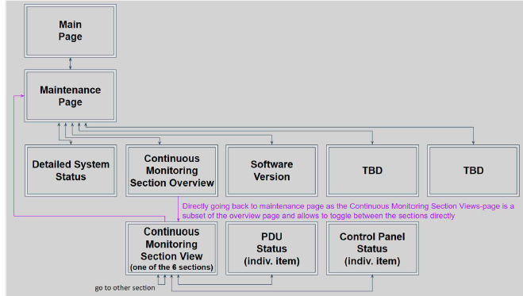

Figure 8 - CDP Page Levels

ID:CDP-CIRD-26430

The CDP **shall** have capability to transition from one page to another page in 1 Sec +/-10%.

**Applicability:** SW  
**Object Type:** Derived  
**Rational for Derived Req:**This is a derived requirement which specifies about the time taken for the CDP to transition from one page to another.  
**Verification Method:** Test  
**Safety Tag:** true  
**Safety Impact:** false  
**Safety Rationale:** This is Derived Requirement. Failure of this requirement is not safety critical and is as per the Design assurance Level D.

ID:CDP-CIRD-43399

The CDP **shall** display the Page name for Level 2 to Level 4 pages in the respective Page as a Heading.

**Applicability:** SW  
**Object Type:** Derived  
**Rational for Derived Req:**This is a derived requirement which specifies about the Page heading information  
**Verification Method:** Test  
**Safety Tag:** true  
**Safety Impact:** false  
**Safety Rationale:** This is Derived Requirement. Failure of this requirement is not safety critical and is as per the Design assurance Level D.

ID:CDP-CIRD-82777

The CDP **shall** provide means to navigate back from the lower level pages to the higher-level Pages and represented as pictorial icon as shown in the figure referenced below:

**Applicability:** SW  
**Object Type:** Verbatim  
**Verification Method:** Inspection  
**Safety Tag:** false  
**Safety Impact:** false  
**Safety Rationale:** NA

Embedded Image

Figure 9 - Back Navigation Icon

ID:CDP-CIRD-82782

The CDP pages **shall** be implemented to follow the below HMI rules:

* All Control Panels to be represented as pictorial icons
* Symbolic Aircraft outline and Cargo Door
* Display Legends on demand
* Control Panel status to be indicated using different colors on the respective Control panel icons as mentioned in CDP-CIRD-83645
* PDU to be represented as mentioned in CDP-CIRD-41504
* PDU status to be indicated using different color as mentioned in requirement CDP-CIRD-41508
* Visually associate Panel zones to panel icons as mentioned in requirement CDP-CIRD-29230, CDP-CIRD-85440
* Impact area / active access zone legend for LH and RH panels, also for OCP, MCP and ICP

**Applicability:** SW  
**Object Type:** Decomposed  
**Verification Method:** Design Review, Inspection  
**Safety Tag:** false  
**Safety Impact:** false  
**Safety Rationale:** NA

## CDP SW MAIN PAGE

This section describes the requirements associated with the System status that are to be displayed on the Main Page of the Cargo Display Panel (CDP)

ID:CDP-CIRD-26467

The CDP **shall** implement the Main Page layout by replicating the visual indication of Main Deck Cargo Bay with the PDUs, Control Panel positions, and Access Zones, as shown in below picture.

**Applicability:** SW  
**Object Type:** Decomposed  
**Verification Method:** Inspection, Test  
**Safety Tag:** false  
**Safety Impact:** false  
**Safety Rationale:** NA

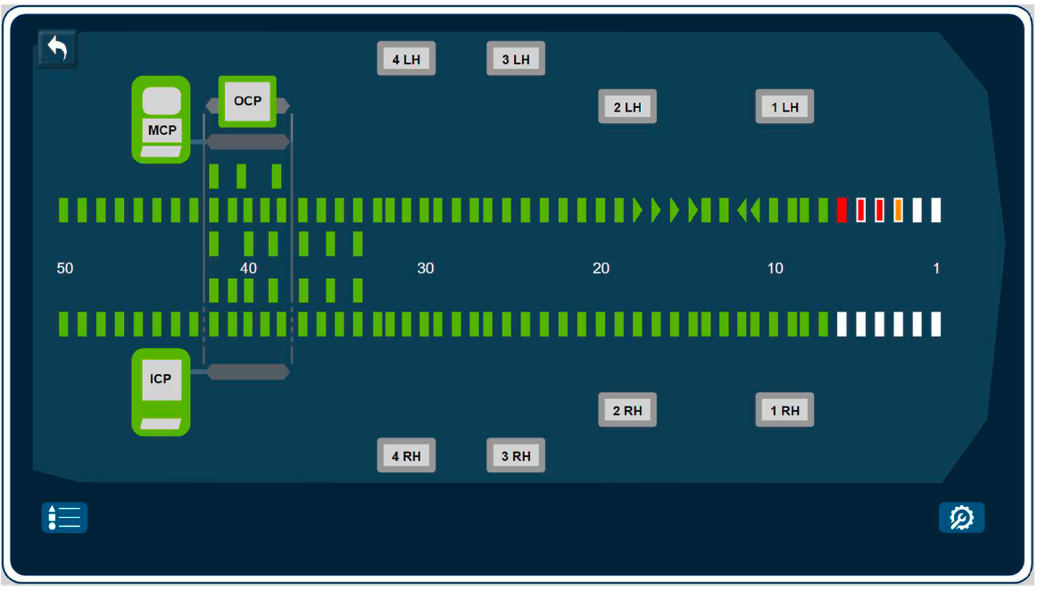

Figure 10 - CDP MAIN PAGE LAYOUT

ID:CDP-CIRD-26956

The CDP Main page **shall** have an option to navigate to "**Maintenance Page**" by means of pictorial icon as shown below:

**Applicability:** SW  
**Object Type:** Decomposed  
**Verification Method:** Test  
**Safety Tag:** false  
**Safety Impact:** false  
**Safety Rationale:** NA

Embedded Image

Figure 11 - CDP Main Page - Navigation to Maintenance Page Icon

ID:CDP-CIRD-83238

The CDP s**hall** implement the visual representation of the legends menu icon as shown in the below figure:

**Applicability:** SW  
**Object Type:** Derived  
**Rational for Derived Req:**This is a derived requirement which specifies about the legends menu representation in the Main page.  
**Verification Method:** Inspection  
**Safety Tag:** true  
**Safety Impact:** false  
**Safety Rationale:** This is Derived Requirement. Failure of this requirement is not safety critical and is as per the Design assurance Level D.

Embedded Image

Figure 12 - CDP Main Page - Legends Icon

ID:CDP-CIRD-83645

The CDP shall implement the visual representation of Control Panels in the Main page as shown in the below referenced figure:

Note: X in the LCPs in the below figure represents the LCP numbers 1- 4

**Applicability:** SW  
**Object Type:** Derived  
**Rational for Derived Req:**This is a derived requirement which specifies about the Control Panel representation in the Main page.  
**Verification Method:** Inspection  
**Safety Tag:** true  
**Safety Impact:** false  
**Safety Rationale:** This is Derived Requirement. Failure of this requirement is not safety critical and is as per the Design assurance Level D.

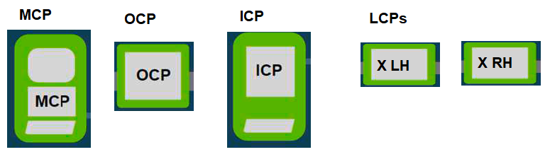

Figure 13 - CDP Main Page- Pictorial representation of Control Panels

ID:CDP-CIRD-28613

The CDP shall implement the visual indication of access zones in the main page as shown in the figures referenced below:

**Applicability:** SW  
**Object Type:** Decomposed  
**Verification Method:** Test  
**Safety Tag:** false  
**Safety Impact:** false  
**Safety Rationale:** NA

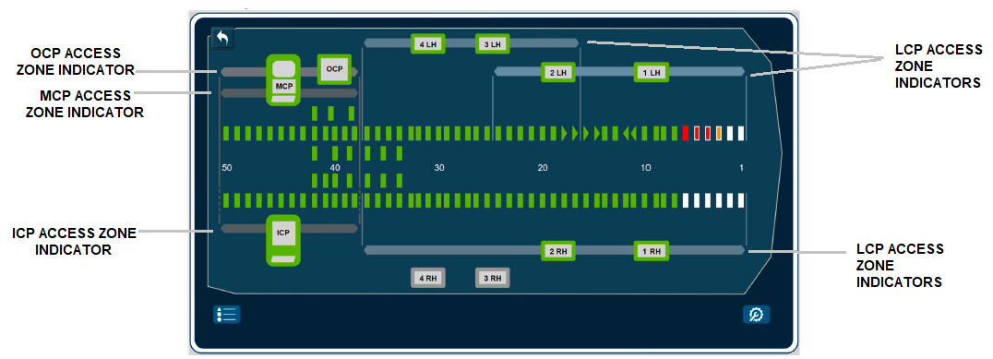

Figure 14 - Sample Main Page Layout with FWD zone enabled for MCP, ICP and OCPs and various LCPs access

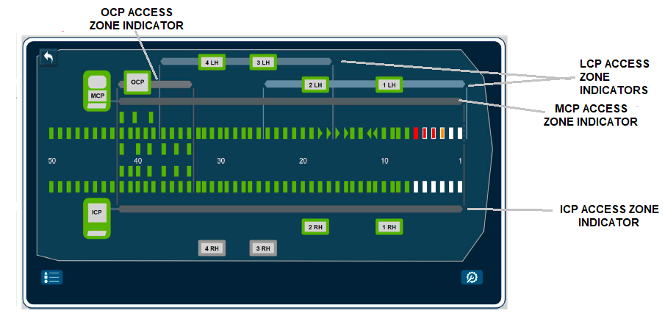

Figure 15 - Sample Main page layout with AFT Zone Enabled for MCP, ICP and OCP and Various LCPs Access

ID:CDP-CIRD-85440

The CDP shall represent the access zones into 3 different indicator parts as mentioned below:

1. Access Zone Indicator

2. Access Zone Border Lines to specify the limit of access for a particular Control Panel.

3. The Connector line from Control Panel to the Access Zone Indicator [This applies only when the Access Zone Indicator doesn't pass through the Control Panel Icons].

Refer to the sample picture below which includes all these definitions:

**Applicability:** SW  
**Object Type:** Derived  
**Rational for Derived Req:**This is a derived requirement which specifies the details of access zone indicator.  
**Verification Method:** Test  
**Safety Tag:** true  
**Safety Impact:** false  
**Safety Rationale:** This is Derived Requirement. Failure of this requirement is not safety critical and is as per the Design assurance Level D.

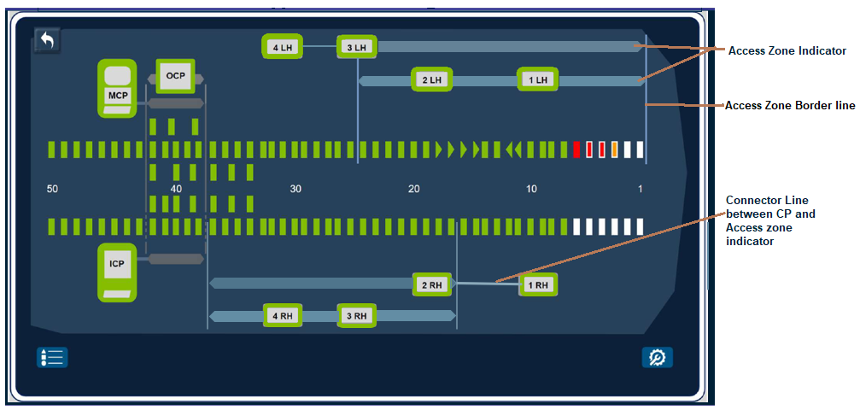

Figure 16 - Sample Figure with Zone 8 and Zone 10 Enabled and with all three access zone definitions

ID:CDP-CIRD-29219

The CDP **shall** show the access zone indicators for the MCP, ICP and OCP in shades of grey.

**Applicability:** SW  
**Object Type:** Derived  
**Rational for Derived Req:**This is a derived requirement which specifies about the representation of access zone indicator.  
**Verification Method:** Test  
**Safety Tag:** true  
**Safety Impact:** false  
**Safety Rationale:** This is Derived Requirement. Failure of this requirement is not safety critical and is as per the Design assurance Level D.

ID:CDP-CIRD-29229

The CDP **shall** show the access zone indicators for the LCPs in the shades of light blue.

**Applicability:** SW  
**Object Type:** Derived  
**Rational for Derived Req:**This is a derived requirement which specifies about the representation of access zone indicator.  
**Verification Method:** Test  
**Safety Tag:** true  
**Safety Impact:** false  
**Safety Rationale:** This is Derived Requirement. Failure of this requirement is not safety critical and is as per the Design assurance Level D.

ID:CDP-CIRD-29230

The CDP **shall** implement the visual representation of access zone indicators to pass through or connect with a line (as needed) to the respective Control Panel Icons in order to visually associate the Panel access to Panel icons.

**Applicability:** SW  
**Object Type:** Derived  
**Rational for Derived Req:**This is a derived requirement which specifies about the representation of access zone indicator.  
**Verification Method:** Test  
**Safety Tag:** true  
**Safety Impact:** false  
**Safety Rationale:** This is Derived Requirement. Failure of this requirement is not safety critical and is as per the Design assurance Level D.

ID:CDP-CIRD-28614

The CDP **shall** implement access zone indicators to grow or shrink dynamically based on access zones that are enabled out of 29 possible access zone scenarios.

**Applicability:** SW  
**Object Type:** Derived  
**Rational for Derived Req:**This is a derived requirement which explains on the design implementation of the access zone on the CDP display.  
**Verification Method:** Test  
**Safety Tag:** true  
**Safety Impact:** false  
**Safety Rationale:** This is Derived Requirement. Failure of this requirement is not safety critical and is as per the Design assurance Level D.

ID:CDP-CIRD-85273

The CDP shall identify the enabled access zone when Access_Zone_X_Enabled received on the CAN bus is set to True.

Note: X may be any of 1 to 29. Also more than one access zone can be enabled at a time. Hence multiple signals in the CARGO_ZONE_ENABLED message can be set to True.

Refer to CPIOM CIRD Rpt 11633 for the details related to the various access zones.

**Applicability:** SW  
**Object Type:** Derived  
**Rational for Derived Req:**This is a derived requirement which maps the access zone signal received on the CAN bus to the CDP display function which indicates the access zones enabled.  
**Verification Method:** Test  
**Safety Tag:** true  
**Safety Impact:** false  
**Safety Rationale:** This is Derived Requirement. Failure of this requirement is not safety critical and is as per the Design assurance Level D.

ID:CDP-CIRD-41502

The CDP shall provide the Panel Status symbols as shown in the figure referenced below:

**Applicability:** SW  
**Object Type:** Decomposed  
**Verification Method:** Test  
**Safety Tag:** false  
**Safety Impact:** false  
**Safety Rationale:** NA

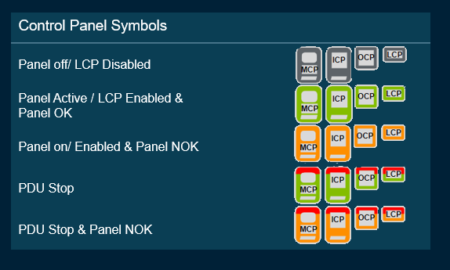

Figure 17 - Panel Status Symbol

ID:CDP-CIRD-41503

The CDP **shall** indicate the Control Panel status through the Control Panel Icons accordingly in correlation with the figure referenced below:

**Applicability:** SW  
**Object Type:** Decomposed  
**Verification Method:** Design Review, Inspection, Test  
**Safety Tag:** false  
**Safety Impact:** false  
**Safety Rationale:** NA

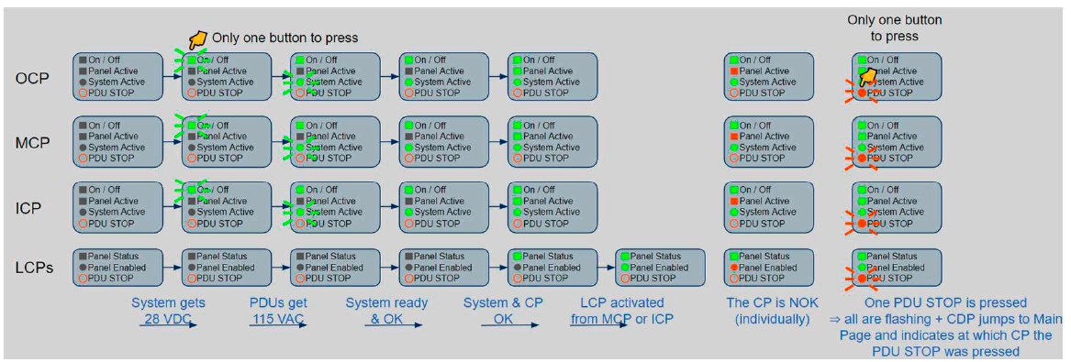

Figure 18 - Overall Panel Status indication

ID:CDP-CIRD-85407

The CDP **shall** implement the Panel Status indications based on the conditions identified in the table below for each of the control panels against each Panel state.

**Applicability:** SW  
**Object Type:** Derived  
**Rational for Derived Req:**This is a derived requirement which specifies about the representation of Panel Status indications on Main Page  
**Verification Method:** Test  
**Safety Tag:** true  
**Safety Impact:** false  
**Safety Rationale:** This is Derived Requirement. Failure of this requirement is not safety critical and is as per the Design assurance Level D.

|  |  |  |  |  |  |
| --- | --- | --- | --- | --- | --- |
| **Panel Status** | **MCP** | **ICP** | **OCP** | **LCP** | **Color** |
| **Panel OFF / Disabled** | MCP_PB_On_Off_LED = False | ICP_PB_On_Off_LED = False | OCP_PB_On_Off_LED = False | LCP1LH_LED_Panel_Enabled = False **And**  (LCP1LH_Panel_Status !=4 **OR**LCP1LH_Panel_Status !=5 )  ______________________________  LCP2LH_LED_Panel_Enabled = False A**nd**  (LCP2LH_Panel_Status !=4 **OR**LCP2LH_Panel_Status !=5)  ______________________________________  LCP3LH_LED_Panel_Enabled = False **And**  (LCP3LH_Panel_Status !=4 **OR**LCP3LH_Panel_Status !=5)  ______________________________________  LCP4LH_LED_Panel_Enabled = False **And**  (LCP4LH_Panel_Status !=4 **OR**LCP4LH_Panel_Status !=5)  _____________________________________  LCP1RH_LED_Panel_Enabled = False **And**  (LCP1RH_Panel_Status !=4 **OR**LCP1RH_Panel_Status !=5)  _____________________________________  LCP2RH_LED_Panel_Enabled = False **And**  (LCP2RH_Panel_Status !=4 **OR**LCP2RH_Panel_Status !=5)  _____________________________________  LCP3RH_LED_Panel_Enabled = False **And**  (LCP3RH_Panel_Status !=4 **OR**LCP3RH_Panel_Status !=5)  _____________________________________  LCP4RH_LED_Panel_Enabled = False **And**  (LCP4RH_Panel_Status !=4 **OR** LCP4RH_Panel_Status !=5) | **Grey** |
| **Panel Active / LCP Enabled**  **& Panels OK** | (MCP_PB_On_Off_LED =  True **And**  MCP_LED_System_Active = True ) **And**  (MCP_Panel_Status = 4 (OP State) **And**  MCP_Switch_Fault_Status = False ) | (ICP_PB_On_Off_LED =  True **And**  ICP_LED_System_Active = True ) **And**  (ICP_Panel_Status =  4 (OP State) **And**  ICP_Switch_Fault_Status = False) | (OCP_PB_On_Off_LED =  True **And**  OCP_LED_System_Active = True ) **And**  (OCP_Panel_Status =  4 (OP State) **And**  OCP_Switch_Fault_Status= False) | LCP1LH_LED_Panel_Enabled =  True **And**  (LCP1LH_Switch_Fault_Status = False  **And** LCP1LH_Panel_Status = 4 (OP State))  _______________________________________  LCP2LH_LED_Panel_Enabled =  True **And**  (LCP2LH_Switch_Fault_Status = False **And** LCP2LH_Panel_Status = 4 (OP State) )  ___________________________________  LCP3LH_LED_Panel_Enabled =  True **And**  (LCP3LH_Switch_Fault_Status = False **And** LCP3LH_Panel_Status = 4 (OP State) )  ____________________________________  LCP4LH_LED_Panel_Enabled =  True **And**  (LCP4LH_Switch_Fault_Status = False **And** LCP4LH_Panel_Status = 4 (OP State))  ____________________________________  LCP1RH_LED_Panel_Enabled =  True **And**  (LCP1RH_Switch_Fault_Status = False **And** LCP1RH_Panel_Status = 4 (OP State) )  ___________________________________   LCP2RH_LED_Panel_Enabled =  True **And**  (LCP2RH_Switch_Fault_Status = False **And** LCP2RH_Panel_Status = 4 (OP State))  ____________________________________  LCP3RH_LED_Panel_Enabled =  True **And**  (LCP3RH_Switch_Fault_Status = False **And** LCP3RH_Panel_Status = 4 (OP State))  __________________________________  LCP4RH_LED_Panel_Enabled =  True **And**  (LCP4RH_Switch_Fault_Status = False **And** LCP4RH_Panel_Status = 4 (OP State)) | **Green Hat +Green ICON** |
| **System Active / LCP Enabled**  **& Panels NOK** | (MCP_PB_On_Off_LED =  True **And**  MCP_LED_System_Active = True) **And**  (MCP_Panel_Status = 5 (FAIL State) **Or**  MCP_Switch_Fault_Status = True ) | (ICP_PB_On_Off_LED =  True **And**  ICP_LED_System_Active = True ) **And**  (ICP_Panel_Status =   5 (FAIL State) **Or**  ICP_Switch_Fault_Status = True) | (OCP_PB_On_Off_LED =  True **And**  OCP_LED_System_Active = True ) **And**  (OCP_Panel_Status =   5 (FAIL State) **Or**  OCP_Switch_Fault_Status= True ) | LCP1LH_LED_Panel_Enabled =  True **And**  (LCP1LH_Switch_Fault_Status = True **Or** LCP1LH_Panel_Status =  5 (FAIL State) )  _______________________________________  LCP2LH_LED_Panel_Enabled =  True **And**  (LCP2LH_Switch_Fault_Status =  True **Or** LCP2LH_Panel_Status = 5 (FAIL State) )  ___________________________________  LCP3LH_LED_Panel_Enabled =  True **And**  (LCP3LH_Switch_Fault_Status =  True **Or** LCP3LH_Panel_Status = 5 (FAIL State) )  ____________________________________  LCP4LH_LED_Panel_Enabled =  True **And**  (LCP4LH_Switch_Fault_Status =  True **Or** LCP4LH_Panel_Status = 5 (FAIL State) )  ____________________________________  LCP1RH_LED_Panel_Enabled =  True **And**  (LCP1RH_Switch_Fault_Status =  True **Or** LCP1RH_Panel_Status = 5 (FAIL State) )  ___________________________________   LCP2RH_LED_Panel_Enabled =  True **And**  (LCP2RH_Switch_Fault_Status =  True **Or** LCP2RH_Panel_Status = 5 (FAIL State) )  ____________________________________  LCP3RH_LED_Panel_Enabled =  True **And**  (LCP3RH_Switch_Fault_Status =  True **Or** LCP3RH_Panel_Status =5 (FAIL State) )  __________________________________  LCP4RH_LED_Panel_Enabled =  True **And**  (LCP4RH_Switch_Fault_Status = False **Or** LCP4RH_Panel_Status = 5 (FAIL State) ) | **Amber Hat +Amber ICON** |
| **PDU Stop** | (MCP_PB_On_Off_LED =  True **And**  MCP_LED_System_Active = True ) **And**  (MCP_Panel_Status = 4 (OP State) **And**  MCP_Switch_Fault_Status = False ) **And**  MCP_PB_PDU_Stop = True | (ICP_PB_On_Off_LED =  True **And**  ICP_LED_System_Active = True) **And**  (ICP_Panel_Status =  4 (OP State) **And**  ICP_Switch_Fault_Status = False ) **And**  ICP_PB_PDU_Stop = True | (OCP_PB_On_Off_LED =  True **And**  OCP_LED_System_Active = True) **And**  (OCP_Panel_Status =  4 (OP State) **And**  OCP_Switch_Fault_Status= False) **And**  OCP_PB_PDU_Stop = True | LCP1LH_LED_Panel_Enabled =  True **And**  (LCP1LH_Switch_Fault_Status = False  **And** LCP1LH_Panel_Status = 4 (OP State))  **And**LCP1LH_PB_PDU_Stop = True  _______________________________________  LCP2LH_LED_Panel_Enabled =  True **And**  (LCP2LH_Switch_Fault_Status = False **And** LCP2LH_Panel_Status = 4 (OP State))  **And**LCP2LH_PB_PDU_Stop = True  ___________________________________  (LCP3LH_LED_Panel_Enabled =  True **And**  LCP3LH_Switch_Fault_Status = False **And** LCP3LH_Panel_Status = 4 (OP State))  **And** LCP3LH_PB_PDU_Stop = True  ____________________________________  (LCP4LH_LED_Panel_Enabled =  True **And**  LCP4LH_Switch_Fault_Status = False) **And** (LCP4LH_Panel_Status = 4 (OP State) )  **And** LCP4LH_PB_PDU_Stop = True  ____________________________________  LCP1RH_LED_Panel_Enabled =  True **And**  LCP1RH_Switch_Fault_Status = False **And** LCP1RH_Panel_Status = 4 (OP State)  **And** LCP1RH_PB_PDU_Stop = True  ___________________________________   LCP2RH_LED_Panel_Enabled =  True **And**  (LCP2RH_Switch_Fault_Status = False **And** LCP2RH_Panel_Status = 4 (OP State))  **And** LCP2RH_PB_PDU_Stop = True  ____________________________________  LCP3RH_LED_Panel_Enabled =  True **And**  (LCP3RH_Switch_Fault_Status = False **And** LCP3RH_Panel_Status = 4 (OP State))  **And** LCP3RH_PB_PDU_Stop = True  __________________________________  LCP4RH_LED_Panel_Enabled =  True **And**  (LCP4RH_Switch_Fault_Status = False **And** LCP4RH_Panel_Status = 4 (OP State) )**And** LCP4RH_PB_PDU_Stop = True | **Red Hat + Green ICON** |
| **PDU Stop & Panel NOK** | (MCP_PB_On_Off_LED =  True **And**  MCP_LED_System_Active = True) **And**  (MCP_Panel_Status = 5 (FAIL State) **Or**  MCP_Switch_Fault_Status = True) **And**  MCP_PB_PDU_Stop = True | (ICP_PB_On_Off_LED =  True **And**  ICP_LED_System_Active = True) **And**  (ICP_Panel_Status =   5 (FAIL State) **or**  ICP_Switch_Fault_Status = True ) **And**  ICP_PB_PDU_Stop = True | (OCP_PB_On_Off_LED =  True **And**  OCP_LED_System_Active = True ) **And**  (OCP_Panel_Status =   5 (FAIL State) **or**  OCP_Switch_Fault_Status= True) **And**  OCP_PB_PDU_Stop = True | LCP1LH_LED_Panel_Enabled =  True **And**  (LCP1LH_Switch_Fault_Status = True **or** LCP1LH_Panel_Status =  5 (FAIL State) ) **And** LCP1LH_PB_PDU_Stop = True  _______________________________________  LCP2LH_LED_Panel_Enabled =  True **And**  (LCP2LH_Switch_Fault_Status =  True **Or** LCP2LH_Panel_Status = 5 (FAIL State) ) **And** LCP2LH_PB_PDU_Stop = True  ___________________________________  LCP3LH_LED_Panel_Enabled =  True **And**  (LCP3LH_Switch_Fault_Status =  True **Or** LCP3LH_Panel_Status = 5 (FAIL State) )  **And**LCP3LH_PB_PDU_Stop = True  ____________________________________  LCP4LH_LED_Panel_Enabled =  True **And**  (LCP4LH_Switch_Fault_Status =  True **Or** LCP4LH_Panel_Status = 5 (FAIL State) )  **And** LCP4LH_PB_PDU_Stop = True  ____________________________________  LCP1RH_LED_Panel_Enabled =  True **And**  (LCP1RH_Switch_Fault_Status =  True **Or** LCP1RH_Panel_Status = 5 (FAIL State) )  **And** LCP1RH_PB_PDU_Stop = True  ___________________________________   LCP2RH_LED_Panel_Enabled =  True**And**  (LCP2RH_Switch_Fault_Status =  True**Or** LCP2RH_Panel_Status = 5 (FAIL State) )  **And** LCP2RH_PB_PDU_Stop = True  ____________________________________  LCP3RH_LED_Panel_Enabled =  True **And**  (LCP3RH_Switch_Fault_Status =  True **Or** LCP3RH_Panel_Status =5 (FAIL State) )  **And** LCP3RH_PB_PDU_Stop = True  __________________________________  LCP4RH_LED_Panel_Enabled =  True **And**  (LCP4RH_Switch_Fault_Status = False**Or** LCP4RH_Panel_Status = 5 (FAIL State) )  **And** LCP4RH_PB_PDU_Stop = True | **Red Hat + Amber ICON** |

Table - Panels Status Indication Mapping

ID:CDP-CIRD-41504

The CDP **shall** represent PDUs as shown in the figure referenced below:

**Applicability:** SW  
**Object Type:** Decomposed  
**Verification Method:** Test  
**Safety Tag:** false  
**Safety Impact:** false  
**Safety Rationale:** NA

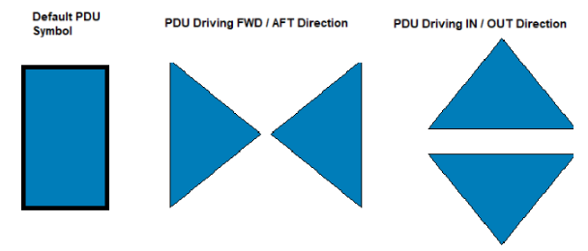

Figure 19 - PDU Representation Symbols

ID:CDP-CIRD-85410

The CDP **shall** update the PDU symbol and point to the respective direction while the PDU is driving as described in CDP-CIRD-41504

**Applicability:** SW  
**Object Type:** Derived  
**Rational for Derived Req:**This is a derived requirement which specifies about the representation of PDU symbol indications on Main Page  
**Verification Method:** Inspection  
**Safety Tag:** true  
**Safety Impact:** false  
**Safety Rationale:** This is Derived Requirement. Failure of this requirement is not safety critical and is as per the Design assurance Level D.

ID:CDP-CIRD-85446

The CDP **shall** implement the PDU State indications based on the "General Status".

Note: Refer to the requirement CDP-CIRD-42052 for the "General Status".

**Applicability:** SW  
**Object Type:** Derived  
**Rational for Derived Req:**This is a derived requirement which specifies about the representation of PDU state indications on Main Page  
**Verification Method:** Test  
**Safety Tag:** true  
**Safety Impact:** false  
**Safety Rationale:** This is Derived Requirement. Failure of this requirement is not safety critical and is as per the Design assurance Level D.

ID:CDP-CIRD-41508

The CDP **shall** implement the visual indication of each PDU state with different shape and color as mentioned in the below table:

**Applicability:** SW  
**Object Type:** Decomposed  
**Verification Method:** Test  
**Safety Tag:** false  
**Safety Impact:** false  
**Safety Rationale:** NA

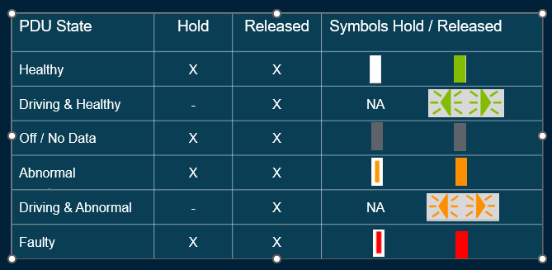

Figure 20 - CDP PDU Status Symbol

ID:CDP-CIRD-41510

The CDP **shall** display the Panel Status symbols and PDU status symbols in a pop up screen when the legends menu icon is selected as shown in the below:

**Applicability:** SW  
**Object Type:** Derived  
**Rational for Derived Req:**This is a derived requirement which specifies about the representation of the legends used in the Main page.  
**Verification Method:** Test  
**Safety Tag:** true  
**Safety Impact:** false  
**Safety Rationale:** This is Derived Requirement. Failure of this requirement is not safety critical and is as per the Design assurance Level D.

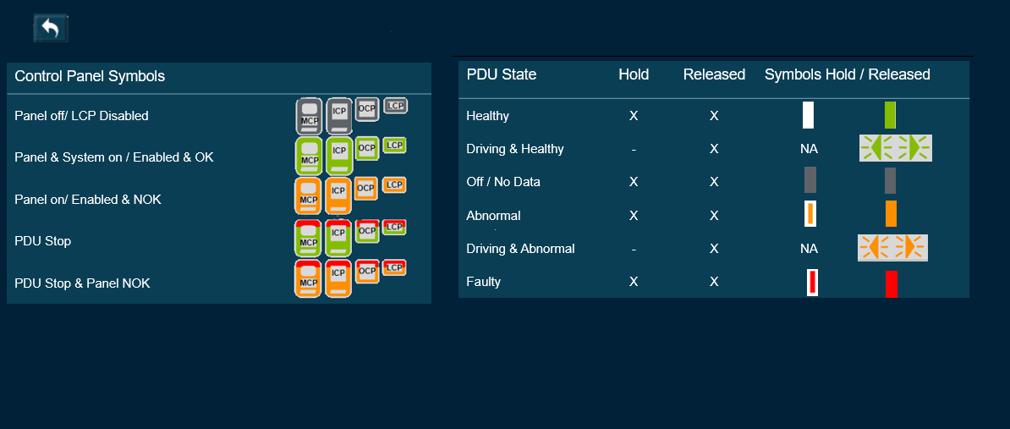

Figure 21 - COLOR-CODING INFORMATION FOR CONTROL PANEL AND PDU INDICATORS

ID:CDP-CIRD-83458

The CDP **shall** have option to navigate back to Main Page from the Legends Menu page.

**Applicability:** SW  
**Object Type:** Derived  
**Rational for Derived Req:**This is a derived requirement which specifies about the navigation to the Main Page  
**Verification Method:** Inspection, Test  
**Safety Tag:** true  
**Safety Impact:** false  
**Safety Rationale:** This is Derived Requirement. Failure of this requirement is not safety critical and is as per the Design assurance Level D.

## CDP SW MAINTANENCE PAGE

This section describes the requirements associated with the System status and the subpages that are to be displayed on the Maintenance Pages of the Cargo Display Panel (CDP).

ID:CDP-CIRD-42284

The CDP **shall** implement the Maintenance page with the buttons to navigate to the following subpages as shown in the below referenced figure:

* System Status
* Continuous Monitoring
* Software Version

**Applicability:** SW  
**Object Type:** Decomposed  
**Verification Method:** Test  
**Safety Tag:** false  
**Safety Impact:** false  
**Safety Rationale:** NA

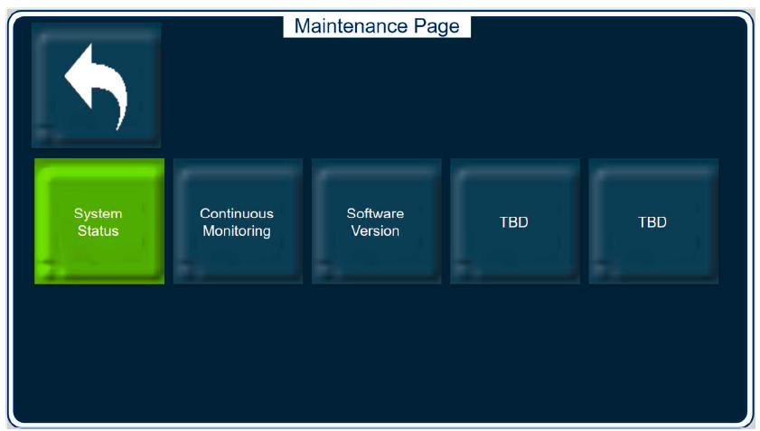

Figure 22 - CDP SW Maintenance Page

ID:CDP-CIRD-28618

The CDP SW application Maintenance page **shall** have an option to navigate back to CDP SW application Main page.

**Applicability:** SW  
**Object Type:** Decomposed  
**Verification Method:** Test  
**Safety Tag:** false  
**Safety Impact:** false  
**Safety Rationale:** NA

ID:CDP-CIRD-28619

The CDP SW application Maintenance page **shall** have an option to navigate to "Continuous Monitoring" page.

**Applicability:** SW  
**Object Type:** Decomposed  
**Verification Method:** Test  
**Safety Tag:** false  
**Safety Impact:** false  
**Safety Rationale:** NA

ID:CDP-CIRD-42136

The CDP SW application Maintenance page **shall** have an option to navigate to "DETAILED SYSTEM STATUS" page

**Applicability:** SW  
**Object Type:** Decomposed  
**Verification Method:** Test  
**Safety Tag:** false  
**Safety Impact:** false  
**Safety Rationale:** NA

ID:CDP-CIRD-42137

The CDP SW application Maintenance page **shall** have an option to navigate to “SW VERSION DETAILS" PAGE.

**Applicability:** SW  
**Object Type:** Decomposed  
**Verification Method:** Test  
**Safety Tag:** false  
**Safety Impact:** false  
**Safety Rationale:** NA

### DETAILED SYSTEM STATUS

This section describes the requirements associated with the System status information that are to be displayed in the Detailed System status Page.

ID:CDP-CIRD-42167

The CDP **shall** replicate visual indication of Main Deck Cargo Bay with respective PDUs and Control Panel positions, as shown in below picture.

**Applicability:** SW  
**Object Type:** Decomposed  
**Verification Method:** Test  
**Safety Tag:** false  
**Safety Impact:** false  
**Safety Rationale:** NA

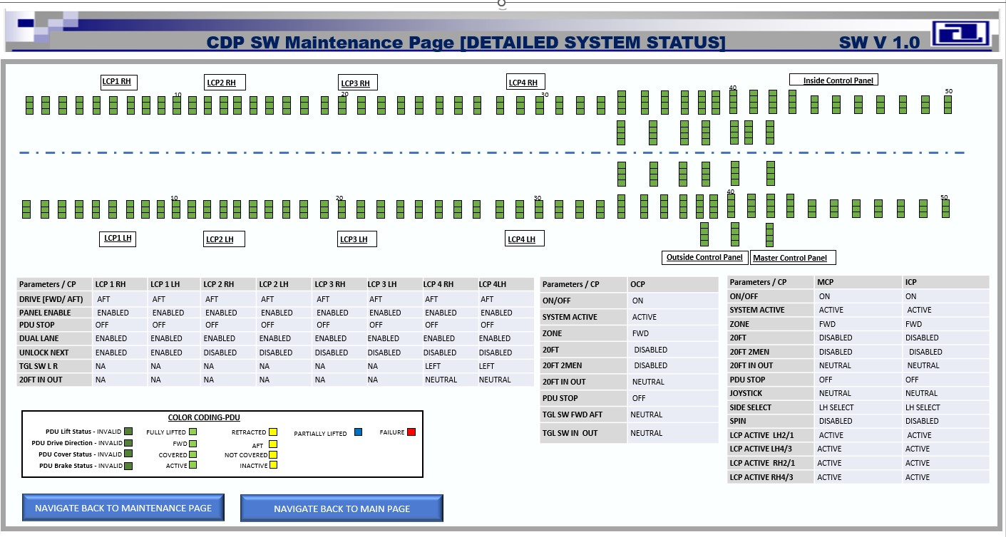

Figure 23 - CDP MAINTENANCE PAGE - DETAILED SYSTEM STATUS

ID:CDP-CIRD-42140

The CDP **shall** have an option to navigate back to "Maintenance Page" from DETAILED SYSTEM STATUS Page

**Applicability:** SW  
**Object Type:** Decomposed  
**Verification Method:** Test  
**Safety Tag:** false  
**Safety Impact:** false  
**Safety Rationale:** NA

ID:CDP-CIRD-42145

The CDP **shall** have an option to navigate back to "Main Page" from DETAILED SYSTEM STATUS Page

**Applicability:** SW  
**Object Type:** Decomposed  
**Verification Method:** Test  
**Safety Tag:** false  
**Safety Impact:** false  
**Safety Rationale:** NA

ID:CDP-CIRD-26957

For all spring-loaded PDUs, the CDP **shall** display the indications in the form of rectangular boxes for the following signals with each indicator placed one below the other:  
1. PDU Drive Direction  
2. PDU Cover Status  
3. PDU Brake State

**Applicability:** SW  
**Object Type:** Decomposed  
**Verification Method:** Test  
**Safety Tag:** false  
**Safety Impact:** false  
**Safety Rationale:** NA

ID:CDP-CIRD-26958

For all self-lifting PDUs, the CDP **shall** display the indications in the form of rectangular boxes for the following signals with each indicator placed one below the other:  
1. PDU Lift Status  
2. PDU Drive Direction  
3. PDU Cover Status  
4. PDU Brake State

**Applicability:** SW  
**Object Type:** Decomposed  
**Verification Method:** Test  
**Safety Tag:** false  
**Safety Impact:** false  
**Safety Rationale:** NA

ID:CDP-CIRD-26959

The CDP **shall** show visual indication with different color for each state of **PDU Drive Direction** signal as listed below:  
1. Invalid --> Dark Green  
2. FWD --> Light Green  
3. AFT --> Yellow

**Applicability:** SW  
**Object Type:** Decomposed  
**Verification Method:** Test  
**Safety Tag:** false  
**Safety Impact:** false  
**Safety Rationale:** NA

ID:CDP-CIRD-26960

The CDP **shall** show visual indication with different color for each state of **PDU Cover Status** signal as listed below:  
1. Invalid --> Dark Green  
2. Covered --> Light Green  
3. Not Covered --> Yellow

**Applicability:** SW  
**Object Type:** Decomposed  
**Verification Method:** Test  
**Safety Tag:** false  
**Safety Impact:** false  
**Safety Rationale:** NA

ID:CDP-CIRD-26961

The CDP **shall** show visual indication with different color for each state of **PDU BRAKE Status** signal as listed below:  
1. Invalid --> Dark Green  
2. ACTIVE --> Light Green  
3. INACTIVE --> Yellow

**Applicability:** SW  
**Object Type:** Decomposed  
**Verification Method:** Test  
**Safety Tag:** false  
**Safety Impact:** false  
**Safety Rationale:** NA

ID:CDP-CIRD-26962

The CDP **shall** show visual indication with different color for each state of **PDU Lift Status** signal as listed below:  
1. Invalid --> Dark Green  
2. Fully Lifted --> Light Green  
3. Retracted --> Yellow  
4. Partially Lifted --> Blue  
5. Failure --> Red

**Applicability:** SW  
**Object Type:** Decomposed  
**Verification Method:** Test  
**Safety Tag:** false  
**Safety Impact:** false  
**Safety Rationale:** NA

ID:CDP-CIRD-26963

For  Local Control Panels LCP 1 LH, LCP 1 RH, LCP 2 LH, LCP 2 RH, LCP 3 LH and LCP 3 RH, the CDP **shall** display the indicator names as shown below.

•    DRIVE[FWD/ AFT]  
•    PANEL ENABLE  
•    PDU STOP  
•    DUAL LANE  
•    UNLOCK NEXT

**Applicability:** SW  
**Object Type:** Decomposed  
**Verification Method:** Test  
**Safety Tag:** false  
**Safety Impact:** false  
**Safety Rationale:** NA

ID:CDP-CIRD-42210

For Local Control Panels LCP 4 LH and LCP 4 RH, the CDP **shall** display the indicator names as shown below.  
•    DRIVE [FWD/ AFT)  
•    PANEL ENABLE  
•    TGL SW L R  
•    20FT IN OUT  
•    PDU STOP  
•    DUAL LANE  
•    UNLOCK NEXT

**Applicability:** SW  
**Object Type:** Decomposed  
**Verification Method:** Test  
**Safety Tag:** false  
**Safety Impact:** false  
**Safety Rationale:** NA

ID:CDP-CIRD-26964

For Master Control Panel and Inside Control Panel, the CDP **shall** display the Indicator names as shown below.  
     
•    ON/OFF  
•    JOYSTICK  
•    ZONE  
•    PDU STOP  
•    SYSTEM ACTIVE  
•    SPIN  
•    SIDE SELECT  
•    20FT  
•    20FT 2MEN  
•    20FT IN OUT  
•    LCP ACTIVE LH2/1  
•    LCP ACTIVE LH 4/3  
•    LCP ACTIVE RH2/1  
•    LCP ACTIVE RH4/3

**Applicability:** SW  
**Object Type:** Decomposed  
**Verification Method:** Test  
**Safety Tag:** false  
**Safety Impact:** false  
**Safety Rationale:** NA

ID:CDP-CIRD-26965

For Outside Control Panel, the CDP **shall** display the indicator names as mentioned below:  
     
•    ON/OFF  
•    ZONE  
•    PDU STOP  
•    SYSTEM ACTIVE  
•    20FT  
•    20FT 2MEN  
•    20FT IN OUT  
•    TGL SW FWD AFT  
•    TGL SW IN OUT

**Applicability:** SW  
**Object Type:** Decomposed  
**Verification Method:** Test  
**Safety Tag:** false  
**Safety Impact:** false  
**Safety Rationale:** NA

ID:CDP-CIRD-28608

The CDP **shall** display the Control Panel indicators and its associated indications in Table Format as illustrated in below picture with 3 different tables as described below:   
•    One table for all the LCPs (LCP 1 RH, LCP 1 LH, LCP 2 RH, LCP 2 LH , LCP 3 RH, LCP 4 RH, LCP 4 LH)   
•    One table for OCP  
•     One table for MCP and ICP.  
 Refer to the sample picture of the Main Page with the tables present in the Req. ID 42141

**Applicability:** SW  
**Object Type:** Decomposed  
**Verification Method:** Test  
**Safety Tag:** false  
**Safety Impact:** false  
**Safety Rationale:** NA

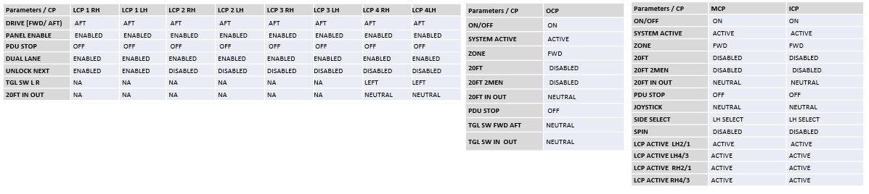

Figure 24 - CP TABLE REPRESENTATION

ID:CDP-CIRD-42212

The CDP **shall** display the color coding information of PDU status indicators as shown in the below picture

**Applicability:** SW  
**Object Type:** Derived  
**Rational for Derived Req:**This is a derived requirement which specifies about the representation of PDU status indications on Main Page  
**Verification Method:** Test  
**Safety Tag:** true  
**Safety Impact:** false  
**Safety Rationale:** This is Derived Requirement. Failure of this requirement is not safety critical and is as per the Design assurance Level D.

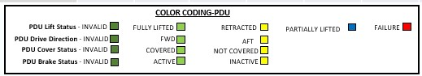

Figure 25 - PDU Color Coding information

### CDP SW Continuous Monitoring page

This section describes the requirements associated with the System status that are to be displayed on the Continuous Monitoring page of the Cargo Display Panel (CDP).

ID:CDP-CIRD-28621

The CDP **shall** have options to navigate back to "Main" Page from the Continuous Monitoring page.

**Applicability:** SW  
**Object Type:** Decomposed  
**Verification Method:** Test  
**Safety Tag:** false  
**Safety Impact:** false  
**Safety Rationale:** NA

ID:CDP-CIRD-28622

The CDP **shall** show PDUs and CPs Main Deck layout in background in one half of the page as depicted in the Main Page and have navigation buttons in foreground for each group of PDUs and CPs as sections in the Continuous Monitoring page as shown in the figure referenced below:

**Applicability:** SW  
**Object Type:** Decomposed  
**Verification Method:** Test  
**Safety Tag:** false  
**Safety Impact:** false  
**Safety Rationale:** NA

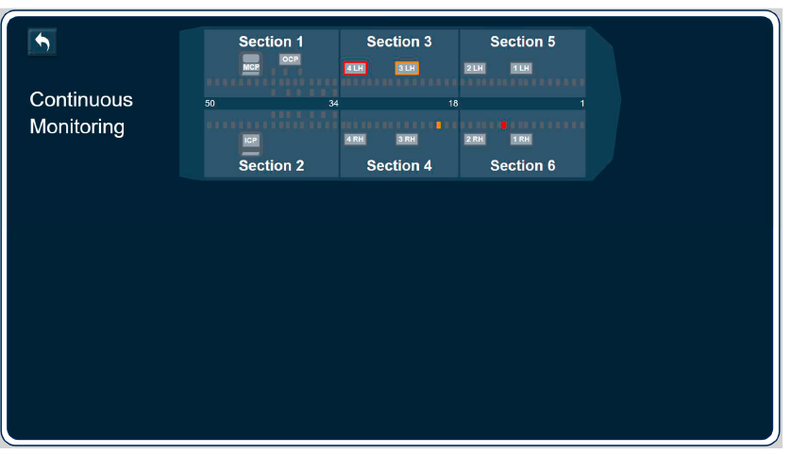

Figure 26 - Continuous Monitoring Page Access sections classification

ID:CDP-CIRD-28624

The CDP **shall** display the LRUs as buttons from the selected Section as well as reflect the current status as depicted in the Main Page in the bottom half of the page as shown in the figures referenced below:  
Note: See below pictures for reference.

**Applicability:** SW  
**Object Type:** Decomposed  
**Verification Method:** Test  
**Safety Tag:** false  
**Safety Impact:** false  
**Safety Rationale:** NA

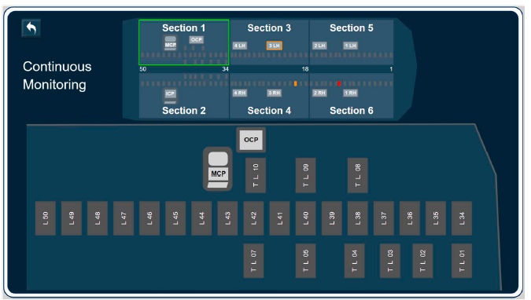

Figure 27 - CDP Continuous monitoring Page - Section -1 page

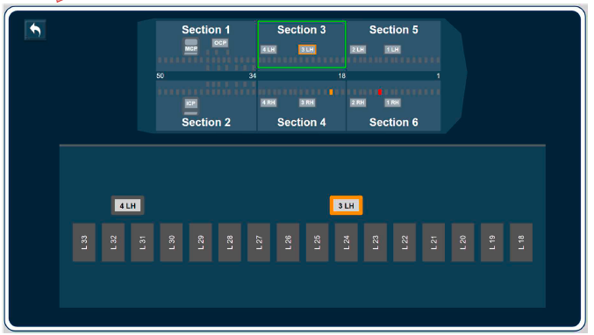

Figure 28 - CDP Continuous Monitoring Page - Section -3 Page

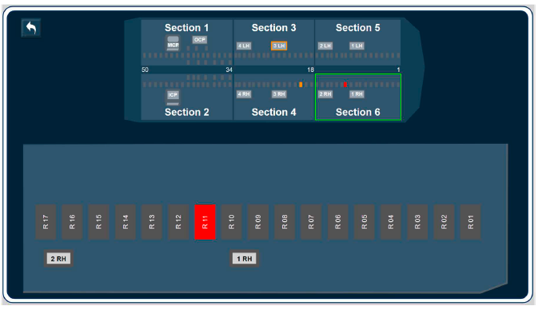

Figure 29 - CDP Continuous Monitoring Page - Section 6 Page

ID:CDP-CIRD-28630

The CDP **shall** navigate in to respective individual LRU status page when any of the PDUs are selected in the Continuous Monitoring Section View Page as shown in the figures referenced below:

**Applicability:** SW  
**Object Type:** Decomposed  
**Verification Method:** Test  
**Safety Tag:** false  
**Safety Impact:** false  
**Safety Rationale:** NA

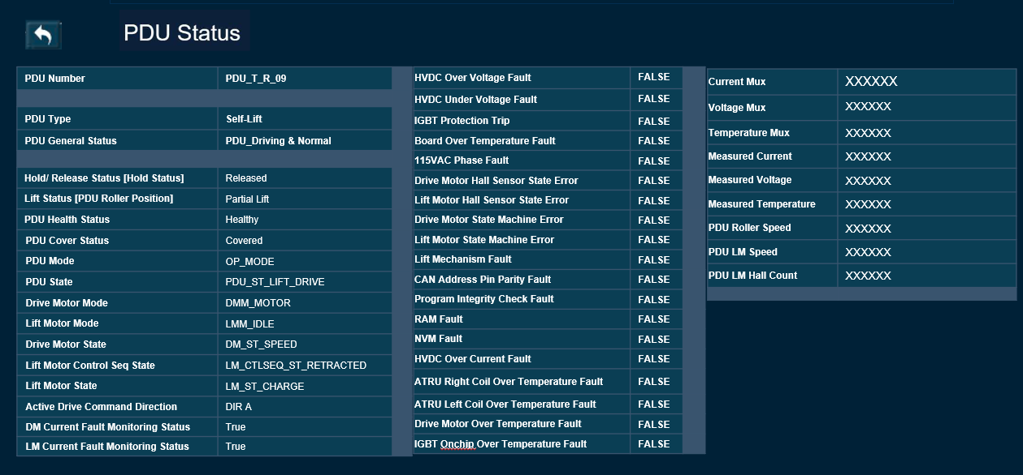

Figure 30 - CDP Continuous Monitoring - PDU Status Page

ID:CDP-CIRD-28632

The CDP **shall** have options to navigate back to Main Page from the CDP SW Continuous Monitoring PDU Status page.

**Applicability:** SW  
**Object Type:** Decomposed  
**Verification Method:** Test  
**Safety Tag:** false  
**Safety Impact:** false  
**Safety Rationale:** NA

ID:CDP-CIRD-28634

The CDP **shall** reflect the status of the PDU signals listed below as received on the CAN bus in the CDP SW Continuous Monitoring PDU Status page.

* PDU Number
* PDU Type
* PDU General Status
* Hold/ Release Status [Hold Status]
* Lift Status [PDU Roller Position]
* PDU Health Status
* PDU Cover Status
* PDU Mode
* PDU State
* Drive Motor Mode
* Lift Motor Mode
* Drive Motor State
* Lift Motor Control Seq State
* Lift Motor State
* Active Drive Command Direction
* DM Current Fault Monitoring Status
* LM Current Fault Monitoring Status
* HVDC Over Voltage Fault
* HVDC Under Voltage Fault
* IGBT Protection Trip
* Board Over Temperature Fault
* 115VAC Phase Fault
* Drive Motor Hall Sensor State Error
* Lift Motor Hall Sensor State Error
* Drive Motor State Machine Error
* Lift Motor State Machine Error
* Lift Mechanism Fault
* CAN Address Pin Parity Fault
* Program Integrity Check Fault
* RAM Fault
* NVM Fault
* HVDC Over Current Fault
* ATRU Right Coil Over Temperature Fault
* ATRU Left Coil Over Temperature Fault
* Drive Motor Over Temperature Fault
* IGBT Onchip Over Temperature Fault
* Current Mux
* Voltage Mux
* Temperature Mux
* Measured Current
* Measured Voltage
* Measured Temperature
* PDU Roller Speed
* PDU LM Speed
* PDU LM Hall Count

**Applicability:** SW  
**Object Type:** Decomposed  
**Verification Method:** Test  
**Safety Tag:** false  
**Safety Impact:** false  
**Safety Rationale:** NA

ID:CDP-CIRD-28635

The CDP **shall** be able to update the status of the PDU signals mentioned in CDP-CIRD-28634 every 250 ms +/-10% in the PDU Status page.

**Applicability:** SW  
**Object Type:** Decomposed  
**Verification Method:** Test  
**Safety Tag:** false  
**Safety Impact:** false  
**Safety Rationale:** NA

ID:CDP-CIRD-28636

The CDP **shall** navigate in to respective individual LRU status page when any of the CPs are selected in the Continuous Monitoring Section View Page as shown in the figures referenced below:

**Applicability:** SW  
**Object Type:** Decomposed  
**Verification Method:** Test  
**Safety Tag:** false  
**Safety Impact:** false  
**Safety Rationale:** NA

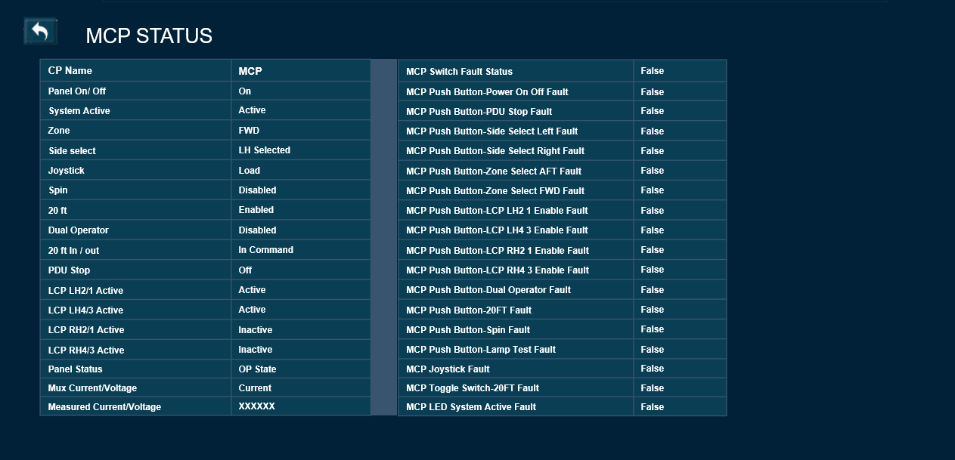

Figure 31 - CDP Continuous Monitoring Page - CP Status Page - MCP

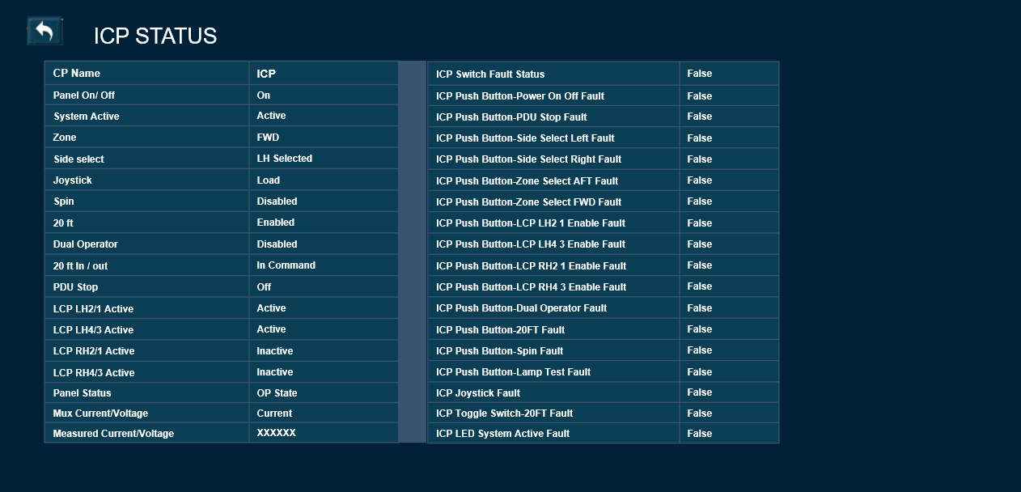

Figure 32 - CDP Continuous Monitoring Page - CP Status Page - ICP

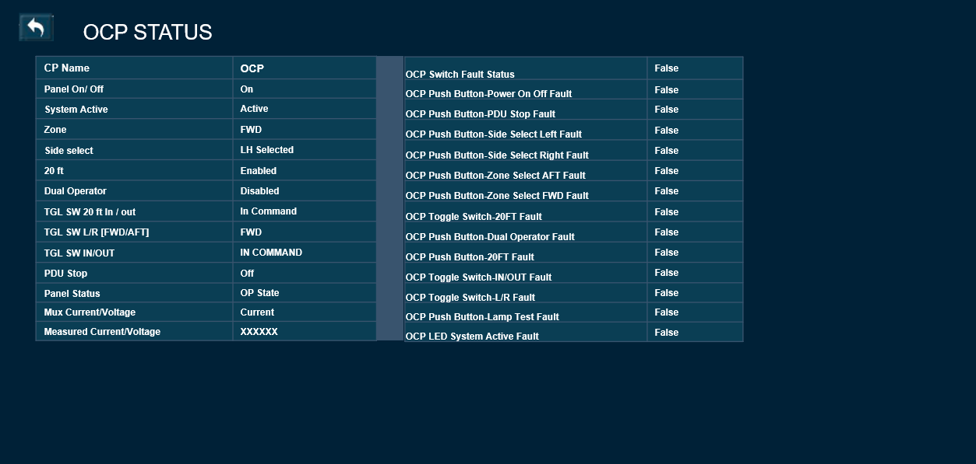

Figure 33 - CDP Continuous Monitoring Page - CP Status Page - OCP

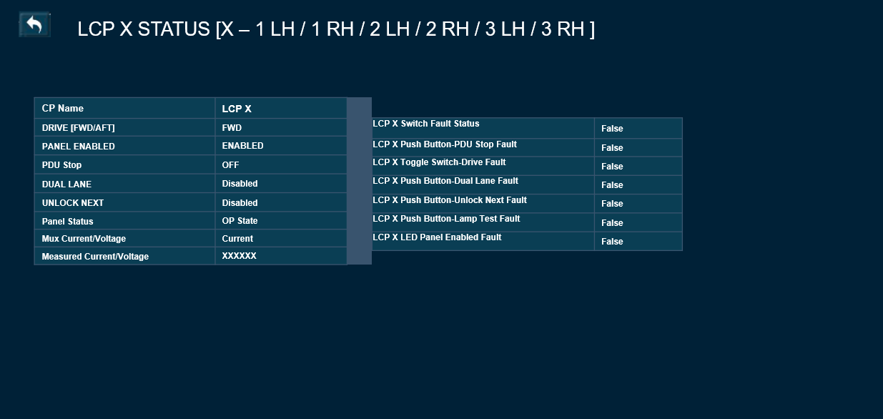

Figure 34 - CDP Continuous Monitoring Page - CP Status Page - LCP 1, LCP 2, LCP 3

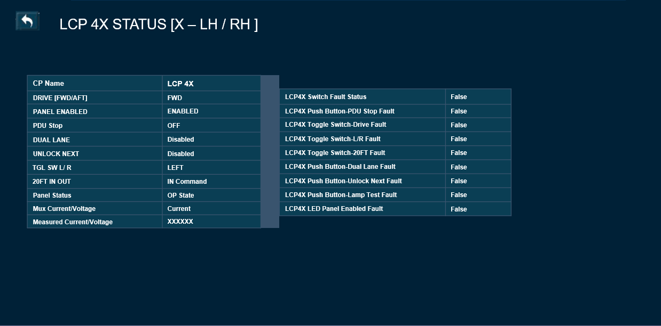

Figure 35 - CDP Continuous Monitoring Page - CP Status Page - LCP 4

ID:CDP-CIRD-28638

The CDP **shall** have options to navigate back to Main Page from the CP Status Page

**Applicability:** SW  
**Object Type:** Decomposed  
**Verification Method:** Test  
**Safety Tag:** false  
**Safety Impact:** false  
**Safety Rationale:** NA

ID:CDP-CIRD-28640

When the operator selects the MCP button on the selected Section, the CDP **shall** reflect the status of the CP signals listed below as received on the CAN bus in CDP Continuous Monitoring CP Status page.

* CP Name
* Panel On/ Off
* System Active
* Zone
* Side select
* Joystick
* Spin
* 20 ft
* Dual Operator
* 20 ft In / out
* PDU Stop
* LCP LH2/1 Active
* LCP LH4/3 Active
* LCP RH2/1 Active
* LCP RH4/3 Active
* Panel Status
* Mux Current/Voltage
* Measured Current/Voltage
* MCP Switch Fault Status
* MCP Push Button-Power On Off Fault
* MCP Push Button-PDU Stop Fault
* MCP Push Button-Side Select Left Fault
* MCP Push Button-Side Select Right Fault
* MCP Push Button-Zone Select AFT Fault
* MCP Push Button-Zone Select FWD Fault
* MCP Push Button-LCP LH2 1 Enable Fault
* MCP Push Button-LCP LH4 3 Enable Fault
* MCP Push Button-LCP RH2 1 Enable Fault
* MCP Push Button-LCP RH4 3 Enable Fault
* MCP Push Button-Dual Operator Fault
* MCP Push Button-20FT Fault
* MCP Push Button-Spin Fault
* MCP Push Button-Lamp Test Fault
* MCP Joystick Fault
* MCP Toggle Switch-20FT Fault
* MCP LED System Active Fault

**Applicability:** SW  
**Object Type:** Decomposed  
**Verification Method:** Test  
**Safety Tag:** false  
**Safety Impact:** false  
**Safety Rationale:** NA

ID:CDP-CIRD-84416

When the operator selects the ICP button on the selected Section, the CDP **shall** reflect the status of the CP signals listed below as received on the CAN bus in CDP Continuous Monitoring CP Status page.

* CP Name
* Panel On/ Off
* System Active
* Zone
* Side select
* Joystick
* Spin
* 20 ft
* Dual Operator
* 20 ft In / out
* PDU Stop
* LCP LH2/1 Active
* LCP LH4/3 Active
* LCP RH2/1 Active
* LCP RH4/3 Active
* Panel Status
* Mux Current/Voltage
* Measured Current/Voltage
* ICP Switch Fault Status
* ICP Push Button-Power On Off Fault
* ICP Push Button-PDU Stop Fault
* ICP Push Button-Side Select Left Fault
* ICP Push Button-Side Select Right Fault
* ICP Push Button-Zone Select AFT Fault
* ICP Push Button-Zone Select FWD Fault
* ICP Push Button-LCP LH2 1 Enable Fault
* ICP Push Button-LCP LH4 3 Enable Fault
* ICP Push Button-LCP RH2 1 Enable Fault
* ICP Push Button-LCP RH4 3 Enable Fault
* ICP Push Button-Dual Operator Fault
* ICP Push Button-20FT Fault
* ICP Push Button-Spin Fault
* ICP Push Button-Lamp Test Fault
* ICP Joystick Fault
* ICP Toggle Switch-20FT Fault
* ICP LED System Active Fault

**Applicability:** SW  
**Object Type:** Decomposed  
**Verification Method:** Test  
**Safety Tag:** false  
**Safety Impact:** false  
**Safety Rationale:** NA

ID:CDP-CIRD-43396

When the operator selects the OCP button on the Section -1, the CDP **shall** reflect the status of the CP signals listed below as received on the CAN bus in CDP Continuous Monitoring CP Status page.

* CP Name
* Panel On/ Off
* System Active
* Zone
* Side select
* 20 ft
* Dual Operator
* TGL SW 20 ft In / out
* TGL SW L/R [FWD/AFT]
* TGL SW IN/OUT
* PDU Stop
* Panel Status
* Mux Current/Voltage
* Measured Current/Voltage
* OCP Switch Fault Status
* OCP Push Button-Power On Off Fault
* OCP Push Button-PDU Stop Fault
* OCP Push Button-Side Select Left Fault
* OCP Push Button-Side Select Right Fault
* OCP Push Button-Zone Select AFT Fault
* OCP Push Button-Zone Select FWD Fault
* OCP Toggle Switch-20FT Fault
* OCP Push Button-Dual Operator Fault
* OCP Push Button-20FT Fault
* OCP Toggle Switch-IN/OUT Fault
* OCP Toggle Switch-L/R Fault
* OCP Push Button-Lamp Test Fault
* OCP LED System Active Fault

**Applicability:** SW  
**Object Type:** Decomposed  
**Verification Method:** Test  
**Safety Tag:** false  
**Safety Impact:** false  
**Safety Rationale:** NA

ID:CDP-CIRD-43397

When the operator selects any of the LCP 1 LH / LCP 2 LH / LCP 3 LH / LCP 1 RH / LCP 2 RH / LCP 3 RH buttons on the selected Section, the CDP **shall** reflect the status of the CP signals listed below as received on the CAN bus in CDP Continuous Monitoring CP Status page.

* CP Name
* DRIVE [FWD/AFT]
* PANEL ENABLED
* PDU Stop
* DUAL LANE
* UNLOCK NEXT
* Panel Status
* Mux Current/Voltage
* Measured Current/Voltage
* LCP X Switch Fault Status
* LCP X Push Button-PDU Stop Fault
* LCP X Toggle Switch-Drive Fault
* LCP X Push Button-Dual Lane Fault
* LCP X Push Button-Unlock Next Fault
* LCP X Push Button-Lamp Test Fault
* LCP X LED Panel Enabled Fault

Note: X may be one of 1 LH / 2 LH / 3 LH / 1 RH / 2 RH / 3 RH

**Applicability:** SW  
**Object Type:** Decomposed  
**Verification Method:** Test  
**Safety Tag:** false  
**Safety Impact:** false  
**Safety Rationale:** NA

ID:CDP-CIRD-43398

When the operator selects the LCP 4LH or LCP 4RH button on the selected Section, the CDP **shall** reflect the status of the CP signals listed below as received on the CAN bus in CDP Continuous Monitoring CP Status page

* CP Name
* DRIVE [FWD/AFT]
* PANEL ENABLED
* PDU Stop
* DUAL LANE
* UNLOCK NEXT
* TGL SW L/ R
* 20FT IN OUT
* Panel Status
* Mux Current/Voltage
* Measured Current/Voltage
* LCP4X Switch Fault Status
* LCP4X Push Button-PDU Stop Fault
* LCP4X Toggle Switch-Drive Fault
* LCP4X Toggle Switch-L/R Fault
* LCP4X Toggle Switch-20FT Fault
* LCP4X Push Button-Dual Lane Fault
* LCP4X Push Button-Unlock Next Fault
* LCP4X Push Button-Lamp Test Fault
* LCP4X LED Panel Enabled Fault

Note: X may be one of 4LH or 4RH

**Applicability:** SW  
**Object Type:** Decomposed  
**Verification Method:** Test  
**Safety Tag:** false  
**Safety Impact:** false  
**Safety Rationale:** NA

ID:CDP-CIRD-28641

The CDP **shall** be able to update the status of all the CP signals listed in the below requirements every 250 ms +/-10% in Continuous Monitoring CP Status page.

* CDP-CIRD-28640
* CDP-CIRD-84416
* CDP-CIRD-43396
* CDP-CIRD-43397
* CDP-CIRD-43398

**Applicability:** SW  
**Object Type:** Decomposed  
**Verification Method:** Test  
**Safety Tag:** false  
**Safety Impact:** false  
**Safety Rationale:** NA

## CAN SIGNAL MAPPING TO DISPLAY INDICATIONS

This section describes about the mapping of signals received on the CAN Bus interface to the indicators that would be displayed on the Cargo Display Panel Pages.

ID:CDP-CIRD-84417

The CDP **shall** set CP Name / PDU Number to the respective LRU name based on the translated Node identifier defined in CAN ICD Rpt 11594.

**Applicability:** SW  
**Object Type:** Derived  
**Rational for Derived Req:**This is a derived requirement which maps the CDP display data with the CAN signal received.  
**Verification Method:** Test  
**Safety Tag:** true  
**Safety Impact:** false  
**Safety Rationale:** This is Derived Requirement. Failure of this requirement is not safety critical and is as per the Design assurance Level D.

### CONTROL PANEL SIGNALS

#### LOCAL CONTROL PANEL SIGNALS

ID:CDP-CIRD-41670

For the Local Control Panel LCP 1LH, the CDP **shall** set the DRIVE [FWD/ AFT] indicator to the state as mentioned below:  
•    FWD when LCP1LH_TGLS_Drive_FWD is TRUE   
•    AFT when LCP1LH_TGLS_Drive_AFT is TRUE   
•    INVALID when more than one signal or none of the above signals are set to True

**Applicability:** SW  
**Object Type:** Derived  
**Rational for Derived Req:**This is a derived requirement which maps the CDP display data with the CAN signal received.  
**Verification Method:** Test  
**Safety Tag:** true  
**Safety Impact:** false  
**Safety Rationale:** This is Derived Requirement. Failure of this requirement is not safety critical and is as per the Design assurance Level D.

ID:CDP-CIRD-41672

For the Local Control Panel LCP 1LH, the CDP **shall** set the PANEL ENABLED indicator to the state as mentioned below:  
•    ENABLED when LCP1LH_LED_Panel_Enabled is TRUE   
•    DISABLED when LCP1LH_LED_Panel_Enabled is FALSE

**Applicability:** SW  
**Object Type:** Derived  
**Rational for Derived Req:**This is a derived requirement which maps the CDP display data with the CAN signal received.  
**Verification Method:** Test  
**Safety Tag:** true  
**Safety Impact:** false  
**Safety Rationale:** This is Derived Requirement. Failure of this requirement is not safety critical and is as per the Design assurance Level D.

ID:CDP-CIRD-41673

For the Local Control Panel LCP 1LH, the CDP **shall** set the PDU STOP indicator to the state as mentioned below:  
•    ON when LCP1LH_PB_PDU_Stop is TRUE   
•    OFF when LCP1LH_PB_PDU_Stop is FALSE

**Applicability:** SW  
**Object Type:** Derived  
**Rational for Derived Req:**This is a derived requirement which maps the CDP display data with the CAN signal received.  
**Verification Method:** Test  
**Safety Tag:** true  
**Safety Impact:** false  
**Safety Rationale:** This is Derived Requirement. Failure of this requirement is not safety critical and is as per the Design assurance Level D.

ID:CDP-CIRD-41674

For the Local Control Panel LCP 1LH, the CDP **shall** set the DUAL LANE indicator to the state as mentioned below:  
•    ENABLED when LCP1LH_PB_Dual_Lane_LED is TRUE   
•    DISABLED when LCP1LH_PB_Dual_Lane_LED is FALSE

**Applicability:** SW  
**Object Type:** Derived  
**Rational for Derived Req:**This is a derived requirement which maps the CDP display data with the CAN signal received.  
**Verification Method:** Test  
**Safety Tag:** true  
**Safety Impact:** false  
**Safety Rationale:** This is Derived Requirement. Failure of this requirement is not safety critical and is as per the Design assurance Level D.

ID:CDP-CIRD-41675

For the Local Control Panel LCP 1LH, the CDP **shall** set the UNLOCK NEXT indicator to the state as mentioned below:  
•    ENABLED when LCP1LH_PB_Unlock_Next_LED is TRUE   
•    DISABLED when LCP1LH_PB_Unlock_Next_LED is FALSE

**Applicability:** SW  
**Object Type:** Derived  
**Rational for Derived Req:**This is a derived requirement which maps the CDP display data with the CAN signal received.  
**Verification Method:** Test  
**Safety Tag:** true  
**Safety Impact:** false  
**Safety Rationale:** This is Derived Requirement. Failure of this requirement is not safety critical and is as per the Design assurance Level D.

ID:CDP-CIRD-41676

For the Local Control Panel LCP 1RH, the CDP **shall** set the DRIVE [FWD/ AFT] indicator to the state as mentioned below:  
•    FWD when LCP1RH_TGLS_Drive_FWD is TRUE   
•    AFT when LCP1RH_TGLS_Drive_AFT is TRUE   
•    INVALID when more than one signal or none of the above signals are set to True

**Applicability:** SW  
**Object Type:** Derived  
**Rational for Derived Req:**This is a derived requirement which maps the CDP display data with the CAN signal received.  
**Verification Method:** Test  
**Safety Tag:** true  
**Safety Impact:** false  
**Safety Rationale:** This is Derived Requirement. Failure of this requirement is not safety critical and is as per the Design assurance Level D.

ID:CDP-CIRD-41677

For the Local Control Panel LCP 1RH, the CDP **shall** set the PANEL ENABLED indicator to the state as mentioned below:  
•    ENABLED when LCP1RH_LED_Panel_Enabled is TRUE   
•    DISABLED when LCP1RH_LED_Panel_Enabled is FALSE

**Applicability:** SW  
**Object Type:** Derived  
**Rational for Derived Req:**This is a derived requirement which maps the CDP display data with the CAN signal received.  
**Verification Method:** Test  
**Safety Tag:** true  
**Safety Impact:** false  
**Safety Rationale:** This is Derived Requirement. Failure of this requirement is not safety critical and is as per the Design assurance Level D.

ID:CDP-CIRD-41678

For the Local Control Panel LCP 1RH, the CDP **shall** set the PDU STOP indicator to the state as mentioned below:  
•    ON when LCP1RH_PB_PDU_Stop is TRUE   
•    OFF when LCP1RH_PB_PDU_Stop is FALSE

**Applicability:** SW  
**Object Type:** Derived  
**Rational for Derived Req:**This is a derived requirement which maps the CDP display data with the CAN signal received.  
**Verification Method:** Test  
**Safety Tag:** true  
**Safety Impact:** false  
**Safety Rationale:** This is Derived Requirement. Failure of this requirement is not safety critical and is as per the Design assurance Level D.

ID:CDP-CIRD-41680

For the Local Control Panel LCP 1RH, the CDP **shall** set the DUAL LANE indicator to the state as mentioned below:  
•    ENABLED when LCP1RH_PB_Dual_Lane_LED is TRUE   
•    DISABLED when LCP1RH_PB_Dual_Lane_LED is FALSE

**Applicability:** SW  
**Object Type:** Derived  
**Rational for Derived Req:**This is a derived requirement which maps the CDP display data with the CAN signal received.  
**Verification Method:** Test  
**Safety Tag:** true  
**Safety Impact:** false  
**Safety Rationale:** This is Derived Requirement. Failure of this requirement is not safety critical and is as per the Design assurance Level D.

ID:CDP-CIRD-41906

For the Local Control Panel LCP 1RH, the CDP **shall** set the UNLOCK NEXT indicator to the state as mentioned below:  
•    ENABLED when LCP1RH_PB_Unlock_Next_LED is TRUE   
•    DISABLED when LCP1RH_PB_Unlock_Next_LED is FALSE

**Applicability:** SW  
**Object Type:** Derived  
**Rational for Derived Req:**This is a derived requirement which maps the CDP display data with the CAN signal received.  
**Verification Method:** Test  
**Safety Tag:** true  
**Safety Impact:** false  
**Safety Rationale:** This is Derived Requirement. Failure of this requirement is not safety critical and is as per the Design assurance Level D.

ID:CDP-CIRD-41907

For the Local Control Panel LCP 2LH, the CDP **shall** set the DRIVE [FWD/ AFT] indicator to the state as mentioned below:  
•    FWD when LCP2LH_TGLS_Drive_FWD is TRUE   
•    AFT when LCP2LH_TGLS_Drive_AFT is TRUE   
•    INVALID when more than one signal or none of the above signals are set to True

**Applicability:** SW  
**Object Type:** Derived  
**Rational for Derived Req:**This is a derived requirement which maps the CDP display data with the CAN signal received.  
**Verification Method:** Test  
**Safety Tag:** true  
**Safety Impact:** false  
**Safety Rationale:** This is Derived Requirement. Failure of this requirement is not safety critical and is as per the Design assurance Level D.

ID:CDP-CIRD-41908

For the Local Control Panel LCP 2LH, the CDP **shall** set the PANEL ENABLED indicator to the state as mentioned below:  
•    ENABLED when LCP2LH_LED_Panel_Enabled is TRUE   
•    DISABLED when LCP2LH_LED_Panel_Enabled is FALSE

**Applicability:** SW  
**Object Type:** Derived  
**Rational for Derived Req:**This is a derived requirement which maps the CDP display data with the CAN signal received.  
**Verification Method:** Test  
**Safety Tag:** true  
**Safety Impact:** false  
**Safety Rationale:** This is Derived Requirement. Failure of this requirement is not safety critical and is as per the Design assurance Level D.

ID:CDP-CIRD-41909

For the Local Control Panel LCP 2LH, the CDP **shall** set the PDU STOP indicator to the state as mentioned below:  
•    ON when LCP2LH_PB_PDU_Stop is TRUE   
•    OFF when LCP2LH_PB_PDU_Stop is FALSE

**Applicability:** SW  
**Object Type:** Derived  
**Rational for Derived Req:**This is a derived requirement which maps the CDP display data with the CAN signal received.  
**Verification Method:** Test  
**Safety Tag:** true  
**Safety Impact:** false  
**Safety Rationale:** This is Derived Requirement. Failure of this requirement is not safety critical and is as per the Design assurance Level D.

ID:CDP-CIRD-41910

For the Local Control Panel LCP 2LH, the CDP **shall** set the DUAL LANE indicator to the state as mentioned below:  
•    ENABLED when LCP2LH_PB_Dual_Lane_LED is TRUE   
•    DISABLED when LCP2LH_PB_Dual_Lane_LED is FALSE

**Applicability:** SW  
**Object Type:** Derived  
**Rational for Derived Req:**This is a derived requirement which maps the CDP display data with the CAN signal received.  
**Verification Method:** Test  
**Safety Tag:** true  
**Safety Impact:** false  
**Safety Rationale:** This is Derived Requirement. Failure of this requirement is not safety critical and is as per the Design assurance Level D.

ID:CDP-CIRD-41911

For the Local Control Panel LCP 2LH, the CDP **shall** set the UNLOCK NEXT indicator to the state as mentioned below:  
•    ENABLED when LCP2LH_PB_Unlock_Next_LED is TRUE  
•    DISABLED when LCP2LH_PB_Unlock_Next_LED is FALSE

**Applicability:** SW  
**Object Type:** Derived  
**Rational for Derived Req:**This is a derived requirement which maps the CDP display data with the CAN signal received.  
**Verification Method:** Test  
**Safety Tag:** true  
**Safety Impact:** false  
**Safety Rationale:** This is Derived Requirement. Failure of this requirement is not safety critical and is as per the Design assurance Level D.

ID:CDP-CIRD-41912

For the Local Control Panel LCP 2RH, the CDP **shall** set the DRIVE [FWD/ AFT] indicator to the state as mentioned below:  
•    FWD when LCP2RH_TGLS_Drive_FWD is TRUE   
•    AFT when LCP2RH_TGLS_Drive_AFT is TRUE   
•    INVALID when more than one signal or none of the above signals are set to True

**Applicability:** SW  
**Object Type:** Derived  
**Rational for Derived Req:**This is a derived requirement which maps the CDP display data with the CAN signal received.  
**Verification Method:** Test  
**Safety Tag:** true  
**Safety Impact:** false  
**Safety Rationale:** This is Derived Requirement. Failure of this requirement is not safety critical and is as per the Design assurance Level D.

ID:CDP-CIRD-41913

For the Local Control Panel LCP 2RH, the CDP **shall** set the PANEL ENABLED indicator to the state as mentioned below:  
•    ENABLED when LCP2RH_LED_Panel_Enabled is TRUE   
•    DISABLED when LCP2RH_LED_Panel_Enabled is FALSE

**Applicability:** SW  
**Object Type:** Derived  
**Rational for Derived Req:**This is a derived requirement which maps the CDP display data with the CAN signal received.  
**Verification Method:** Test  
**Safety Tag:** true  
**Safety Impact:** false  
**Safety Rationale:** This is Derived Requirement. Failure of this requirement is not safety critical and is as per the Design assurance Level D.

ID:CDP-CIRD-41921

For the Local Control Panel LCP 2RH, the CDP **shall** set the PDU STOP indicator to the state as mentioned below:  
•    ON when LCP2RH_PB_PDU_Stop is TRUE   
•    OFF when LCP2RH_PB_PDU_Stop is FALSE

**Applicability:** SW  
**Object Type:** Derived  
**Rational for Derived Req:**This is a derived requirement which maps the CDP display data with the CAN signal received.  
**Verification Method:** Test  
**Safety Tag:** true  
**Safety Impact:** false  
**Safety Rationale:** This is Derived Requirement. Failure of this requirement is not safety critical and is as per the Design assurance Level D.

ID:CDP-CIRD-41922

For the Local Control Panel LCP 2RH, the CDP **shall** set the DUAL LANE indicator to the state as mentioned below:  
•    ENABLED when LCP2RH_PB_Dual_Lane is TRUE   
•    DISABLED when LCP2RH_PB_Dual_Lane is FALSE

**Applicability:** SW  
**Object Type:** Derived  
**Rational for Derived Req:**This is a derived requirement which maps the CDP display data with the CAN signal received.  
**Verification Method:** Test  
**Safety Tag:** true  
**Safety Impact:** false  
**Safety Rationale:** This is Derived Requirement. Failure of this requirement is not safety critical and is as per the Design assurance Level D.

ID:CDP-CIRD-41978

For the Local Control Panel LCP 2RH, the CDP **shall** set the UNLOCK NEXT indicator to the state as mentioned below:  
•    ENABLED when LCP2RH_PB_Unlock_Next is TRUE   
•    DISABLED when LCP2RH_PB_Unlock_Next is FALSE

**Applicability:** SW  
**Object Type:** Derived  
**Rational for Derived Req:**This is a derived requirement which maps the CDP display data with the CAN signal received.  
**Verification Method:** Test  
**Safety Tag:** true  
**Safety Impact:** false  
**Safety Rationale:** This is Derived Requirement. Failure of this requirement is not safety critical and is as per the Design assurance Level D.

ID:CDP-CIRD-41979

For the Local Control Panel LCP 3LH, the CDP **shall** set the DRIVE [FWD/ AFT] indicator to the state as mentioned below:  
•    FWD when LCP3LH_TGLS_Drive_FWD is TRUE   
•    AFT when LCP3LH_TGLS_Drive_AFT is TRUE   
•    INVALID when more than one signal or none of the above signals are set to True

**Applicability:** SW  
**Object Type:** Derived  
**Rational for Derived Req:**This is a derived requirement which maps the CDP display data with the CAN signal received.  
**Verification Method:** Test  
**Safety Tag:** true  
**Safety Impact:** false  
**Safety Rationale:** This is Derived Requirement. Failure of this requirement is not safety critical and is as per the Design assurance Level D.

ID:CDP-CIRD-41980

For the Local Control Panel LCP 3LH, the CDP **shall** set the PANEL ENABLED indicator to the state as mentioned below:  
•    ENABLED when LCP3LH_LED_Panel_Enabled is TRUE   
•    DISABLED when LCP3LH_LED_Panel_Enabled is FALSE

**Applicability:** SW  
**Object Type:** Derived  
**Rational for Derived Req:**This is a derived requirement which maps the CDP display data with the CAN signal received.  
**Verification Method:** Test  
**Safety Tag:** true  
**Safety Impact:** false  
**Safety Rationale:** This is Derived Requirement. Failure of this requirement is not safety critical and is as per the Design assurance Level D.

ID:CDP-CIRD-41981

For the Local Control Panel LCP 3LH, the CDP **shall** set the PDU STOP indicator to the state as mentioned below:  
•    ON when LCP3LH_PB_PDU_Stop is TRUE   
•    OFF when LCP3LH_PB_PDU_Stop is FALSE

**Applicability:** SW  
**Object Type:** Derived  
**Rational for Derived Req:**This is a derived requirement which maps the CDP display data with the CAN signal received.  
**Verification Method:** Test  
**Safety Tag:** true  
**Safety Impact:** false  
**Safety Rationale:** This is Derived Requirement. Failure of this requirement is not safety critical and is as per the Design assurance Level D.

ID:CDP-CIRD-41982

For the Local Control Panel LCP 3LH, the CDP **shall** set the DUAL LANE indicator to the state as mentioned below:  
•    ENABLED when LCP3LH_PB_Dual_Lane_LED is TRUE   
•    DISABLED when LCP3LH_PB_Dual_Lane_LED is FALSE

**Applicability:** SW  
**Object Type:** Derived  
**Rational for Derived Req:**This is a derived requirement which maps the CDP display data with the CAN signal received.  
**Verification Method:** Test  
**Safety Tag:** true  
**Safety Impact:** false  
**Safety Rationale:** This is Derived Requirement. Failure of this requirement is not safety critical and is as per the Design assurance Level D.

ID:CDP-CIRD-41983

For the Local Control Panel LCP 3LH, the CDP **shall** set the UNLOCK NEXT indicator to the state as mentioned below:  
•    ENABLED when LCP3LH_PB_Unlock_Next_LED is TRUE   
•    DISABLED when LCP3LH_PB_Unlock_Next_LED is FALSE

**Applicability:** SW  
**Object Type:** Derived  
**Rational for Derived Req:**This is a derived requirement which maps the CDP display data with the CAN signal received.  
**Verification Method:** Test  
**Safety Tag:** true  
**Safety Impact:** false  
**Safety Rationale:** This is Derived Requirement. Failure of this requirement is not safety critical and is as per the Design assurance Level D.

ID:CDP-CIRD-41984

For the Local Control Panel LCP 3RH, the CDP **shall** set the DRIVE [FWD/ AFT] indicator to the state as mentioned below:  
•    FWD when LCP3RH_TGLS_Drive_FWD is TRUE   
•    AFT when LCP3RH_TGLS_Drive_AFT is TRUE   
•    INVALID when more than one signal or none of the above signals are set to True

**Applicability:** SW  
**Object Type:** Derived  
**Rational for Derived Req:**This is a derived requirement which maps the CDP display data with the CAN signal received.  
**Verification Method:** Test  
**Safety Tag:** true  
**Safety Impact:** false  
**Safety Rationale:** This is Derived Requirement. Failure of this requirement is not safety critical and is as per the Design assurance Level D.

ID:CDP-CIRD-41985

For the Local Control Panel LCP 3RH, the CDP **shall** set the PANEL ENABLED indicator to the state as mentioned below:  
•    ENABLED when LCP3RH_LED_Panel_Enabled is TRUE   
•    DISABLED when LCP3RH_LED_Panel_Enabled is FALSE

**Applicability:** SW  
**Object Type:** Derived  
**Rational for Derived Req:**This is a derived requirement which maps the CDP display data with the CAN signal received.  
**Verification Method:** Test  
**Safety Tag:** true  
**Safety Impact:** false  
**Safety Rationale:** This is Derived Requirement. Failure of this requirement is not safety critical and is as per the Design assurance Level D.

ID:CDP-CIRD-41986

For the Local Control Panel LCP 3RH, the CDP **shall** set the PDU STOP indicator to the state as mentioned below:  
•    ON when LCP3RH_PB_PDU_Stop is TRUE   
•    OFF when LCP3RH_PB_PDU_Stop is FALSE

**Applicability:** SW  
**Object Type:** Derived  
**Rational for Derived Req:**This is a derived requirement which maps the CDP display data with the CAN signal received.  
**Verification Method:** Test  
**Safety Tag:** true  
**Safety Impact:** false  
**Safety Rationale:** This is Derived Requirement. Failure of this requirement is not safety critical and is as per the Design assurance Level D.

ID:CDP-CIRD-41987

For the Local Control Panel LCP 3RH, the CDP **shall** set the DUAL LANE indicator to the state as mentioned below:  
•    ENABLED when LCP3RH_PB_Dual_Lane_LED is TRUE   
•    DISABLED when LCP3RH_PB_Dual_Lane_LED is FALSE

**Applicability:** SW  
**Object Type:** Derived  
**Rational for Derived Req:**This is a derived requirement which maps the CDP display data with the CAN signal received.  
**Verification Method:** Test  
**Safety Tag:** true  
**Safety Impact:** false  
**Safety Rationale:** This is Derived Requirement. Failure of this requirement is not safety critical and is as per the Design assurance Level D.

ID:CDP-CIRD-41988

For the Local Control Panel LCP 3RH, the CDP **shall** set the UNLOCK NEXT indicator to the state as mentioned below:  
•    ENABLED when LCP3RH_PB_Unlock_Next_LED is TRUE   
•    DISABLED when LCP3RH_PB_Unlock_Next_LED is FALSE

**Applicability:** SW  
**Object Type:** Derived  
**Rational for Derived Req:**This is a derived requirement which maps the CDP display data with the CAN signal received.  
**Verification Method:** Test  
**Safety Tag:** true  
**Safety Impact:** false  
**Safety Rationale:** This is Derived Requirement. Failure of this requirement is not safety critical and is as per the Design assurance Level D.

ID:CDP-CIRD-41989

For the Local Control Panel LCP 4LH, the CDP **shall** set the DRIVE [FWD/ AFT] indicator to the state as mentioned below:  
•    FWD when LCP4LH_TGLS_Drive_FWD is TRUE   
•    AFT when LCP4LH_TGLS_Drive_AFT is TRUE   
•    INVALID when more than one signal or none of the above signals are set to True

**Applicability:** SW  
**Object Type:** Derived  
**Rational for Derived Req:**This is a derived requirement which maps the CDP display data with the CAN signal received.  
**Verification Method:** Test  
**Safety Tag:** true  
**Safety Impact:** false  
**Safety Rationale:** This is Derived Requirement. Failure of this requirement is not safety critical and is as per the Design assurance Level D.

ID:CDP-CIRD-41991

For the Local Control Panel LCP 4LH, the CDP **shall** set the PANEL ENABLED indicator to the state as mentioned below:  
•    ENABLED when LCP4LH_LED_Panel_Enabled is TRUE   
•    DISABLED when LCP4LH_LED_Panel_Enabled is FALSE

**Applicability:** SW  
**Object Type:** Derived  
**Rational for Derived Req:**This is a derived requirement which maps the CDP display data with the CAN signal received.  
**Verification Method:** Test  
**Safety Tag:** true  
**Safety Impact:** false  
**Safety Rationale:** This is Derived Requirement. Failure of this requirement is not safety critical and is as per the Design assurance Level D.

ID:CDP-CIRD-41992

For the Local Control Panel LCP 4LH, the CDP **shall** set the TGL SW L/R indicator to the state as mentioned below:  
•    LEFT when LCP4LH_TGLS_L_R_LEFT is TRUE   
•    RIGHT when LCP4LH_TGLS_L_R_RIGHT is TRUE   
•    INVALID when more than one signal or none of the above signals are set to True

**Applicability:** SW  
**Object Type:** Derived  
**Rational for Derived Req:**This is a derived requirement which maps the CDP display data with the CAN signal received.  
**Verification Method:** Test  
**Safety Tag:** true  
**Safety Impact:** false  
**Safety Rationale:** This is Derived Requirement. Failure of this requirement is not safety critical and is as per the Design assurance Level D.

ID:CDP-CIRD-41993

For the Local Control Panel LCP 4LH, the CDP **shall** set the 20FT IN OUT indicator to the state as mentioned below:  
•    IN CMD when LCP4LH_TGLS_20FT_IN is TRUE   
•    OUT CMD when LCP4LH_TGLS_20FT_OUT is TRUE   
•    INVALID when more than one signal or none of the above signals are set to True

**Applicability:** SW  
**Object Type:** Derived  
**Rational for Derived Req:**This is a derived requirement which maps the CDP display data with the CAN signal received.  
**Verification Method:** Test  
**Safety Tag:** true  
**Safety Impact:** false  
**Safety Rationale:** This is Derived Requirement. Failure of this requirement is not safety critical and is as per the Design assurance Level D.

ID:CDP-CIRD-41994

For the Local Control Panel LCP 4LH, the CDP **shall** set the PDU STOP indicator to the state as mentioned below:  
•    ON when LCP4LH_PB_PDU_Stop is TRUE   
•    OFF when LCP4LH_PB_PDU_Stop is FALSE

**Applicability:** SW  
**Object Type:** Derived  
**Rational for Derived Req:**This is a derived requirement which maps the CDP display data with the CAN signal received.  
**Verification Method:** Test  
**Safety Tag:** true  
**Safety Impact:** false  
**Safety Rationale:** This is Derived Requirement. Failure of this requirement is not safety critical and is as per the Design assurance Level D.

ID:CDP-CIRD-41995

For the Local Control Panel LCP 4LH, the CDP **shall** set the DUAL LANE indicator to the state as mentioned below:  
•    ENABLED when LCP4LH_PB_Dual_Lane_LED is TRUE   
•    DISABLED when LCP4LH_PB_Dual_Lane_LED is FALSE

**Applicability:** SW  
**Object Type:** Derived  
**Rational for Derived Req:**This is a derived requirement which maps the CDP display data with the CAN signal received.  
**Verification Method:** Test  
**Safety Tag:** true  
**Safety Impact:** false  
**Safety Rationale:** This is Derived Requirement. Failure of this requirement is not safety critical and is as per the Design assurance Level D.

ID:CDP-CIRD-41996

For the Local Control Panel LCP 4LH, the CDP **shall** set the UNLOCK NEXT indicator to the state as mentioned below:  
•    ENABLED when LCP4LH_PB_Unlock_Next_LED is TRUE   
•    DISABLED when LCP4LH_PB_Unlock_Next_LED is FALSE

**Applicability:** SW  
**Object Type:** Derived  
**Rational for Derived Req:**This is a derived requirement which maps the CDP display data with the CAN signal received.  
**Verification Method:** Test  
**Safety Tag:** true  
**Safety Impact:** false  
**Safety Rationale:** This is Derived Requirement. Failure of this requirement is not safety critical and is as per the Design assurance Level D.

ID:CDP-CIRD-41997

For the Local Control Panel LCP 4RH, the CDP **shall** set the DRIVE [FWD/ AFT] indicator to the state as mentioned below:  
•    FWD when LCP4RH_TGLS_Drive_FWD is TRUE   
•    AFT when LCP4RH_TGLS_Drive_AFT is TRUE   
•    INVALID when more than one signal or none of the above signals are set to True

**Applicability:** SW  
**Object Type:** Derived  
**Rational for Derived Req:**This is a derived requirement which maps the CDP display data with the CAN signal received.  
**Verification Method:** Test  
**Safety Tag:** true  
**Safety Impact:** false  
**Safety Rationale:** This is Derived Requirement. Failure of this requirement is not safety critical and is as per the Design assurance Level D.

ID:CDP-CIRD-41998

For the Local Control Panel LCP 4RH, the CDP **shall** set the PANEL ENABLED indicator to the state as mentioned below:  
•    ENABLED when LCP4RH_LED_Panel_Enabled is TRUE   
•    DISABLED when LCP4RH_LED_Panel_Enabled is FALSE

**Applicability:** SW  
**Object Type:** Derived  
**Rational for Derived Req:**This is a derived requirement which maps the CDP display data with the CAN signal received.  
**Verification Method:** Test  
**Safety Tag:** true  
**Safety Impact:** false  
**Safety Rationale:** This is Derived Requirement. Failure of this requirement is not safety critical and is as per the Design assurance Level D.

ID:CDP-CIRD-41999

For the Local Control Panel LCP 4RH, the CDP **shall** set the TGL SW L/R indicator to the state as mentioned below:  
•    LEFT when LCP4RH_TGLS_L_R_LEFT is TRUE   
•    RIGHT when LCP4RH_TGLS_L_R_RIGHT is TRUE   
•    INVALID when more than one signal or none of the above signals are set to True

**Applicability:** SW  
**Object Type:** Derived  
**Rational for Derived Req:**This is a derived requirement which maps the CDP display data with the CAN signal received.  
**Verification Method:** Test  
**Safety Tag:** true  
**Safety Impact:** false  
**Safety Rationale:** This is Derived Requirement. Failure of this requirement is not safety critical and is as per the Design assurance Level D.

ID:CDP-CIRD-42000

For the Local Control Panel LCP 4RH, the CDP **shall** set the 20FT IN OUT indicator to the state as mentioned below:  
•    IN CMD when LCP4RH_TGLS_20FT_IN is TRUE   
•    OUT CMD when LCP4RH_TGLS_20FT_OUT is TRUE   
•    INVALID when more than one signal or none of the above signals are set to True

**Applicability:** SW  
**Object Type:** Derived  
**Rational for Derived Req:**This is a derived requirement which maps the CDP display data with the CAN signal received.  
**Verification Method:** Test  
**Safety Tag:** true  
**Safety Impact:** false  
**Safety Rationale:** This is Derived Requirement. Failure of this requirement is not safety critical and is as per the Design assurance Level D.

ID:CDP-CIRD-42001

For the Local Control Panel LCP 4RH, the CDP **shall** set the PDU STOP indicator to the state as mentioned below:  
•    ON when LCP4RH_PB_PDU_Stop is TRUE   
•    OFF when LCP4RH_PB_PDU_Stop is FALSE

**Applicability:** SW  
**Object Type:** Derived  
**Rational for Derived Req:**This is a derived requirement which maps the CDP display data with the CAN signal received.  
**Verification Method:** Test  
**Safety Tag:** true  
**Safety Impact:** false  
**Safety Rationale:** This is Derived Requirement. Failure of this requirement is not safety critical and is as per the Design assurance Level D.

ID:CDP-CIRD-42002

For the Local Control Panel LCP 4RH, the CDP **shall** set the DUAL LANE indicator to the state as mentioned below:  
•    ENABLED when LCP4RH_PB_Dual_Lane_LED is TRUE   
•    DISABLED when LCP4RH_PB_Dual_Lane_LED is FALSE

**Applicability:** SW  
**Object Type:** Derived  
**Rational for Derived Req:**This is a derived requirement which maps the CDP display data with the CAN signal received.  
**Verification Method:** Test  
**Safety Tag:** true  
**Safety Impact:** false  
**Safety Rationale:** This is Derived Requirement. Failure of this requirement is not safety critical and is as per the Design assurance Level D.

ID:CDP-CIRD-42003

For the Local Control Panel LCP 4RH, the CDP **shall** set the UNLOCK NEXT indicator to the state as mentioned below:  
•    ENABLED when LCP4RH_PB_Unlock_Next_LED is TRUE  
•    DISABLED when LCP4RH_PB_Unlock_Next_LED is FALSE

**Applicability:** SW  
**Object Type:** Derived  
**Rational for Derived Req:**This is a derived requirement which maps the CDP display data with the CAN signal received.  
**Verification Method:** Test  
**Safety Tag:** true  
**Safety Impact:** false  
**Safety Rationale:** This is Derived Requirement. Failure of this requirement is not safety critical and is as per the Design assurance Level D.

ID:CDP-CIRD-84372

For each of the Local Control Panels, the CDP **shall** set the Panel Status indicator to the enumerated value of the respective signal mentioned below as defined in the CAN ICD Rpt 11594

**Applicability:** SW  
**Object Type:** Derived  
**Rational for Derived Req:**This is a derived requirement which maps the CDP display data with the CAN signal received.  
**Verification Method:** Test  
**Safety Tag:** true  
**Safety Impact:** false  
**Safety Rationale:** This is Derived Requirement. Failure of this requirement is not safety critical and is as per the Design assurance Level D.

|  |  |
| --- | --- |
| **LCP** | **SIGNAL NAME** |
| LCP 1 LH | LCP1LH_Panel_Status |
| LCP 1 RH | LCP1RH_Panel_Status |
| LCP 2 LH | LCP2LH_Panel_Status |
| LCP 2 RH | LCP2RH_Panel_Status |
| LCP 3 LH | LCP3LH_Panel_Status |
| LCP 3 RH | LCP3RH_Panel_Status |
| LCP 4 LH | LCP4LH_Panel_Status |
| LCP 4 RH | LCP4RH_Panel_Status |

Table - Panel_Status signal on each LCP

ID:CDP-CIRD-84374

For each of the Local Control Panels, the CDP **shall** set the Mux Current/ Voltage to the enumerated value of respective signal mentioned below as defined in CAN ICD Rpt 11594.

**Applicability:** SW  
**Object Type:** Derived  
**Rational for Derived Req:**This is a derived requirement which maps the CDP display data with the CAN signal received.  
**Verification Method:** Test  
**Safety Tag:** true  
**Safety Impact:** false  
**Safety Rationale:** This is Derived Requirement. Failure of this requirement is not safety critical and is as per the Design assurance Level D.

|  |  |
| --- | --- |
| **LCP** | **SIGNAL NAME** |
| LCP 1 LH | LCP1LH_Mux_Current_Voltage |
| LCP 1 RH | LCP1RH_Mux_Current_Voltage |
| LCP 2 LH | LCP2LH_Mux_Current_Voltage |
| LCP 2 RH | LCP2RH_Mux_Current_Voltage |
| LCP 3 LH | LCP3LH_Mux_Current_Voltage |
| LCP 3 RH | LCP3RH_Mux_Current_Voltage |
| LCP 4 LH | LCP4LH_Mux_Current_Voltage |
| LCP 4 RH | LCP4RH_Mux_Current_Voltage |

Table - Mux_Current_Voltage signal for each LCP

ID:CDP-CIRD-84377

For each of the Local Control Panels, the CDP **shall** set the Measured Current/ Voltage to the value of respective signal mentioned below.

**Applicability:** SW  
**Object Type:** Derived  
**Rational for Derived Req:**This is a derived requirement which maps the CDP display data with the CAN signal received.  
**Verification Method:** Test  
**Safety Tag:** true  
**Safety Impact:** false  
**Safety Rationale:** This is Derived Requirement. Failure of this requirement is not safety critical and is as per the Design assurance Level D.

|  |  |
| --- | --- |
| **LCP** | **SIGNAL NAME** |
| LCP 1 LH | LCP1LH_Measured_Current_Voltage |
| LCP 1 RH | LCP1RH_Measured_Current_Voltage |
| LCP 2 LH | LCP2LH_Measured_Current_Voltage |
| LCP 2 RH | LCP2RH_Measured_Current_Voltage |
| LCP 3 LH | LCP3LH_Measured_Current_Voltage |
| LCP 3 RH | LCP3RH_Measured_Current_Voltage |
| LCP 4 LH | LCP4LH_Measured_Current_Voltage |
| LCP 4 RH | LCP4RH_Measured_Current_Voltage |

Table - Measured_Current_Voltage Signal on each LCP

ID:CDP-CIRD-84386

For each of the Local Control Panels, the CDP **shall** map the faults listed in the below table in column "Faults" to the respective Fault Signal listed in column "Fault Signal" and sets the Fault to True if the Fault Signal is received as 1 or to False otherwise.

**Applicability:** SW  
**Object Type:** Derived  
**Rational for Derived Req:**This is a derived requirement which maps the CDP display data with the CAN signal received.  
**Verification Method:** Test  
**Safety Tag:** true  
**Safety Impact:** false  
**Safety Rationale:** This is Derived Requirement. Failure of this requirement is not safety critical and is as per the Design assurance Level D.

|  |  |  |
| --- | --- | --- |
| **LCP** | **Faults** | **Fault Signal** |
| **LCP 1 LH** | LCP1LH Switch Fault Status | LCP1LH_Switch_Fault_Status |
| LCP1LH Push Button-PDU Stop Fault | LCP1LH_PB_PDU_Stop_Fault |
| LCP1LH Toggle Switch-Drive Fault | LCP1LH_TGLS_Drive_Fault |
| LCP1LH Push Button-Dual Lane Fault | LCP1LH_PB_Dual_Lane_Fault |
| LCP1LH Push Button-Unlock Next Fault | LCP1LH_PB_Unlock_Next_Fault |
| LCP1LH Push Button-Lamp Test Fault | LCP1LH_PB_Lamp_Test_Fault |
| LCP1LH LED Panel Enabled Fault | LCP1LH_LED_Panel_Enabled_Fault |
|  |  |  |
| **LCP1RH** | LCP1RH Switch Fault Status | LCP1RH_Switch_Fault_Status |
| LCP1RH Push Button-PDU Stop Fault | LCP1RH_PB_PDU_Stop_Fault |
| LCP1RH Toggle Switch-Drive Fault | LCP1RH_TGLS_Drive_Fault |
| LCP1RH Push Button-Dual Lane Fault | LCP1RH_PB_Dual_Lane_Fault |
| LCP1RH Push Button-Unlock Next Fault | LCP1RH_PB_Unlock_Next_Fault |
| LCP1RH Push Button-Lamp Test Fault | LCP1RH_PB_Lamp_Test_Fault |
| LCP1RH LED Panel Enabled Fault | LCP1RH_LED_Panel_Enabled_Fault |
|  |  |  |
| **LCP2LH** | LCP2LH Switch Fault Status | LCP2LH_Switch_Fault_Status |
| LCP2LH Push Button-PDU Stop Fault | LCP2LH_PB_PDU_Stop_Fault |
| LCP2LH Toggle Switch-Drive Fault | LCP2LH_TGLS_Drive_Fault |
| LCP2LH Push Button-Dual Lane Fault | LCP2LH_PB_Dual_Lane_Fault |
| LCP2LH Push Button-Unlock Next Fault | LCP2LH_PB_Unlock_Next_Fault |
| LCP2LH Push Button-Lamp Test Fault | LCP2LH_PB_Lamp_Test_Fault |
| LCP2LH LED Panel Enabled Fault | LCP2LH_LED_Panel_Enabled_Fault |
|  |  |  |
| **LCP2RH** | LCP2RH Switch Fault Status | LCP2RH_Switch_Fault_Status |
| LCP2RH Push Button-PDU Stop Fault | LCP2RH_PB_PDU_Stop_Fault |
| LCP2RH Toggle Switch-Drive Fault | LCP2RH_TGLS_Drive_Fault |
| LCP2RH Push Button-Dual Lane Fault | LCP2RH_PB_Dual_Lane_Fault |
| LCP2RH Push Button-Unlock Next Fault | LCP2RH_PB_Unlock_Next_Fault |
| LCP2RH Push Button-Lamp Test Fault | LCP2RH_PB_Lamp_Test_Fault |
| LCP2RH LED Panel Enabled Fault | LCP2RH_LED_Panel_Enabled_Fault |
|  |  |  |
| **LCP 3LH** | LCP3LH Switch Fault Status | LCP3LH_Switch_Fault_Status |
| LCP3LH Push Button-PDU Stop Fault | LCP3LH_PB_PDU_Stop_Fault |
| LCP3LH Toggle Switch-Drive Fault | LCP3LH_TGLS_Drive_Fault |
| LCP3LH Push Button-Dual Lane Fault | LCP3LH_PB_Dual_Lane_Fault |
| LCP3LH Push Button-Unlock Next Fault | LCP3LH_PB_Unlock_Next_Fault |
| LCP3LH Push Button-Lamp Test Fault | LCP3LH_PB_Lamp_Test_Fault |
| LCP3LH LED Panel Enabled Fault | LCP3LH_LED_Panel_Enabled_Fault |
|  |  |  |
| **LCP 3RH** | LCP3RH Switch Fault Status | LCP3RH_Switch_Fault_Status |
| LCP3RH Push Button-PDU Stop Fault | LCP3RH_PB_PDU_Stop_Fault |
| LCP3RH Toggle Switch-Drive Fault | LCP3RH_TGLS_Drive_Fault |
| LCP3RH Push Button-Dual Lane Fault | LCP3RH_PB_Dual_Lane_Fault |
| LCP3RH Push Button-Unlock Next Fault | LCP3RH_PB_Unlock_Next_Fault |
| LCP3RH Push Button-Lamp Test Fault | LCP3RH_PB_Lamp_Test_Fault |
| LCP3RH LED Panel Enabled Fault | LCP3RH_LED_Panel_Enabled_Fault |
|  |  |  |
| **LCP 4LH** | LCP4LH Switch Fault Status | LCP4LH_Switch_Fault_Status |
| LCP4LH Push Button-PDU Stop Fault | LCP4LH_PB_PDU_Stop_Fault |
| LCP4LH Toggle Switch-Drive Fault | LCP4LH_TGLS_Drive_Fault |
| LCP4LH Toggle Switch-L/R Fault | LCP4LH_TGLS_L_R_Fault |
| LCP4LH Toggle Switch-20FT Fault | LCP4LH_TGLS_20FT_Fault |
| LCP4LH Push Button-Dual Lane Fault | LCP4LH_PB_Dual_Lane_Fault |
| LCP4LH Push Button-Unlock Next Fault | LCP4LH_PB_Unlock_Next_Fault |
| LCP4LH Push Button-Lamp Test Fault | LCP4LH_PB_Lamp_Test_Fault |
| LCP4LH LED Panel Enabled Fault | LCP4LH_LED_Panel_Enabled_Fault |
|  |  |  |
| **LCP 4RH** | LCP4RH Switch Fault Status | LCP4RH_Switch_Fault_Status |
| LCP4RH Push Button-PDU Stop Fault | LCP4RH_PB_PDU_Stop_Fault |
| LCP4RH Toggle Switch-Drive Fault | LCP4RH_TGLS_Drive_Fault |
| LCP4RH Toggle Switch-L/R Fault | LCP4RH_TGLS_L_R_Fault |
| LCP4RH Toggle Switch-20FT Fault | LCP4RH_TGLS_20FT_Fault |
| LCP4RH Push Button-Dual Lane Fault | LCP4RH_PB_Dual_Lane_Fault |
| LCP4RH Push Button-Unlock Next Fault | LCP4RH_PB_Unlock_Next_Fault |
| LCP4RH Push Button-Lamp Test Fault | LCP4RH_PB_Lamp_Test_Fault |
| LCP4RH LED Panel Enabled Fault | LCP4RH_LED_Panel_Enabled_Fault |

Table - LCP Faults to signal mapping

#### MASTER CONTROL PANEL SIGNALS

ID:CDP-CIRD-42008

For the Master Control Panel, the CDP **shall** set the ON/OFF indicator to the state as mentioned below:  
•    ON when MCP_PB_On_Off_LED is TRUE   
•    OFF when MCP_PB_On_Off_LED is FALSE

**Applicability:** SW  
**Object Type:** Derived  
**Rational for Derived Req:**This is a derived requirement which maps the CDP display data with the CAN signal received.  
**Verification Method:** Test  
**Safety Tag:** true  
**Safety Impact:** false  
**Safety Rationale:** This is Derived Requirement. Failure of this requirement is not safety critical and is as per the Design assurance Level D.

ID:CDP-CIRD-42009

For the Master Control Panel, the CDP **shall** set the JOYSTICK indicator to the state as mentioned below:  
•    UNLOAD when MCP_Joystick_AFT is TRUE   
•    LOAD when MCP_Joystick_FWD is TRUE   
•    IN CMD when MCP_Joystick_IN is TRUE  
•    OUT CMD when MCP_Joystick_OUT is TRUE  
•    NEUTRAL when MCP_Joystick_NEUTRAL is TRUE  
•    INVALID when more than one signal or none of the above signals are set to True

**Applicability:** SW  
**Object Type:** Derived  
**Rational for Derived Req:**This is a derived requirement which maps the CDP display data with the CAN signal received.  
**Verification Method:** Test  
**Safety Tag:** true  
**Safety Impact:** false  
**Safety Rationale:** This is Derived Requirement. Failure of this requirement is not safety critical and is as per the Design assurance Level D.

ID:CDP-CIRD-42010

For the Master Control Panel, the CDP **shall** set the ZONE indicator to the state as mentioned below:  
•    AFT when MCP_PB_Zone_Select_AFT is TRUE   
•    FWD when MCP_PB_Zone_Select_FWD is TRUE   
•    BOTH when MCP_PB_Zone_Select_AFT AND MCP_PB_Zone_Select_FWD is TRUE  
•    INVALID when none of the above signals are set to True

**Applicability:** SW  
**Object Type:** Derived  
**Rational for Derived Req:**This is a derived requirement which maps the CDP display data with the CAN signal received.  
**Verification Method:** Test  
**Safety Tag:** true  
**Safety Impact:** false  
**Safety Rationale:** This is Derived Requirement. Failure of this requirement is not safety critical and is as per the Design assurance Level D.

ID:CDP-CIRD-42011

For the Master Control Panel, the CDP **shall** set the PDU STOP indicator to the state as mentioned below:  
•    ON when MCP_PB_PDU_Stop is TRUE   
•    OFF when MCP_PB_PDU_Stop is FALSE

**Applicability:** SW  
**Object Type:** Derived  
**Rational for Derived Req:**This is a derived requirement which maps the CDP display data with the CAN signal received.  
**Verification Method:** Test  
**Safety Tag:** true  
**Safety Impact:** false  
**Safety Rationale:** This is Derived Requirement. Failure of this requirement is not safety critical and is as per the Design assurance Level D.

ID:CDP-CIRD-42012

For the Master Control Panel, the CDP **shall** set the SYSTEM ACTIVE indicator to the state as mentioned below:  
•    ACTIVE when MCP_LED_System_Active is TRUE   
•    INACTIVE when MCP_LED_System_Active is FALSE

**Applicability:** SW  
**Object Type:** Derived  
**Rational for Derived Req:**This is a derived requirement which maps the CDP display data with the CAN signal received.  
**Verification Method:** Test  
**Safety Tag:** true  
**Safety Impact:** false  
**Safety Rationale:** This is Derived Requirement. Failure of this requirement is not safety critical and is as per the Design assurance Level D.

ID:CDP-CIRD-42013

For the Master Control Panel, the CDP **shall** set the SPIN indicator to the state as mentioned below:  
•    ENABLED when MCP_PB_Spin_LED is TRUE   
•    DISABLED when MCP_PB_Spin_LED is FALSE

**Applicability:** SW  
**Object Type:** Derived  
**Rational for Derived Req:**This is a derived requirement which maps the CDP display data with the CAN signal received.  
**Verification Method:** Test  
**Safety Tag:** true  
**Safety Impact:** false  
**Safety Rationale:** This is Derived Requirement. Failure of this requirement is not safety critical and is as per the Design assurance Level D.

ID:CDP-CIRD-42014

For the Master Control Panel, the CDP **shall** set the SIDE SELECT indicator to the state as mentioned below:  
•    LH SELECT when MCP_PB_Side_Select_Left_LED is TRUE   
•    RH SELECT when MCP_PB_Side_Select_Right_LED is TRUE  
•    BOTH when MCP_PB_Side_Select_Left_LED  AND MCP_PB_Side_Select_Right_LED are TRUE  
•    INVALID when none of the above signals are set to True

**Applicability:** SW  
**Object Type:** Derived  
**Rational for Derived Req:**This is a derived requirement which maps the CDP display data with the CAN signal received.  
**Verification Method:** Test  
**Safety Tag:** true  
**Safety Impact:** false  
**Safety Rationale:** This is Derived Requirement. Failure of this requirement is not safety critical and is as per the Design assurance Level D.

ID:CDP-CIRD-42017

For the Master Control Panel, the CDP **shall** set the 20FT indicator to the state as mentioned below:  
•    ENABLED when MCP_PB_20FT_LED is TRUE   
•    DISABLED when MCP_PB_20FT_LED is FALSE

**Applicability:** SW  
**Object Type:** Derived  
**Rational for Derived Req:**This is a derived requirement which maps the CDP display data with the CAN signal received.  
**Verification Method:** Test  
**Safety Tag:** true  
**Safety Impact:** false  
**Safety Rationale:** This is Derived Requirement. Failure of this requirement is not safety critical and is as per the Design assurance Level D.

ID:CDP-CIRD-42020

For the Master Control Panel, the CDP **shall** set the DUAL OPERATOR indicator to the state as mentioned below:  
•    ENABLED when MCP_PB_Dual_Operator_LED is TRUE   
•    DISABLED when MCP_PB_Dual_Operator_LED is FALSE

**Applicability:** SW  
**Object Type:** Derived  
**Rational for Derived Req:**This is a derived requirement which maps the CDP display data with the CAN signal received.  
**Verification Method:** Test  
**Safety Tag:** true  
**Safety Impact:** false  
**Safety Rationale:** This is Derived Requirement. Failure of this requirement is not safety critical and is as per the Design assurance Level D.

ID:CDP-CIRD-42021

For the Master Control Panel, the CDP **shall** set the 20FT IN OUT indicator to the state as mentioned below:  
•    OUT CMD when MCP_TGLS_20FT_OUT is TRUE   
•    IN CMD when MCP_TGLS_20FT_IN is TRUE   
•    INVALID when more than one signal or none of the above signals are set to True

**Applicability:** SW  
**Object Type:** Derived  
**Rational for Derived Req:**This is a derived requirement which maps the CDP display data with the CAN signal received.  
**Verification Method:** Test  
**Safety Tag:** true  
**Safety Impact:** false  
**Safety Rationale:** This is Derived Requirement. Failure of this requirement is not safety critical and is as per the Design assurance Level D.

ID:CDP-CIRD-42022

For the Master Control Panel, the CDP **shall** set the LCP ACTIVE LH2/1 indicator to the state as mentioned below:  
•    ACTIVE when MCP_PB_LCP_LH2_1_Enable_LED  is TRUE   
•    INACTIVE when MCP_PB_LCP_LH2_1_Enable_LED is FALSE

**Applicability:** SW  
**Object Type:** Derived  
**Rational for Derived Req:**This is a derived requirement which maps the CDP display data with the CAN signal received.  
**Verification Method:** Test  
**Safety Tag:** true  
**Safety Impact:** false  
**Safety Rationale:** This is Derived Requirement. Failure of this requirement is not safety critical and is as per the Design assurance Level D.

ID:CDP-CIRD-42023

For the Master Control Panel, the CDP **shall** set the LCP ACTIVE LH4/3 indicator to the state as mentioned below:  
•    ACTIVE when MCP_PB_LCP_LH4_3_Enable_LED is TRUE   
•    INACTIVE when MCP_PB_LCP_LH4_3_Enable_LED is FALSE

**Applicability:** SW  
**Object Type:** Derived  
**Rational for Derived Req:**This is a derived requirement which maps the CDP display data with the CAN signal received.  
**Verification Method:** Test  
**Safety Tag:** true  
**Safety Impact:** false  
**Safety Rationale:** This is Derived Requirement. Failure of this requirement is not safety critical and is as per the Design assurance Level D.

ID:CDP-CIRD-42024

For the Master Control Panel, the CDP **shall** set the LCP ACTIVE RH2/1 indicator to the state as mentioned below:  
•    ACTIVE when MCP_PB_LCP_RH2_1_Enable_LED is TRUE   
•    INACTIVE when MCP_PB_LCP_RH2_1_Enable_LED is FALSE

**Applicability:** SW  
**Object Type:** Derived  
**Rational for Derived Req:**This is a derived requirement which maps the CDP display data with the CAN signal received.  
**Verification Method:** Test  
**Safety Tag:** true  
**Safety Impact:** false  
**Safety Rationale:** This is Derived Requirement. Failure of this requirement is not safety critical and is as per the Design assurance Level D.

ID:CDP-CIRD-42025

For the Master Control Panel, the CDP **shall** set the LCP ACTIVE RH4/3 indicator to the state as mentioned below:  
•    ACTIVE when MCP_PB_LCP_RH4_3_Enable_LED is TRUE   
•    INACTIVE when MCP_PB_LCP_RH4_3_Enable_LED is FALSE

**Applicability:** SW  
**Object Type:** Derived  
**Rational for Derived Req:**This is a derived requirement which maps the CDP display data with the CAN signal received.  
**Verification Method:** Test  
**Safety Tag:** true  
**Safety Impact:** false  
**Safety Rationale:** This is Derived Requirement. Failure of this requirement is not safety critical and is as per the Design assurance Level D.

ID:CDP-CIRD-84319

For the Master Control Panel, the CDP **shall** set the Panel Status indicator to the enumerated value of MCP_Panel_Status as defined in the CAN ICD Rpt 11594

**Applicability:** SW  
**Object Type:** Derived  
**Rational for Derived Req:**This is a derived requirement which maps the CDP display data with the CAN signal received.  
**Verification Method:** Test  
**Safety Tag:** true  
**Safety Impact:** false  
**Safety Rationale:** This is Derived Requirement. Failure of this requirement is not safety critical and is as per the Design assurance Level D.

ID:CDP-CIRD-84320

For the Master Control Panel, the CDP **shall** set the Mux Current/ Voltage to the enumerated value of MCP_Mux_Current_Voltage as defined in CAN ICD Rpt 11594.

**Applicability:** SW  
**Object Type:** Derived  
**Rational for Derived Req:**This is a derived requirement which maps the CDP display data with the CAN signal received.  
**Verification Method:** Test  
**Safety Tag:** true  
**Safety Impact:** false  
**Safety Rationale:** This is Derived Requirement. Failure of this requirement is not safety critical and is as per the Design assurance Level D.

ID:CDP-CIRD-84321

For the Master Control Panel, the CDP **shall** set the Measured Current/ Voltage indicator to MCP_Measured_Current_Voltage.

**Applicability:** SW  
**Object Type:** Derived  
**Rational for Derived Req:**This is a derived requirement which maps the CDP display data with the CAN signal received.  
**Verification Method:** Test  
**Safety Tag:** true  
**Safety Impact:** false  
**Safety Rationale:** This is Derived Requirement. Failure of this requirement is not safety critical and is as per the Design assurance Level D.

ID:CDP-CIRD-84322

For the Master Control Panel, the CDP **shall** map the faults listed in the below table in column "Faults" to the Fault Signal listed in column "Fault Signal" and sets the Fault to True if the Fault Signal is received as 1 or to False otherwise.

**Applicability:** SW  
**Object Type:** Derived  
**Rational for Derived Req:**This is a derived requirement which maps the CDP display data with the CAN signal received.  
**Verification Method:** Test  
**Safety Tag:** true  
**Safety Impact:** false  
**Safety Rationale:** This is Derived Requirement. Failure of this requirement is not safety critical and is as per the Design assurance Level D.

|  |  |
| --- | --- |
| **Faults** | **Fault Signal** |
| MCP Switch Fault Status | MCP_Switch_Fault_Status |
| MCP Push Button-Power On Off Fault | MCP_PB_Power_On_Off_Fault |
| MCP Push Button-PDU Stop Fault | MCP_PB_PDU_Stop_Fault |
| MCP Push Button-Side Select Left Fault | MCP_PB_Side_Select_Left_Fault |
| MCP Push Button-Side Select Right Fault | MCP_PB_Side_Select_Right_Fault |
| MCP Push Button-Zone Select AFT Fault | MCP_PB_Zone_Select_AFT_Fault |
| MCP Push Button-Zone Select FWD Fault | MCP_PB_Zone_Select_FWD_Fault |
| MCP Push Button-LCP LH2 1 Enable Fault | MCP_PB_LCP_LH2_1_Enable_Fault |
| MCP Push Button-LCP LH4 3 Enable Fault | MCP_PB_LCP_LH4_3_Enable_Fault |
| MCP Push Button-LCP RH2 1 Enable Fault | MCP_PB_LCP_RH2_1_Enable_Fault |
| MCP Push Button-LCP RH4 3 Enable Fault | MCP_PB_LCP_RH4_3_Enable_Fault |
| MCP Push Button-Dual Operator Fault | MCP_PB_Dual_Operator_Fault |
| MCP Push Button-20FT Fault | MCP_PB_20FT_Fault |
| MCP Push Button-Spin Fault | MCP_PB_Spin_Fault |
| MCP Push Button-Lamp Test Fault | MCP_PB_Lamp_Test_Fault |
| MCP Joystick Fault | MCP_Joystick_Fault |
| MCP Toggle Switch-20FT Fault | MCP_TGLS_20FT_Fault |
| MCP LED System Active Fault | MCP_LED_System_Active_Fault |

Table - MCP faults to signal mapping

#### INSIDE CONTROL PANEL SIGNALS

ID:CDP-CIRD-42026

For the Inside Control Panel, the CDP **shall** set the ON/OFF indicator to the state as mentioned below:  
•    ON when ICP_PB_On_Off_LED is TRUE   
•    OFF when ICP_PB_On_Off_LED is FALSE

**Applicability:** SW  
**Object Type:** Derived  
**Rational for Derived Req:**This is a derived requirement which maps the CDP display data with the CAN signal received.  
**Verification Method:** Test  
**Safety Tag:** true  
**Safety Impact:** false  
**Safety Rationale:** This is Derived Requirement. Failure of this requirement is not safety critical and is as per the Design assurance Level D.

ID:CDP-CIRD-42027

For the Inside Control Panel, the CDP **shall** set the JOYSTICK indicator to the following state indicator to the state as mentioned below:  
•    UNLOAD when ICP_Joystick_AFT is TRUE   
•    LOAD when ICP_Joystick_FWD is TRUE   
•    IN CMD when ICP_Joystick_IN is TRUE  
•    OUT CMD when ICP_Joystick_OUT is TRUE  
•    NEUTRAL when ICP_Joystick_NEUTRAL is TRUE  
•    INVALID when more than one signal or none of the above signals are set to True

**Applicability:** SW  
**Object Type:** Derived  
**Rational for Derived Req:**This is a derived requirement which maps the CDP display data with the CAN signal received.  
**Verification Method:** Test  
**Safety Tag:** true  
**Safety Impact:** false  
**Safety Rationale:** This is Derived Requirement. Failure of this requirement is not safety critical and is as per the Design assurance Level D.

ID:CDP-CIRD-42029

For the Inside Control Panel, the CDP **shall** set the ZONE indicator to the state as mentioned below:  
•    AFT when ICP_PB_Zone_Select_AFT_LED is TRUE   
•    FWD when ICP_PB_Zone_Select_FWD_LED is TRUE   
•    BOTH when ICP_PB_Zone_Select_AFT_LED AND ICP_PB_Zone_Select_FWD_LED is TRUE  
•    INVALID when none of the above signals are set to True

**Applicability:** SW  
**Object Type:** Derived  
**Rational for Derived Req:**This is a derived requirement which maps the CDP display data with the CAN signal received.  
**Verification Method:** Test  
**Safety Tag:** true  
**Safety Impact:** false  
**Safety Rationale:** This is Derived Requirement. Failure of this requirement is not safety critical and is as per the Design assurance Level D.

ID:CDP-CIRD-42031

For the Inside Control Panel, the CDP **shall** set the PDU STOP indicator to the state as mentioned below:  
•    ON when ICP_PDU_Stop is TRUE   
•    OFF when ICP_PDU_Stop is FALSE

**Applicability:** SW  
**Object Type:** Derived  
**Rational for Derived Req:**This is a derived requirement which maps the CDP display data with the CAN signal received.  
**Verification Method:** Test  
**Safety Tag:** true  
**Safety Impact:** false  
**Safety Rationale:** This is Derived Requirement. Failure of this requirement is not safety critical and is as per the Design assurance Level D.

ID:CDP-CIRD-42032

For the Inside Control Panel, the CDP **shall** set the SYSTEM ACTIVE indicator to the state as mentioned below:  
•    ACTIVE when ICP_LED_System_Active is TRUE   
•    INACTIVE when ICP_LED_System_Active is FALSE

**Applicability:** SW  
**Object Type:** Derived  
**Rational for Derived Req:**This is a derived requirement which maps the CDP display data with the CAN signal received.  
**Verification Method:** Test  
**Safety Tag:** true  
**Safety Impact:** false  
**Safety Rationale:** This is Derived Requirement. Failure of this requirement is not safety critical and is as per the Design assurance Level D.

ID:CDP-CIRD-42033

For the Inside Control Panel, the CDP **shall** set the SPIN indicator to the state as mentioned below:  
•    ENABLED when ICP_PB_Spin_LED is TRUE   
•    DISABLED when ICP_PB_Spin_LED is FALSE

**Applicability:** SW  
**Object Type:** Derived  
**Rational for Derived Req:**This is a derived requirement which maps the CDP display data with the CAN signal received.  
**Verification Method:** Test  
**Safety Tag:** true  
**Safety Impact:** false  
**Safety Rationale:** This is Derived Requirement. Failure of this requirement is not safety critical and is as per the Design assurance Level D.

ID:CDP-CIRD-42034

For the Inside Control Panel, the CDP **shall** set the SIDE SELECT indicator to the state as mentioned below:  
•    LH SELECT when ICP_PB_Side_Select_Left_LED is TRUE   
•    RH SELECT when ICP_PB_Side_Select_Right_LED is TRUE  
•    BOTH when ICP_PB_Side_Select_Left_LED  AND ICP_PB_Side_Select_Right_LED are TRUE  
•    INVALID when none of the above signals are set to True

**Applicability:** SW  
**Object Type:** Derived  
**Rational for Derived Req:**This is a derived requirement which maps the CDP display data with the CAN signal received.  
**Verification Method:** Test  
**Safety Tag:** true  
**Safety Impact:** false  
**Safety Rationale:** This is Derived Requirement. Failure of this requirement is not safety critical and is as per the Design assurance Level D.

ID:CDP-CIRD-42035

For the Inside Control Panel, the CDP **shall** set the 20FT indicator to the state as mentioned below:  
•    ENABLED when ICP_PB_20FT_LED is TRUE   
•    DISABLED when ICP_PB_20FT_LED is FALSE

**Applicability:** SW  
**Object Type:** Derived  
**Rational for Derived Req:**This is a derived requirement which maps the CDP display data with the CAN signal received.  
**Verification Method:** Test  
**Safety Tag:** true  
**Safety Impact:** false  
**Safety Rationale:** This is Derived Requirement. Failure of this requirement is not safety critical and is as per the Design assurance Level D.

ID:CDP-CIRD-42036

For the Inside Control Panel, the CDP **shall** set the DUAL OPERATOR indicator to the state as mentioned below:  
•    ENABLED when ICP_PB_Dual_Operator_LED is TRUE   
•    DISABLED when ICP_PB_Dual_Operator_LED is FALSE

**Applicability:** SW  
**Object Type:** Derived  
**Rational for Derived Req:**This is a derived requirement which maps the CDP display data with the CAN signal received.  
**Verification Method:** Test  
**Safety Tag:** true  
**Safety Impact:** false  
**Safety Rationale:** This is Derived Requirement. Failure of this requirement is not safety critical and is as per the Design assurance Level D.

ID:CDP-CIRD-42037

For the Inside Control Panel, the CDP **shall** set the 20FT IN OUT indicator to the state as mentioned below:  
•    OUT CMD when ICP_TGLS_20FT_OUT is TRUE   
•    IN CMD when ICP_TGLS_20FT_IN is TRUE   
•    INVALID when more than one signal or none of the above signals are set to True

**Applicability:** SW  
**Object Type:** Derived  
**Rational for Derived Req:**This is a derived requirement which maps the CDP display data with the CAN signal received.  
**Verification Method:** Test  
**Safety Tag:** true  
**Safety Impact:** false  
**Safety Rationale:** This is Derived Requirement. Failure of this requirement is not safety critical and is as per the Design assurance Level D.

ID:CDP-CIRD-42038

For the Inside Control Panel, the CDP **shall** set the LCP ACTIVE LH2/1 indicator to the state as mentioned below:  
•    ACTIVE when ICP_PB_LCP_LH2_1_Enable_LED is TRUE   
•    INACTIVE when ICP_PB_LCP_LH2_1_Enable_LED is FALSE

**Applicability:** SW  
**Object Type:** Derived  
**Rational for Derived Req:**This is a derived requirement which maps the CDP display data with the CAN signal received.  
**Verification Method:** Test  
**Safety Tag:** true  
**Safety Impact:** false  
**Safety Rationale:** This is Derived Requirement. Failure of this requirement is not safety critical and is as per the Design assurance Level D.

ID:CDP-CIRD-42039

For the Inside Control Panel, the CDP **shall** set the LCP ACTIVE LH4/3 indicator to the state as mentioned below:  
•    ACTIVE when ICP_PB_LCP_LH4_3_Enable_LED is TRUE   
•    INACTIVE when ICP_PB_LCP_LH4_3_Enable_LED is FALSE

**Applicability:** SW  
**Object Type:** Derived  
**Rational for Derived Req:**This is a derived requirement which maps the CDP display data with the CAN signal received.  
**Verification Method:** Test  
**Safety Tag:** true  
**Safety Impact:** false  
**Safety Rationale:** This is Derived Requirement. Failure of this requirement is not safety critical and is as per the Design assurance Level D.

ID:CDP-CIRD-42040

For the Inside Control Panel, the CDP **shall** set the LCP ACTIVE RH2/1 indicator to the state as mentioned below:  
•    ACTIVE when ICP_PB_LCP_RH2_1_Enable_LED is TRUE   
•    INACTIVE when ICP_PB_LCP_RH2_1_Enable_LED is FALSE

**Applicability:** SW  
**Object Type:** Derived  
**Rational for Derived Req:**This is a derived requirement which maps the CDP display data with the CAN signal received.  
**Verification Method:** Test  
**Safety Tag:** true  
**Safety Impact:** false  
**Safety Rationale:** This is Derived Requirement. Failure of this requirement is not safety critical and is as per the Design assurance Level D.

ID:CDP-CIRD-42041

For the Inside Control Panel, the CDP **shall** set the LCP ACTIVE RH4/3 indicator to the state as mentioned below:  
•    ACTIVE when ICP_PB_LCP_RH4_3_Enable_LED is TRUE   
•    INACTIVE when ICP_PB_LCP_RH4_3_Enable_LED is FALSE

**Applicability:** SW  
**Object Type:** Derived  
**Rational for Derived Req:**This is a derived requirement which maps the CDP display data with the CAN signal received.  
**Verification Method:** Test  
**Safety Tag:** true  
**Safety Impact:** false  
**Safety Rationale:** This is Derived Requirement. Failure of this requirement is not safety critical and is as per the Design assurance Level D.

ID:CDP-CIRD-84323

For the Inside Control Panel, the CDP **shall** set the Panel Status indicator to the enumerated value of ICP_Panel_Status as defined in the CAN ICD Rpt 11594

**Applicability:** SW  
**Object Type:** Derived  
**Rational for Derived Req:**This is a derived requirement which maps the CDP display data with the CAN signal received.  
**Verification Method:** Test  
**Safety Tag:** true  
**Safety Impact:** false  
**Safety Rationale:** This is Derived Requirement. Failure of this requirement is not safety critical and is as per the Design assurance Level D.

ID:CDP-CIRD-84324

For the Inside Control Panel, the CDP **shall** set the Mux Current/ Voltage to the enumerated value of ICP_Mux_Current_Voltage as defined in CAN ICD Rpt 11594.

**Applicability:** SW  
**Object Type:** Derived  
**Rational for Derived Req:**This is a derived requirement which maps the CDP display data with the CAN signal received.  
**Verification Method:** Test  
**Safety Tag:** true  
**Safety Impact:** false  
**Safety Rationale:** This is Derived Requirement. Failure of this requirement is not safety critical and is as per the Design assurance Level D.

ID:CDP-CIRD-84325

For the Inside Control Panel, the CDP **shall** set the Measured Current/ Voltage indicator to ICP_Measured_Current_Voltage.

**Applicability:** SW  
**Object Type:** Derived  
**Rational for Derived Req:**This is a derived requirement which maps the CDP display data with the CAN signal received.  
**Verification Method:** Test  
**Safety Tag:** true  
**Safety Impact:** false  
**Safety Rationale:** This is Derived Requirement. Failure of this requirement is not safety critical and is as per the Design assurance Level D.

ID:CDP-CIRD-84326

For the Inside Control Panel,  the CDP **shall** map the faults listed in the below table in column "Faults" to the Fault Signal listed in column "Fault Signal" and sets the Fault to True if the Fault Signal is received as 1 or to False otherwise.

**Applicability:** SW  
**Object Type:** Derived  
**Rational for Derived Req:**This is a derived requirement which maps the CDP display data with the CAN signal received.  
**Verification Method:** Test  
**Safety Tag:** true  
**Safety Impact:** false  
**Safety Rationale:** This is Derived Requirement. Failure of this requirement is not safety critical and is as per the Design assurance Level D.

|  |  |
| --- | --- |
| **Faults** | **Fault Signal** |
| ICP Switch Fault Status | ICP_Switch_Fault_Status |
| ICP Push Button-Power On Off Fault | ICP_PB_Power_On_Off_Fault |
| ICP Push Button-PDU Stop Fault | ICP_PB_PDU_Stop_Fault |
| ICP Push Button-Side Select Left Fault | ICP_PB_Side_Select_Left_Fault |
| ICP Push Button-Side Select Right Fault | ICP_PB_Side_Select_Right_Fault |
| ICP Push Button-Zone Select AFT Fault | ICP_PB_Zone_Select_AFT_Fault |
| ICP Push Button-Zone Select FWD Fault | ICP_PB_Zone_Select_FWD_Fault |
| ICP Push Button-LCP LH2 1 Enable Fault | ICP_PB_LCP_LH2_1_Enable_Fault |
| ICP Push Button-LCP LH4 3 Enable Fault | ICP_PB_LCP_LH4_3_Enable_Fault |
| ICP Push Button-LCP RH2 1 Enable Fault | ICP_PB_LCP_RH2_1_Enable_Fault |
| ICP Push Button-LCP RH4 3 Enable Fault | ICP_PB_LCP_RH4_3_Enable_Fault |
| ICP Push Button-Dual Operator Fault | ICP_PB_Dual_Operator_Fault |
| ICP Push Button-20FT Fault | ICP_PB_20FT_Fault |
| ICP Push Button-Spin Fault | ICP_PB_Spin_Fault |
| ICP Push Button-Lamp Test Fault | ICP_PB_Lamp_Test_Fault |
| ICP Joystick Fault | ICP_Joystick_Fault |
| ICP Toggle Switch-20FT Fault | ICP_TGLS_20FT_Fault |
| ICP LED System Active Fault | ICP_LED_System_Active_Fault |

Table - ICP faults to signal mapping

#### OUTSIDE CONTROL PANEL SIGNALS

ID:CDP-CIRD-42042

For the Outside Control Panel, the CDP **shall** set the ON/OFF indicator to the state as mentioned below:  
•    ON when OCP_PB_On_Off_LED is TRUE   
•    OFF when OCP_PB_On_Off_LED is FALSE

**Applicability:** SW  
**Object Type:** Derived  
**Rational for Derived Req:**This is a derived requirement which maps the CDP display data with the CAN signal received.  
**Verification Method:** Test  
**Safety Tag:** true  
**Safety Impact:** false  
**Safety Rationale:** This is Derived Requirement. Failure of this requirement is not safety critical and is as per the Design assurance Level D.

ID:CDP-CIRD-42044

For the Outside Control Panel, the CDP **shall** set the ZONE indicator to the state as mentioned below:  
•    AFT when OCP_PB_Zone_Select_AFT_LED is TRUE   
•    FWD when OCP_PB_Zone_Select_FWD_LED is TRUE   
•    BOTH when OCP_PB_Zone_Select_AFT_LED AND OCP_PB_Zone_Select_FWD_LED is TRUE  
•    INVALID when none of the above signals are set to True

**Applicability:** SW  
**Object Type:** Derived  
**Rational for Derived Req:**This is a derived requirement which maps the CDP display data with the CAN signal received.  
**Verification Method:** Test  
**Safety Tag:** true  
**Safety Impact:** false  
**Safety Rationale:** This is Derived Requirement. Failure of this requirement is not safety critical and is as per the Design assurance Level D.

ID:CDP-CIRD-42045

For the Outside Control Panel, the CDP **shall** set the PDU STOP indicator to the state as mentioned below:  
•    ON when OCP_PB_PDU_Stop is TRUE   
•    OFF when OCP_PB_PDU_Stop is FALSE

**Applicability:** SW  
**Object Type:** Derived  
**Rational for Derived Req:**This is a derived requirement which maps the CDP display data with the CAN signal received.  
**Verification Method:** Test  
**Safety Tag:** true  
**Safety Impact:** false  
**Safety Rationale:** This is Derived Requirement. Failure of this requirement is not safety critical and is as per the Design assurance Level D.

ID:CDP-CIRD-42046

For the Outside Control Panel, the CDP **shall** set the SYSTEM ACTIVE indicator to the state as mentioned below:  
•    ACTIVE when OCP_LED_System_Active is TRUE   
•    INACTIVE when OCP_LED_System_Active is FALSE

**Applicability:** SW  
**Object Type:** Derived  
**Rational for Derived Req:**This is a derived requirement which maps the CDP display data with the CAN signal received.  
**Verification Method:** Test  
**Safety Tag:** true  
**Safety Impact:** false  
**Safety Rationale:** This is Derived Requirement. Failure of this requirement is not safety critical and is as per the Design assurance Level D.

ID:CDP-CIRD-42047

For the Outside Control Panel, the CDP **shall** set the 20FT indicator to the state as mentioned below:  
•    ENABLED when OCP_PB_20FT_LED is TRUE   
•    DISABLED when OCP_PB_20FT_LED is FALSE

**Applicability:** SW  
**Object Type:** Derived  
**Rational for Derived Req:**This is a derived requirement which maps the CDP display data with the CAN signal received.  
**Verification Method:** Test  
**Safety Tag:** true  
**Safety Impact:** false  
**Safety Rationale:** This is Derived Requirement. Failure of this requirement is not safety critical and is as per the Design assurance Level D.

ID:CDP-CIRD-42048

For the Outside Control Panel, the CDP **shall** set the DUAL OPERATOR indicator to the state as mentioned below:  
•    ENABLED when OCP_PB_Dual_Operator_LED is TRUE   
•    DISABLED when OCP_PB_Dual_Operator_LED is FALSE

**Applicability:** SW  
**Object Type:** Derived  
**Rational for Derived Req:**This is a derived requirement which maps the CDP display data with the CAN signal received.  
**Verification Method:** Test  
**Safety Tag:** true  
**Safety Impact:** false  
**Safety Rationale:** This is Derived Requirement. Failure of this requirement is not safety critical and is as per the Design assurance Level D.

ID:CDP-CIRD-42049

For the Outside Control Panel, the CDP **shall** set the 20FT IN OUT indicator to the state as mentioned below:  
•    OUT CMD when OCP_TGLS_20FT_OUT is TRUE   
•    IN CMD when OCP_TGLS_20FT_IN is TRUE   
•    INVALID when more than one signal or none of the above signals are set to True

**Applicability:** SW  
**Object Type:** Derived  
**Rational for Derived Req:**This is a derived requirement which maps the CDP display data with the CAN signal received.  
**Verification Method:** Test  
**Safety Tag:** true  
**Safety Impact:** false  
**Safety Rationale:** This is Derived Requirement. Failure of this requirement is not safety critical and is as per the Design assurance Level D.

ID:CDP-CIRD-42050

For the Outside Control Panel, the CDP **shall** set the TGL SW FWD/AFT indicator to the state as mentioned below:  
•    FWD when OCP_TGLS_L_R_FWD is TRUE   
•    AFT when OCP_TGLS_L_R_AFT is TRUE   
•    INVALID when more than one signal or none of the above signals are set to True

**Applicability:** SW  
**Object Type:** Derived  
**Rational for Derived Req:**This is a derived requirement which maps the CDP display data with the CAN signal received.  
**Verification Method:** Test  
**Safety Tag:** true  
**Safety Impact:** false  
**Safety Rationale:** This is Derived Requirement. Failure of this requirement is not safety critical and is as per the Design assurance Level D.

ID:CDP-CIRD-42051

For the Outside Control Panel, the CDP **shall** set the TGL SW IN/OUT indicator to the state as mentioned below:  
•    OUT CMD when OCP_TGLS_IN_OUT_OUT is TRUE   
•    IN CMD when OCP_TGLS_IN_OUT_IN is TRUE   
•    INVALID when more than one signal or none of the above signals are set to True

**Applicability:** SW  
**Object Type:** Derived  
**Rational for Derived Req:**This is a derived requirement which maps the CDP display data with the CAN signal received.  
**Verification Method:** Test  
**Safety Tag:** true  
**Safety Impact:** false  
**Safety Rationale:** This is Derived Requirement. Failure of this requirement is not safety critical and is as per the Design assurance Level D.

ID:CDP-CIRD-84367

For the Outside Control Panel, the CDP **shall** set the SIDE SELECT indicator to the state as mentioned below:

* LH SELECT when OCP_PB_Side_Select_Left_LED is TRUE
* RH SELECT when OCP_PB_Side_Select_Right_LED is TRUE
* BOTH when OCP_PB_Side_Select_Left_LED AND OCP_PB_Side_Select_Right_LED are TRUE
* INVALID when none of the above signals are set to True

**Applicability:** SW  
**Object Type:** Derived  
**Rational for Derived Req:**This is a derived requirement which maps the CDP display data with the CAN signal received.  
**Verification Method:** Test  
**Safety Tag:** true  
**Safety Impact:** false  
**Safety Rationale:** This is Derived Requirement. Failure of this requirement is not safety critical and is as per the Design assurance Level D.

ID:CDP-CIRD-84368

For the Outside Control Panel, the CDP **shall** set the Panel Status indicator to the enumerated value of OCP_Panel_Status as defined in the CAN ICD Rpt 11594

**Applicability:** SW  
**Object Type:** Derived  
**Rational for Derived Req:**This is a derived requirement which maps the CDP display data with the CAN signal received.  
**Verification Method:** Test  
**Safety Tag:** true  
**Safety Impact:** false  
**Safety Rationale:** This is Derived Requirement. Failure of this requirement is not safety critical and is as per the Design assurance Level D.

ID:CDP-CIRD-84369

For the Outside Control Panel, the CDP **shall** set the Mux Current/ Voltage to the enumerated value of OCP_Mux_Current_Voltage as defined in CAN ICD Rpt 11594.

**Applicability:** SW  
**Object Type:** Derived  
**Rational for Derived Req:**This is a derived requirement which maps the CDP display data with the CAN signal received.  
**Verification Method:** Test  
**Safety Tag:** true  
**Safety Impact:** false  
**Safety Rationale:** This is Derived Requirement. Failure of this requirement is not safety critical and is as per the Design assurance Level D.

ID:CDP-CIRD-84370

For the Outside Control Panel, the CDP **shall** set the Measured Current/ Voltage indicator to OCP_Measured_Current_Voltage.

**Applicability:** SW  
**Object Type:** Derived  
**Rational for Derived Req:**This is a derived requirement which maps the CDP display data with the CAN signal received.  
**Verification Method:** Test  
**Safety Tag:** true  
**Safety Impact:** false  
**Safety Rationale:** This is Derived Requirement. Failure of this requirement is not safety critical and is as per the Design assurance Level D.

ID:CDP-CIRD-84371

For the Outside Control Panel, the CDP **shall** map the faults listed in the below table in column "Faults" to the Fault Signal listed in column "Fault Signal" and sets the Fault to True if the Fault Signal is received as 1 or to False otherwise.

**Applicability:** SW  
**Object Type:** Derived  
**Rational for Derived Req:**This is a derived requirement which maps the CDP display data with the CAN signal received.  
**Verification Method:** Test  
**Safety Tag:** true  
**Safety Impact:** false  
**Safety Rationale:** This is Derived Requirement. Failure of this requirement is not safety critical and is as per the Design assurance Level D.

|  |  |
| --- | --- |
| **Faults** | **Fault Signal** |
| OCP Switch Fault Status | OCP_Switch_Fault_Status |
| OCP Push Button-Power On Off Fault | OCP_PB_Power_On_Off_Fault |
| OCP Push Button-PDU Stop Fault | OCP_PB_PDU_Stop_Fault |
| OCP Push Button-Side Select Left Fault | OCP_PB_Side_Select_Left_Fault |
| OCP Push Button-Side Select Right Fault | OCP_PB_Side_Select_Right_Fault |
| OCP Push Button-Zone Select AFT Fault | OCP_PB_Zone_Select_AFT_Fault |
| OCP Push Button-Zone Select FWD Fault | OCP_PB_Zone_Select_FWD_Fault |
| OCP Toggle Switch-20FT Fault | OCP_TGLS_20FT_Fault |
| OCP Push Button-Dual Operator Fault | OCP_PB_Dual_Operator_Fault |
| OCP Push Button-20FT Fault | OCP_PB_20FT_Fault |
| OCP Toggle Switch-IN/OUT Fault | OCP_TGLS_IN_OUT_Fault |
| OCP Toggle Switch-L/R Fault | OCP_TGLS_L_R_Fault |
| OCP Push Button-Lamp Test Fault | OCP_PB_Lamp_Test_Fault |
| OCP LED System Active Fault | OCP_LED_System_Active_Fault |

Table - OCP faults to signal mapping

### PDU SIGNALS

This section explains the mapping of CAN signals redirected from the PDUs to the CDP indicator functions. The requirements are generic to all the PDUs as applicable and hence the Signals are mentioned as "PDU_X_" where X can be any of 116 PDUs defined as per the Translated Node Identifier in CAN ICD Rpt 11594.

ID:CDP-CIRD-85409

The CDP **shall** set PDU_X_Faults_Abnormal to True when any of the following faults are True.

* PDU_X_NVM_Fault
* PDU_X_HVDC_Over_Voltage_Fault
* PDU_X_HVDC_Under_Voltage_Fault
* PDU_X_HVDC_Over_Current_Fault
* PDU_X_115VAC_Phase_Fault
* PDU_X_ATRU_Right_Coil_Over_Temperature_Fault
* PDU_X_ATRU_Left_Coil_Over_Temperature_Fault
* PDU_X_Drive_Motor_Over_Temperature_Fault
* PDU_X_Board_Over_Temperature_Fault
* PDU_X_IGBT_Onchip_Over_Temperature_Fault
* PDU_X_IGBT_Protection_Trip

**Applicability:** SW  
**Object Type:** Derived  
**Rational for Derived Req:**This is a derived requirement which maps the CDP display data with the CAN signal received.  
**Verification Method:** Test  
**Safety Tag:** true  
**Safety Impact:** false  
**Safety Rationale:** This is Derived Requirement. Failure of this requirement is not safety critical and is as per the Design assurance Level D.

ID:CDP-CIRD-42052

The CDP **shall** set the General Status indicator to the states as mentioned below:  
•    PDU HEALTHY when PDU_X_PDU_Health_Status is set to PDU_Healthy  
•    PDU DRIVING & HEALTHY when PDU_X_PDU_Health_Status is set to Overall_Healthy  and PDU_X_PDU_Roller_Speed is non-zero.  
•    PDU OFF/NO DATA when PDU_X_INPUT_Data_Fault is True  
•    PDU ABNORMAL WHEN PDU_X_Faults_Abnormal is set to True  
•    PDU DRIVING  & ABNORMAL WHEN PDU_X_Faults_Abnormal is set to True and PDU_X_PDU_Roller_Speed is non-zero.  
•    PDU FAULTY when PDU_X_Faults_Abnormal is False and (PDU_X_PDU_Health_Status is set to Not_Healthy or PDU_X_PDU_State set to PDU_ST_FAULTY)

Note: For PDU_X_Faults_Abnormal, refer CDP-CIRD-85409

**Applicability:** SW  
**Object Type:** Derived  
**Rational for Derived Req:**This is a derived requirement which maps the CDP display data with the CAN signal received.  
**Verification Method:** Test  
**Safety Tag:** true  
**Safety Impact:** false  
**Safety Rationale:** This is Derived Requirement. Failure of this requirement is not safety critical and is as per the Design assurance Level D.

ID:CDP-CIRD-43581

The CDP **shall** set PDU type as follows:

* SELF LIFTING when PDU_X_PDU_Type is set to Self_Lifting
* SPRING LOADED when PDU_X_PDU_Type is set to Spring_Loaded

**Applicability:** SW  
**Object Type:** Derived  
**Rational for Derived Req:**This is a derived requirement which maps the CDP display data with the CAN signal received.  
**Verification Method:** Test  
**Safety Tag:** true  
**Safety Impact:** false  
**Safety Rationale:** This is Derived Requirement. Failure of this requirement is not safety critical and is as per the Design assurance Level D.

ID:CDP-CIRD-29214

The CDP s**hall** map the indicators mentioned in "PDU status Indicators" Column to the corresponding Signal mentioned in "Signal Name" Column and set it to the respective enumerated value as defined in the CAN ICD Rpt 11594.

**Applicability:** SW  
**Object Type:** Derived  
**Rational for Derived Req:**This is a derived requirement which maps the CDP display data with the CAN signal received.  
**Verification Method:** Test  
**Safety Tag:** true  
**Safety Impact:** false  
**Safety Rationale:** This is Derived Requirement. Failure of this requirement is not safety critical and is as per the Design assurance Level D.

|  |  |
| --- | --- |
| **PDU Status Indicators** | **Signal Name** |
| Hold/ Release Status [Hold Status] | PDU_X_Hold_Status |
| Lift Status [PDU Roller Position] | PDU_X_PDU_Roller_Position |
| PDU Health Status | PDU_X_PDU_Health_Status |
| PDU Cover Status | PDU_X_PDU_Cover_Status |
| PDU Mode | PDU_X_PDU_Mode |
| PDU State | PDU_X_PDU_State |
| Drive Motor Mode | PDU_X_Drive_Motor_Mode |
| Lift Motor Mode | PDU_X_Lift_Motor_Mode |
| Drive Motor State | PDU_X_Drive_Motor_State |
| Lift Motor Control Seq State | PDU_X_Lift_Motor_Control_Seq_State |
| Lift Motor State | PDU_X_Lift_Motor_State |
| Active Drive Command Direction | PDU_X_Active_Drive_Command_Direction |

Table - PDU Status Indicators Signal Mapping

ID:CDP-CIRD-85122

The CDP **shall** map the PDU faults listed in "Faults" column to the Signals listed in "Fault Signal" Column and sets the Fault to True if the Fault Signal is received as 1 or to False otherwise.

**Applicability:** SW  
**Object Type:** Derived  
**Rational for Derived Req:**This is a derived requirement which maps the CDP display data with the CAN signal received.  
**Verification Method:** Test  
**Safety Tag:** true  
**Safety Impact:** false  
**Safety Rationale:** This is Derived Requirement. Failure of this requirement is not safety critical and is as per the Design assurance Level D.

|  |  |
| --- | --- |
| **Faults** | **Fault Signal** |
| HVDC Over Voltage Fault | PDU_X_HVDC_Over_Voltage_Fault |
| HVDC Under Voltage Fault | PDU_X_HVDC_Under_Voltage_Fault |
| IGBT Protection Trip | PDU_X_IGBT_Protection_Trip |
| Board Over Temperature Fault | PDU_X_Board_Over_Temperature_Fault |
| 115VAC Phase Fault | PDU_X_115VAC_Phase_Fault |
| Drive Motor Hall Sensor State Error | PDU_X_Drive_Motor_Hall_Sensor_State_Error |
| Lift Motor Hall Sensor State Error | PDU_X_Lift_Motor_Hall_Sensor_State_Error |
| Drive Motor State Machine Error | PDU_X_Drive_Motor_State_Machine_Error |
| Lift Motor State Machine Error | PDU_X_Lift_Motor_State_Machine_Error |
| Lift Mechanism Fault | PDU_X_Lift_Mechanism_Fault |
| CAN Address Pin Parity Fault | PDU_X_CAN_Address_Pin_Parity_Fault |
| Program Integrity Check Fault | PDU_X_Program_Integrity_Check_Fault |
| RAM Fault | PDU_X_RAM_Fault |
| NVM Fault | PDU_X_NVM_Fault |
| HVDC Over Current Fault | PDU_X_HVDC_Over_Current_Fault |
| ATRU Right Coil Over Temperature Fault | PDU_X_ATRU_Right_Coil_Over_Temperature_Fault |
| ATRU Left Coil Over Temperature Fault | PDU_X_ATRU_Left_Coil_Over_Temperature_Fault |
| Drive Motor Over Temperature Fault | PDU_X_Drive_Motor_Over_Temperature_Fault |
| IGBT Onchip Over Temperature Fault | PDU_X_IGBT_Onchip_Over_Temperature_Fault |
| DM Current Fault Monitoring Status | PDU_X_DM_Current_Fault_Monitoring_Status |
| LM Current Fault Monitoring Status | PDU_X_LM_Current_Fault_Monitoring_Status |

Table - PDU Faults to signal mapping

ID:CDP-CIRD-85176

The CDP **shall** map the PDU status signals mentioned in "PDU Status Signals" Column to the corresponding Signal mentioned in "Signal Name" Column and set it to the respective value as received on the CAN Bus.

**Applicability:** SW  
**Object Type:** Derived  
**Rational for Derived Req:**This is a derived requirement which maps the CDP display data with the CAN signal received.  
**Verification Method:** Test  
**Safety Tag:** true  
**Safety Impact:** false  
**Safety Rationale:** This is Derived Requirement. Failure of this requirement is not safety critical and is as per the Design assurance Level D.

|  |  |
| --- | --- |
| **PDU Status Signals** | **Signal Name** |
| Current Mux | PDU_X_Current_Mux |
| Voltage Mux | PDU_X_Voltage_Mux |
| Temperature Mux | PDU_X_Temperature_Mux |
| Measured Current | PDU_X_Measured_Current |
| Measured Voltage | PDU_X_Measured_Voltage |
| Measured Temperature | PDU_X_Measured_Temperature |
| PDU Roller Speed | PDU_X_PDU_Roller_Speed |
| PDU LM Speed | PDU_X_PDU_LM_Speed |
| PDU LM Hall Count | PDU_X_PDU_LM_Hall_Count |

Table - PDU Status Signals to signal Mapping

## ULD STATUS PAGE

ID:CDP-CIRD-28615

The CDP **shall** show visual indication with dotted line boxes for each loaded ULD's position and scaled down size.

**Applicability:** SW  
**Object Type:** Decomposed  
**Verification Method:** Test  
**Safety Tag:** false  
**Safety Impact:** false  
**Safety Rationale:** NA

ID:CDP-CIRD-28616

The CDP **shall** show a unique identification number in respective dotted line boxes for each loaded ULD.

**Applicability:** SW  
**Object Type:** Decomposed  
**Verification Method:** Test  
**Safety Tag:** false  
**Safety Impact:** false  
**Safety Rationale:** NA

# TRACEABILITY REPORT

## CDP CIRD to SysRD Trace

| **CIRD Object ID** | **In-links from SysRD** |
| --- | --- |
| CDP-CIRD-41435 | SysRD-25692 |
| CDP-CIRD-41437 | SysRD-53465 |
| CDP-CIRD-41436 | SysRD-37790 |
| CDP-CIRD-47932 | SysRD-55077 |
| CDP-CIRD-26416 | SysRD-28647 |
| CDP-CIRD-26417 | SysRD-20833 |
| CDP-CIRD-26419 | SysRD-41990 SysRD-28642 |
| CDP-CIRD-26422 | SysRD-49006 |
| CDP-CIRD-26424 | SysRD-25691 |
| CDP-CIRD-26421 | SysRD-48937 |
| CDP-CIRD-85128 | SysRD-43431 SysRD-43430 |
| CDP-CIRD-41439 | SysRD-54588 |
| CDP-CIRD-43458 | SysRD-42148 |
| CDP-CIRD-85272 | SysRD-84055 |
| CDP-CIRD-51852 | SysRD-20837 |
| CDP-CIRD-51854 | SysRD-48981 |
| CDP-CIRD-85549 | SysRD-48878 |
| CDP-CIRD-52055 | SysRD-48929 |
| CDP-CIRD-52056 | SysRD-48930 |
| CDP-CIRD-52057 | SysRD-48805 |
| CDP-CIRD-51861 | SysRD-20860 SysRD-20862 |
| CDP-CIRD-52065 | SysRD-20847 |
| CDP-CIRD-51858 | SysRD-48977 |
| CDP-CIRD-47946 | SysRD-43525 |
| CDP-CIRD-41447 | SysRD-48937 |
| CDP-CIRD-52262 | SysRD-48936 SysRD-28880 |
| CDP-CIRD-41451 | SysRD-19147 |
| CDP-CIRD-26432 | SysRD-19147 |
| CDP-CIRD-29218 | SysRD-19147 |
| CDP-CIRD-42132 | SysRD-19147 |
| CDP-CIRD-26434 | SysRD-19147 SysRD-18173 |
| CDP-CIRD-26438 | SysRD-19147 SysRD-18173 |
| CDP-CIRD-26440 | SysRD-19147 SysRD-18173 |
| CDP-CIRD-26442 | SysRD-19147 SysRD-18173 |
| CDP-CIRD-26444 | SysRD-19147 SysRD-18173 |
| CDP-CIRD-26447 | SysRD-19147 SysRD-18173 |
| CDP-CIRD-26449 | SysRD-19147 SysRD-18173 |
| CDP-CIRD-26451 | SysRD-19147 SysRD-18173 |
| CDP-CIRD-26453 | SysRD-19147 SysRD-18173 |
| CDP-CIRD-26455 | SysRD-19147 SysRD-18173 |
| CDP-CIRD-26458 | SysRD-19147 SysRD-18173 |
| CDP-CIRD-26460 | SysRD-19147 SysRD-18173 |
| CDP-CIRD-26462 | SysRD-19147 SysRD-18173 |
| CDP-CIRD-26464 | SysRD-19147 SysRD-18173 |
| CDP-CIRD-26466 | SysRD-19147 SysRD-18173 |
| CDP-CIRD-84190 | SysRD-18173 SysRD-19147 |
| CDP-CIRD-42282 | SysRD-28685 SysRD-42165 SysRD-54573 |
| CDP-CIRD-42283 | SysRD-42165 |
| CDP-CIRD-83735 | SysRD-25874 |
| CDP-CIRD-83736 | SysRD-55075 |
| CDP-CIRD-26427 | SysRD-55078 |
| CDP-CIRD-82777 | SysRD-55082 |
| CDP-CIRD-82782 | SysRD-55086 |
| CDP-CIRD-26467 | SysRD-25887 SysRD-25876 SysRD-55087 |
| CDP-CIRD-26956 | SysRD-25874 SysRD-44180 |
| CDP-CIRD-28613 | SysRD-55116 SysRD-25894 |
| CDP-CIRD-41502 | SysRD-55090 SysRD-49014 |
| CDP-CIRD-41503 | SysRD-55099 |
| CDP-CIRD-41504 | SysRD-55106 |
| CDP-CIRD-41508 | SysRD-55102 SysRD-49014 |
| CDP-CIRD-42284 | SysRD-55121 |
| CDP-CIRD-28618 | SysRD-25874 |
| CDP-CIRD-28619 | SysRD-25874 |
| CDP-CIRD-42136 | SysRD-25874 |
| CDP-CIRD-42137 | SysRD-25874 |
| CDP-CIRD-42167 | SysRD-25887 SysRD-25876 |
| CDP-CIRD-42140 | SysRD-25874 |
| CDP-CIRD-42145 | SysRD-25874 |
| CDP-CIRD-26957 | SysRD-25875 SysRD-25881 SysRD-25876 |
| CDP-CIRD-26958 | SysRD-25875 SysRD-25876 |
| CDP-CIRD-26959 | SysRD-25876 |
| CDP-CIRD-26960 | SysRD-25876 SysRD-25883 |
| CDP-CIRD-26961 | SysRD-25876 |
| CDP-CIRD-26962 | SysRD-25876 |
| CDP-CIRD-26963 | SysRD-25887 SysRD-25891 |
| CDP-CIRD-42210 | SysRD-25887 SysRD-25892 |
| CDP-CIRD-26964 | SysRD-25888 SysRD-25887 SysRD-25889 |
| CDP-CIRD-26965 | SysRD-25890 SysRD-25887 |
| CDP-CIRD-28608 | SysRD-25887 |
| CDP-CIRD-28621 | SysRD-25874 |
| CDP-CIRD-28622 | SysRD-55124 |
| CDP-CIRD-28624 | SysRD-55135 |
| CDP-CIRD-28630 | SysRD-55138 |
| CDP-CIRD-28632 | SysRD-25874 |
| CDP-CIRD-28634 | SysRD-25880 SysRD-25875 SysRD-25881 SysRD-25883 SysRD-42163 SysRD-25879 SysRD-25876 SysRD-43417 |
| CDP-CIRD-28635 | SysRD-25883 SysRD-25881 SysRD-42163 SysRD-25880 SysRD-25879 |
| CDP-CIRD-28636 | SysRD-55138 |
| CDP-CIRD-28638 | SysRD-25874 |
| CDP-CIRD-28640 | SysRD-43417 SysRD-25888 SysRD-25887 |
| CDP-CIRD-84416 | SysRD-43417 SysRD-25887 SysRD-25889 |
| CDP-CIRD-43396 | SysRD-25890 SysRD-43417 SysRD-25887 |
| CDP-CIRD-43397 | SysRD-43417 SysRD-25887 SysRD-25891 |
| CDP-CIRD-43398 | SysRD-43417 SysRD-25887 SysRD-25892 |
| CDP-CIRD-28641 | SysRD-25890 SysRD-25891 SysRD-25892 SysRD-25888 SysRD-25889 |
| CDP-CIRD-28615 | SysRD-25896 SysRD-44180 SysRD-25894 SysRD-25895 |
| CDP-CIRD-28616 | SysRD-25896 |

## SysRD to CDP CIRD trace

| **SysRD Object ID** | **Out-links to CDP CIRD** |
| --- | --- |
| SysRD-37790 | CDP-CIRD-41436 |
| SysRD-25692 | CDP-CIRD-41435 |
| SysRD-53465 | CDP-CIRD-41437 |
| SysRD-54588 | CDP-CIRD-41439 |
| SysRD-49014 | CDP-CIRD-41508 CDP-CIRD-41502 |
| SysRD-28647 | CDP-CIRD-26416 |
| SysRD-42148 | CDP-CIRD-43458 |
| SysRD-41990 | CDP-CIRD-26419 |
| SysRD-55077 | CDP-CIRD-47932 |
| SysRD-20837 | CDP-CIRD-51852 |
| SysRD-20833 | CDP-CIRD-26417 |
| SysRD-43525 | CDP-CIRD-47946 |
| SysRD-28642 | CDP-CIRD-26419 |
| SysRD-18173 | CDP-CIRD-84190 CDP-CIRD-26462 CDP-CIRD-26434 CDP-CIRD-26466 CDP-CIRD-26464 CDP-CIRD-26458 CDP-CIRD-26455 CDP-CIRD-26453 CDP-CIRD-26460 CDP-CIRD-26440 CDP-CIRD-26451 CDP-CIRD-26449 CDP-CIRD-26447 CDP-CIRD-26442 CDP-CIRD-26438  CDP-CIRD-26444 CDP-CIRD-84212 |
| SysRD-19147 | CDP-CIRD-26449 CDP-CIRD-41451 CDP-CIRD-26464 CDP-CIRD-26460 CDP-CIRD-26458 CDP-CIRD-26455 CDP-CIRD-26466 CDP-CIRD-26462 CDP-CIRD-26451 CDP-CIRD-26453 CDP-CIRD-26442 CDP-CIRD-26447 CDP-CIRD-26438 CDP-CIRD-26444 CDP-CIRD-26434 CDP-CIRD-26432 CDP-CIRD-42132 CDP-CIRD-26440 CDP-CIRD-29218 CDP-CIRD-84190 CDP-CIRD-84212 |
| SysRD-28685 | CDP-CIRD-42282 |
| SysRD-25691 | CDP-CIRD-26424 |
| SysRD-25874 | CDP-CIRD-42136 CDP-CIRD-42137 CDP-CIRD-42140 CDP-CIRD-42145 CDP-CIRD-26956 CDP-CIRD-28638 CDP-CIRD-28618 CDP-CIRD-28619 CDP-CIRD-28632 CDP-CIRD-28621 CDP-CIRD-83735 |
| SysRD-55075 | CDP-CIRD-83736 |
| SysRD-25875 | CDP-CIRD-28634 CDP-CIRD-26957 CDP-CIRD-26958 |
| SysRD-25876 | CDP-CIRD-26467 CDP-CIRD-42167 CDP-CIRD-28634 CDP-CIRD-26960 CDP-CIRD-26958 CDP-CIRD-26957 CDP-CIRD-26961 CDP-CIRD-26962 CDP-CIRD-26959 |
| SysRD-25879 | CDP-CIRD-28634 CDP-CIRD-28635 |
| SysRD-25880 | CDP-CIRD-28635 CDP-CIRD-28634 |
| SysRD-25881 | CDP-CIRD-28635 CDP-CIRD-28634 CDP-CIRD-26957 |
| SysRD-25883 | CDP-CIRD-28635 CDP-CIRD-28634 CDP-CIRD-26960 |
| SysRD-42163 | CDP-CIRD-28635 CDP-CIRD-28634 |
| SysRD-25887 | CDP-CIRD-26467 CDP-CIRD-42167 CDP-CIRD-42210 CDP-CIRD-43398 CDP-CIRD-26963 CDP-CIRD-43396 CDP-CIRD-43397 CDP-CIRD-28640 CDP-CIRD-26965 CDP-CIRD-26964 CDP-CIRD-84416 CDP-CIRD-28608 |
| SysRD-25888 | CDP-CIRD-28641 CDP-CIRD-28640 CDP-CIRD-26964 |
| SysRD-25889 | CDP-CIRD-26964 CDP-CIRD-28641 CDP-CIRD-84416 |
| SysRD-25890 | CDP-CIRD-26965 CDP-CIRD-43396 CDP-CIRD-28641 |
| SysRD-25891 | CDP-CIRD-28641 CDP-CIRD-26963 CDP-CIRD-43397 |
| SysRD-25892 | CDP-CIRD-28641 CDP-CIRD-42210 CDP-CIRD-43398 |
| SysRD-42165 | CDP-CIRD-42283 CDP-CIRD-42282 |
| SysRD-25894 | CDP-CIRD-28613 CDP-CIRD-28615 |
| SysRD-25895 | CDP-CIRD-28615 |
| SysRD-25896 | CDP-CIRD-28616 CDP-CIRD-28615 |
| SysRD-55078 | CDP-CIRD-26427 |
| SysRD-55082 | CDP-CIRD-82777 |
| SysRD-55086 | CDP-CIRD-82782 |
| SysRD-55087 | CDP-CIRD-26467 |
| SysRD-55090 | CDP-CIRD-41502 |
| SysRD-55099 | CDP-CIRD-41503 |
| SysRD-55102 | CDP-CIRD-41508 |
| SysRD-55106 | CDP-CIRD-41504 |
| SysRD-55116 | CDP-CIRD-28613 |
| SysRD-55121 | CDP-CIRD-42284 |
| SysRD-55124 | CDP-CIRD-28622 |
| SysRD-55135 | CDP-CIRD-28624 |
| SysRD-55138 | CDP-CIRD-28630 CDP-CIRD-28636 |
| SysRD-54573 | CDP-CIRD-42282 |
| SysRD-84055 | CDP-CIRD-85272 |
| SysRD-43417 | CDP-CIRD-28640 CDP-CIRD-43396 CDP-CIRD-43398 CDP-CIRD-43397 CDP-CIRD-84416 CDP-CIRD-28634 |
| SysRD-44180 | CDP-CIRD-26956 CDP-CIRD-28615 |
| SysRD-28880 | CDP-CIRD-52262 |
| SysRD-48936 | CDP-CIRD-52262 |
| SysRD-48937 | CDP-CIRD-41447 CDP-CIRD-26421 |
| SysRD-20847 | CDP-CIRD-52065 |
| SysRD-49006 | CDP-CIRD-26422 |
| SysRD-43431 | CDP-CIRD-85128 |
| SysRD-43430 | CDP-CIRD-85128 |
| SysRD-20860 | CDP-CIRD-51861 |
| SysRD-20862 | CDP-CIRD-51861 |
| SysRD-48929 | CDP-CIRD-52055 |
| SysRD-48930 | CDP-CIRD-52056 |
| SysRD-48805 | CDP-CIRD-52057 |
| SysRD-48977 | CDP-CIRD-51858 |
| SysRD-48981 | CDP-CIRD-51854 |
| SysRD-48878 | CDP-CIRD-85549 |